
ORION 10.4 – User Manual
Budgeting








Table of Contents
INTRODUCTION ............................................................................................................................................ 3
MASTERS......................................................................................................................................................... 6
BUDGET PERIOD MASTER................................................................................................................................ 6 Period Dates................................................................................................................................................ 8 BUDGET LEVEL MASTER............................................................................................................................... 10 Budget Users/Budget Group..................................................................................................................... 11 Level Rules............................................................................................................................................... 12 FORMULA MASTER........................................................................................................................................ 15 BUDGET HIERARCHY MASTER ...................................................................................................................... 17 Level Details............................................................................................................................................. 18 BUDGET CATEGORY MASTER........................................................................................................................ 19 Segment .................................................................................................................................................... 20 Budget Codes............................................................................................................................................ 26 Levels........................................................................................................................................................ 27 FINANCE BUDGET RULES .............................................................................................................................. 28 OPERATIONS BUDGET RULES –PURCHASE REQUISITION .............................................................................. 29 OPERATIONS BUDGET RULES –PO................................................................................................................ 30 Category Priority ...................................................................................................................................... 31
SETUPS........................................................................................................................................................... 32
BUDGET CATEGORY SETUP ........................................................................................................................... 32 BUDGET TRANSACTION SETUP...................................................................................................................... 34 BUDGET CODE SETUP.................................................................................................................................... 35
TRANSACTIONS........................................................................................................................................... 37
BUDGET ENTRY AND APPROVAL -OPERATIONS............................................................................................ 37 Reference.................................................................................................................................................. 39 Budget Details .......................................................................................................................................... 39 Monthly Break-up..................................................................................................................................... 42 BUDGET ENTRY AND APPROVAL -FINANCE.................................................................................................. 44 BUDGET ADDITION/MODIFICATION/DELETION ............................................................................................. 45 BUDGET ADDITION........................................................................................................................................ 45 Budget Modification................................................................................................................................. 45 Budget Deletion........................................................................................................................................ 46 GLTRANSACTION ENTRY ............................................................................................................................. 47 PURCHASE REQUISITION................................................................................................................................ 48 PURCHASE ORDER......................................................................................................................................... 50 BUDGET TRANSFER ....................................................................................................................................... 51 Transfer Details ........................................................................................................................................ 52 Budget Details .......................................................................................................................................... 52 Authorization............................................................................................................................................ 53 Budget Transfer for Operations Budget.................................................................................................... 54 BUDGET CARRY FORWARD ........................................................................................................................... 55
PROCESSING ................................................................................................................................................ 56
TRANSACTION PROCESSING........................................................................................................................... 56
ORION Budget User Manual | Version 1.1 | 1







Table of Figures
FIG.1-BUDGET PROCESS FLOW.......................................................................................................................... 4 FIG.2-OVERALL BUDGET MODULE PROCESS FLOW .......................................................................................... 5 FIG.3-BUDGET PERIOD MASTER........................................................................................................................ 6 FIG.4-PERIOD DATES SCREEN ........................................................................................................................... 8 FIG.5-GENERATE DATE WINDOW...................................................................................................................... 8 FIG.6-BUDGET LEVEL MASTER....................................................................................................................... 10 FIG.7-BUDGET USERS/GROUPS TAB................................................................................................................ 11 FIG.8-LEVEL RULES TAB................................................................................................................................. 12 FIG.9-AUTHORIZATION WINDOW.................................................................................................................... 13 FIG.10-AMENDMENT WINDOW ....................................................................................................................... 14 FIG.11-FORMULA MASTER.............................................................................................................................. 15 FIG.12-FORMULA BUILDER WINDOW.............................................................................................................. 15 FIG.13-BUDGET HIERARCHY MASTER ............................................................................................................ 17 FIG.14-LEVEL DETAILS TAB ........................................................................................................................... 18 FIG.15-BUDGET CATEGORY MASTER.............................................................................................................. 19 FIG.16-SEGMENT TAB ..................................................................................................................................... 20 FIG.17-BUDGET CODES SCREEN...................................................................................................................... 26 FIG.18-LEVEL TAB.......................................................................................................................................... 27 FIG.19-FINANCE BUDGET RULES MASTER....................................................................................................... 28 FIG.20-OPERATIONS BUDGET RULES –POMASTER ....................................................................................... 30 FIG.21-CATEGORY PRIORITY TAB................................................................................................................... 31 FIG.22-BUDGET CATEGORY SETUP ................................................................................................................. 32 FIG.23-BUDGET TRANSACTION SETUP ............................................................................................................ 34 FIG.24-BUDGET CODE SETUP.......................................................................................................................... 35 FIG.25-BUDGET ENTRY AND APPROVAL TRANSACTION -OPERATIONS .......................................................... 37 FIG.26-REFERENCE TAB.................................................................................................................................. 39 FIG.27-BUDGET DETAILS TAB......................................................................................................................... 40 FIG.28-MONTHLY BREAK-UP WINDOW........................................................................................................... 42 FIG.29-CASH FLOW WINDOW ......................................................................................................................... 43 FIG.30–BUDGET ENTRY AND APPROVAL TRANSACTION................................................................................. 44 FIG.31-BUDGET ADDITION SCREEN ................................................................................................................ 45 FIG.32-GLTRANSACTION ENTRY SCREEN...................................................................................................... 47 FIG.34-PURCHASE REQUISITION TRANSACTION.............................................................................................. 48 FIG.35-ITEM DETAILS TAB.............................................................................................................................. 49 FIG.36-DOCUMENT BUDGET TAB.................................................................................................................... 49 FIG.37-POTRANSACTION ............................................................................................................................... 50 FIG.38–BUDGET TRANSFER TRANSACTION..................................................................................................... 51 FIG.39–BUDGET DETAILS TAB OF BUDGET TRANSFER ................................................................................... 53 FIG.40–AUTHORIZATION TAB OF BUDGET TRANSFER..................................................................................... 54 FIG.41–BUDGET CARRY FORWARD TRANSACTION.......................................................................................... 55 FIG.42–FINANCE BUDGET RULES MASTER ..................................................................................................... 56 FIG.43-TRANSACTION PROCESSING SCREEN ................................................................................................... 57
ORION Budget User Manual | Version 1.1 | 2







Introduction
A budget is in simple words a financial plan pertaining to the income and expenses that are estimated for a future period. The budget also proposes a method to meet the expenses while targeting income to meet the expenditure.
Individuals, governments or organizations plan budgets. In the corporate world, the top management of an organization usually performs budgeting.
Budgeting is based on the experience of the organization in handling its accounts. Over a period, the organization establishes a certain pattern of income and expenses, which guides future budgets.
Budgets are generally prepared on an annual basis. However, short- and mid-term budgets such as half-yearly, quarterly, fortnightly, weekly, and daily budgets also exist.
In ORION, the user is able to create both Finance budget and Operations budget. Finance budget is created on the basis of account grouping. Operations budget is prepared at the Item level or as per user grouping. Therefore, it is mandatory to group users and accounts before preparing the budget. The grouping helps for reporting purposes.
There are two approaches to budgeting, Top Down and Bottom Up. The Top Down approach is when the budget is created by the top management and assigned to the lowest level in the organization. The Bottom Up approach implies that budget creation begins at the lowest level of the organization and is further improvised as it progresses through the levels. The intermediary levels play the role of approvers or valuators of the budget. Distribution from higher levels to lower levels is done using the Formula master. This master is not used if the approach is Bottom Up because all values confirmed at lower levels are pulled into the higher levels.
The Budgeting module maintains the budget amounts in Base Currency. For the Finance budget, the user enters the budget amount for the entire budget period. This amount is apportioned into Sub Period and Period. For example, an annual budget is defined with a two-year period in the Period master along with a monthly sub period. The budget amount is entered at the Budget Detail level and further broken down into an annual amount and a monthly amount.
For the Operations budget, users cannot enter quantity/value at the Budget level. This is entered at the Period level and totalled to derive the Budget level values. Thus, the user enters the Sub Period quantity/value and the application validates if the sum at the Sub Period level is equal to the Period level.
The created budget is now displayed in the form of a balance sheet for comparison with the actual amount. Budgeting is done at the Company level or maintained at the Division, Department, and Analysis Codes 1 and 2 levels.
ORION Budget User Manual | Version 1.1 | 3

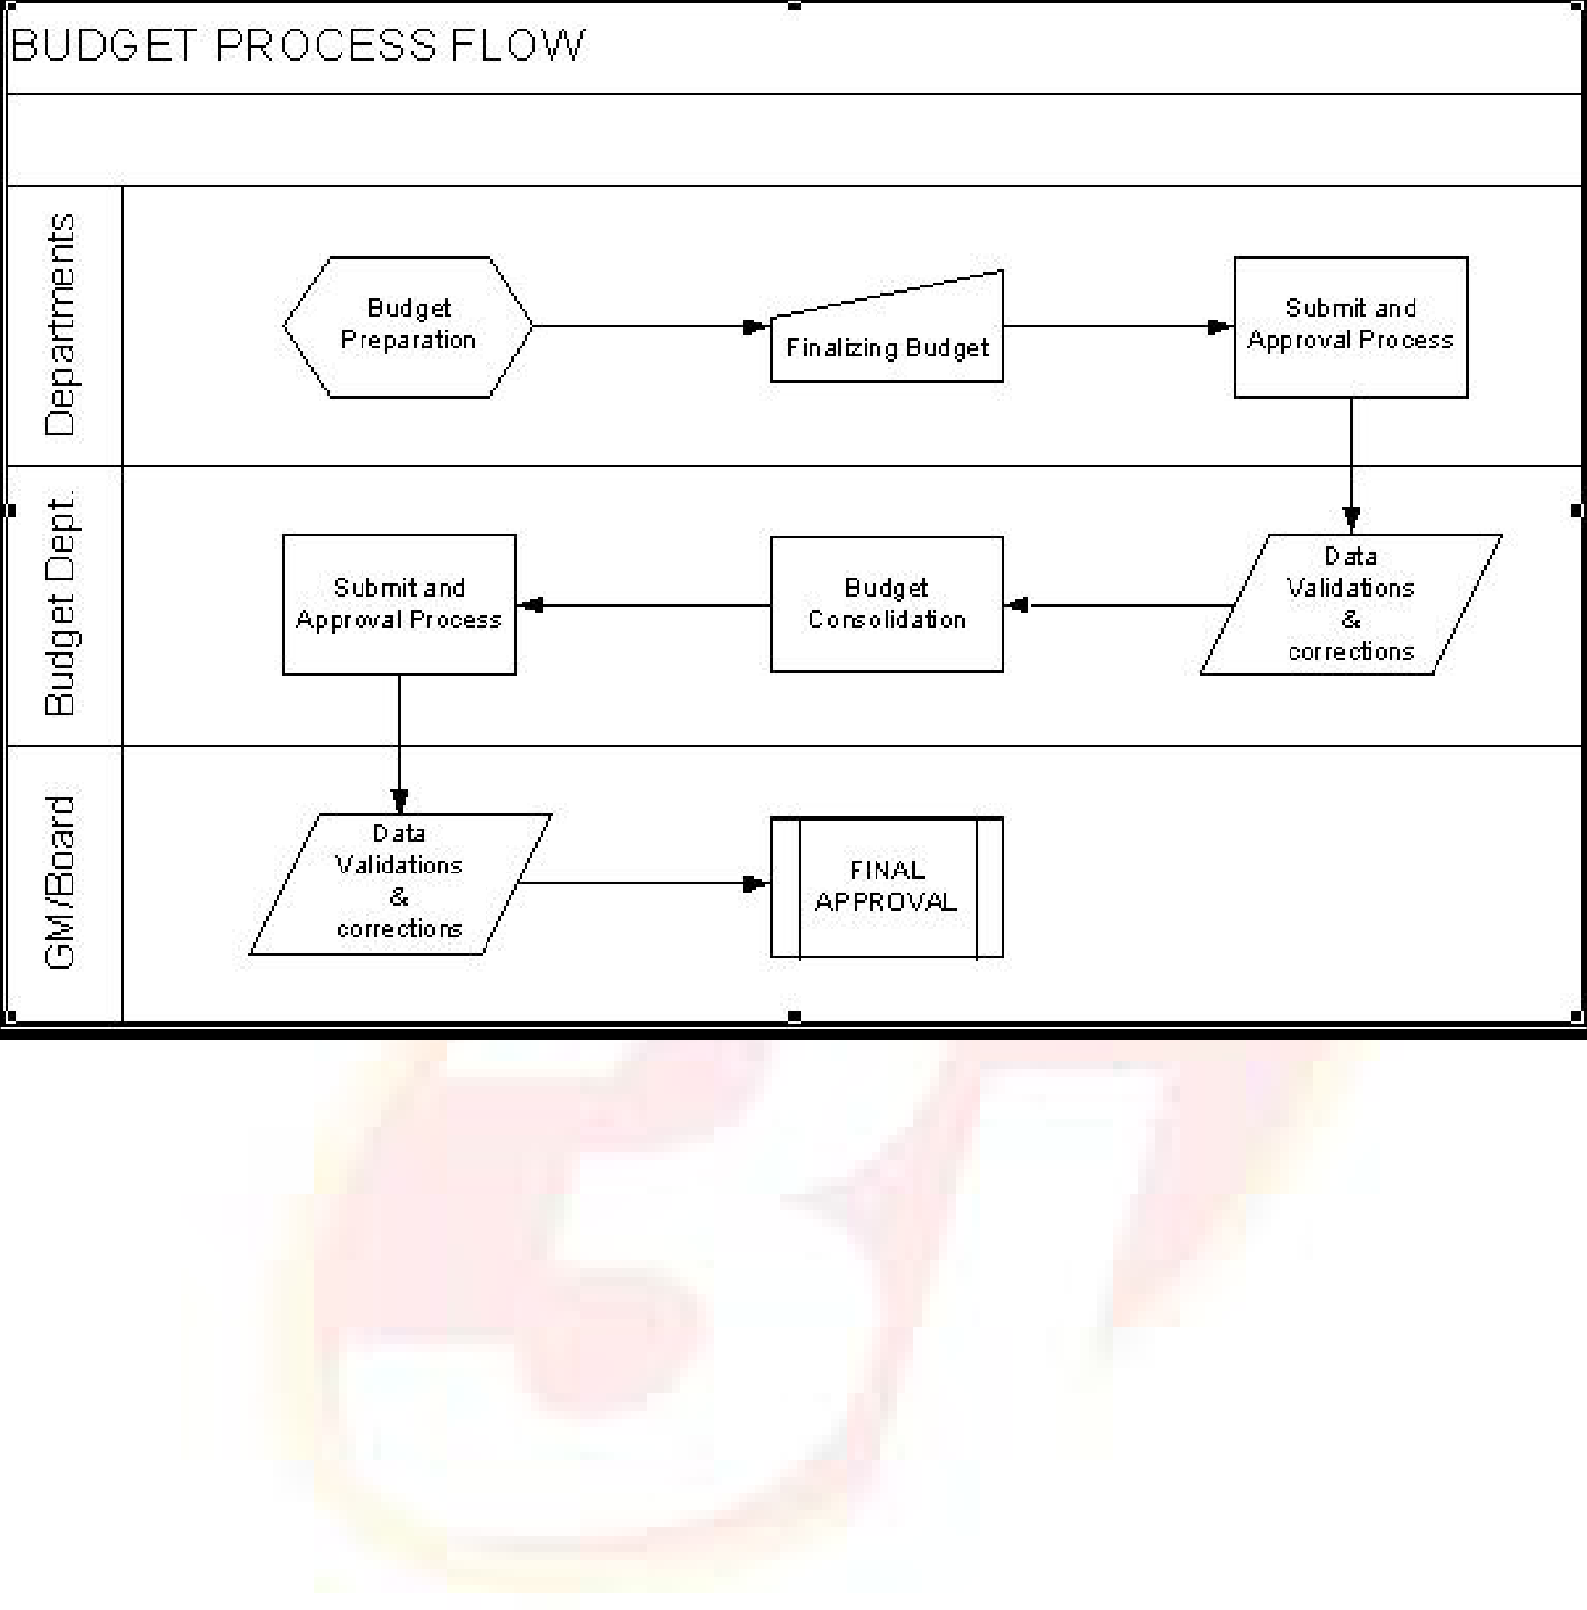





The process of budgeting using a Bottom Up approach is displayed in the following flow chart:
Fig. 1 - Budget Process Flow
ORION Budget User Manual | Version 1.1 | 4

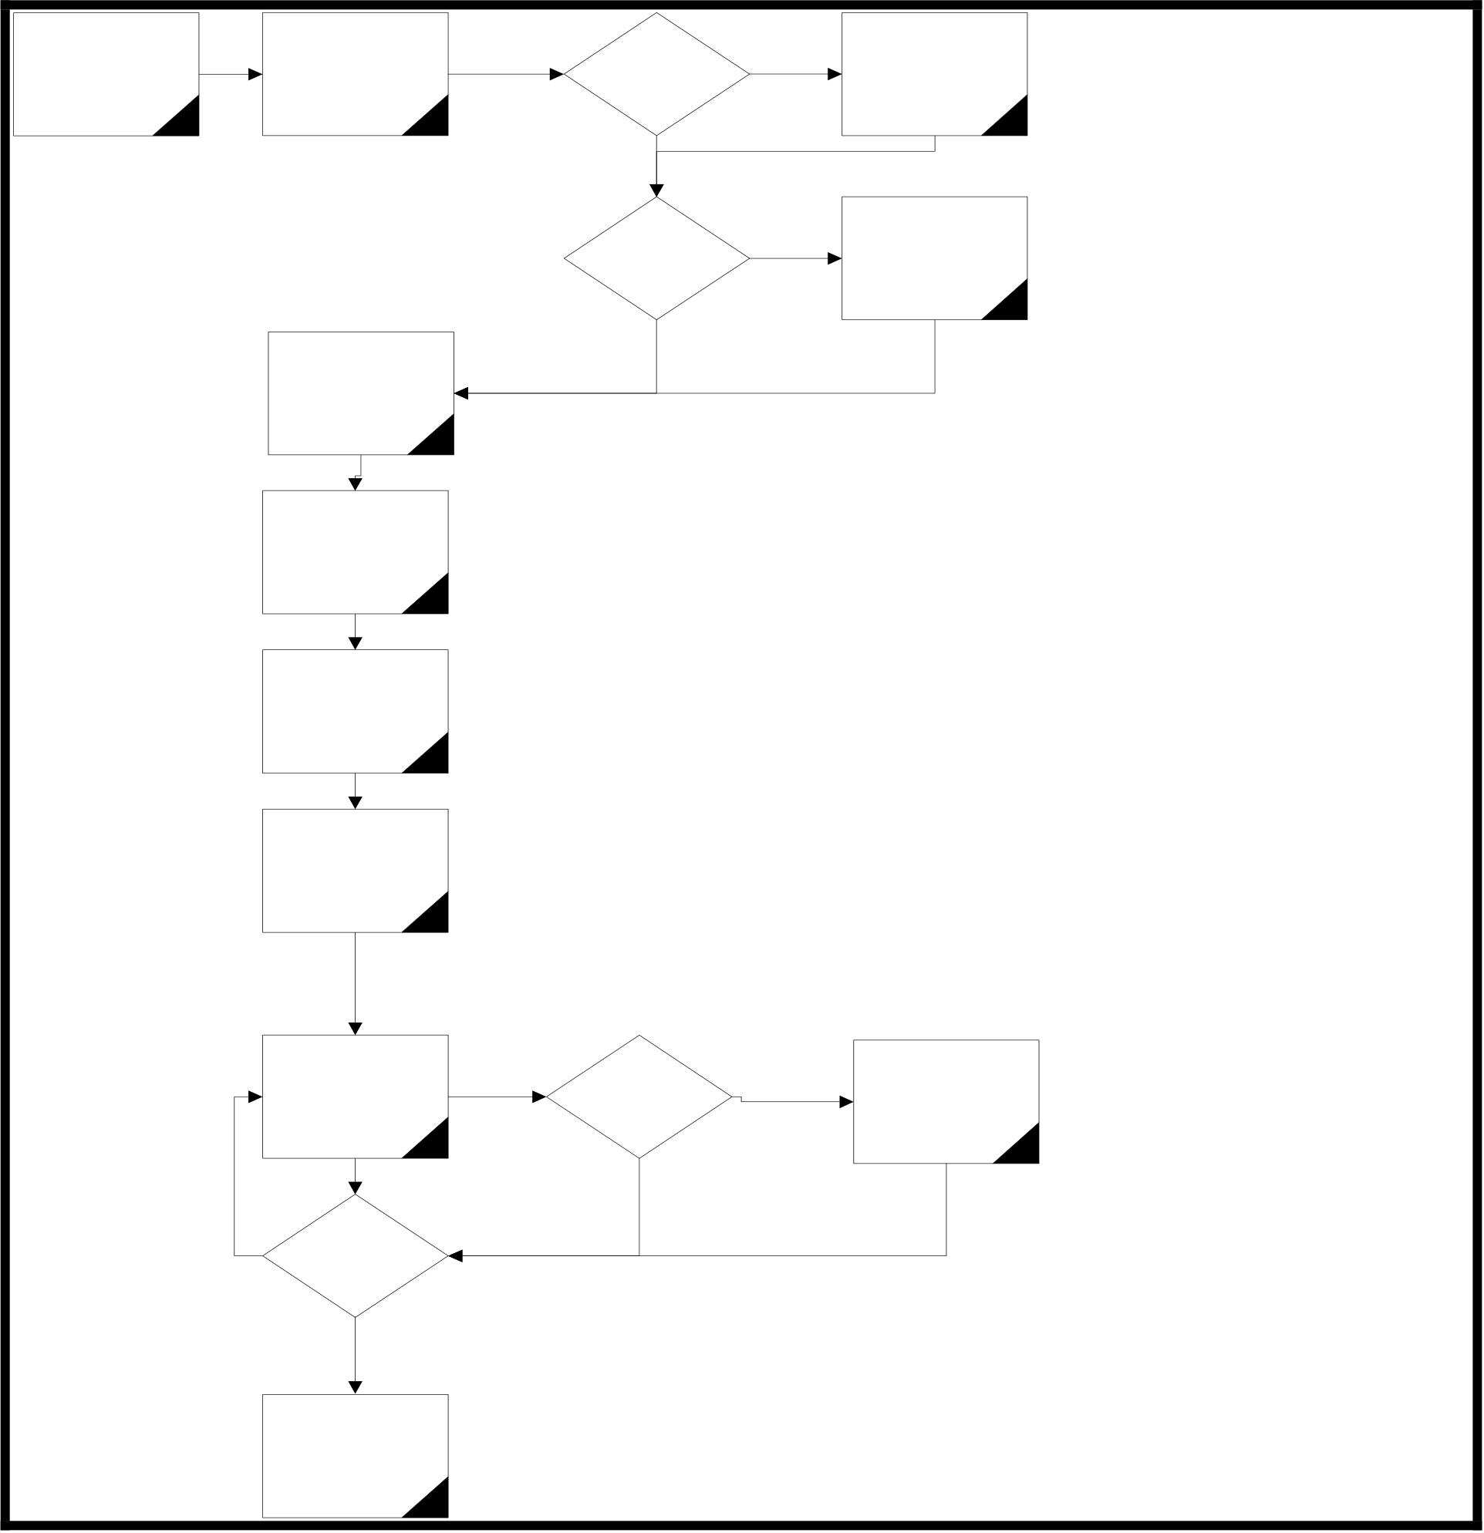
 | 
The overall process flow for the Budget module is as shown in the flowchart:
Creating Budget | Creating Levels, | Approval | Yes | Define Authorised
Period and |  |  |  | Groups and Users
 | Pulling Flow, Level
Defining calender |  | Required ? |  | as per ORION
 | Parameters
for the same |  |  |  | Standards
No
Amendment | Yes | Define
 |  | Amendment
After Approval? |  | Users as per
ORION Standards
No
Defining Budget
Hierarchy
Budget Category  Creation | 1) Document is modified by any user for any level until it is submitted.
2) After Approval, Document is amended if not pulled by the next level. (Based on the Amend After Approval Flag)
Segment Setup,  Applicable  Hierarchy Setup | 3) If Approval is required, only approved document of Child levels is pulled at the next level. If not required, all documents of the child level are pulled.
4) When pulled, a new set of records is created at higher levels.
Budget Setup  (Period Setup, | 5) Approver is allowed to add new records.
Quantity / Value
flags) 6)Next Approving Level includes details pulled from Entry level and also details added at lower approving level
7) Once the documents are pulled at higher level, lower level cannot be selected in new documents.
Budget Creation & | Submit, | Yes | Submission and
Approval at | Approval |  | Approval Process
Different Levels | Required |  | as per ORION for
 |  |  | the level
No
No
Last Level of
Budget
Approved Budget
Fig. 2 - Overall Budget Module Process Flow
ORION Budget User Manual | Version 1.1 | 5

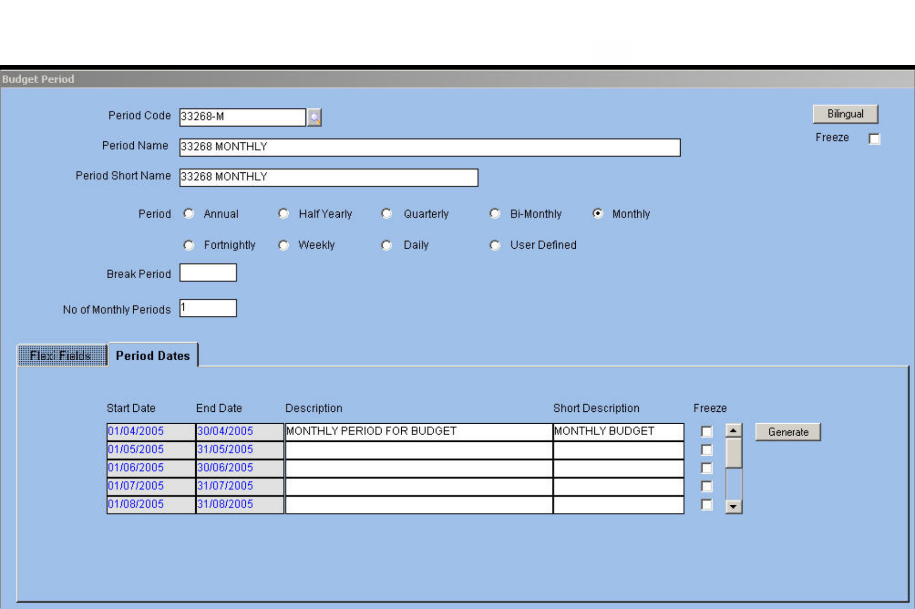





Masters
The Masters in the Budget module include:
 Budget Period
 Budget Level
 Budget Category
 Budget Hierarchy
NOTE: Freeze check box - if this check box is selected in a screen/field, then that
screen/record cannot be used further in the application.
Budget Period Master
The period for which the budget is prepared is defined in the Budget Period master. The budgeting
period is chosen from either system provided or user defined options. The default Budget Period in
ORION is annual.
The Budget Period master is displayed below:
Fig. 3 - Budget Period Master
9Period Code/Name/Short Name
Alphanumeric – 12
Enter or select from LOV a unique budget period code. Next, enter a name for the budget period
that identifies it to the user. The application defaults the shorter version of the name for printing
reports.
NOTE: Period Code cannot be deleted once Budget Setup is defined for the period
or the period is used in a Budget transaction..
ORION Budget User Manual | Version 1.1 | 6







9Period
Option Button
Select the option button as applicable. The available options are:
 Annual
 Half yearly
 Quarterly

Bi-monthly  Monthly
 Fortnightly
 Weekly

Daily  User defined
The user is allowed to define only one period code for periods other than user-defined ones.
9Break Period
The application displays the default break period. The Break Period field accepts entries when Budget Period is user defined. In this case, Break Period is defined in days. The field is left blank when Budget Period is Annual, Half-yearly, Quarterly, Bi-monthly, or Monthly. When the period is Fortnightly, Weekly, or Daily, the application defaults the values 15, 7, and 1 respectively.
9Number of Periods
Numeric – 2
When creating the budget, a period is further divided into Sub Period. Budget Category determines Period and Sub Period for the budget.
The total Budget Period is calculated as Budget Period * Number of Periods defined in the Period master.
Based on this definition, the first Break Period of the budget is identified. This field determines the total projection period for the budget. For example, if the first Break Period is fortnightly and the number of periods is 24 then the budget projection is for 24 fortnights or approximately one year.
ORION Budget User Manual | Version 1.1 | 7

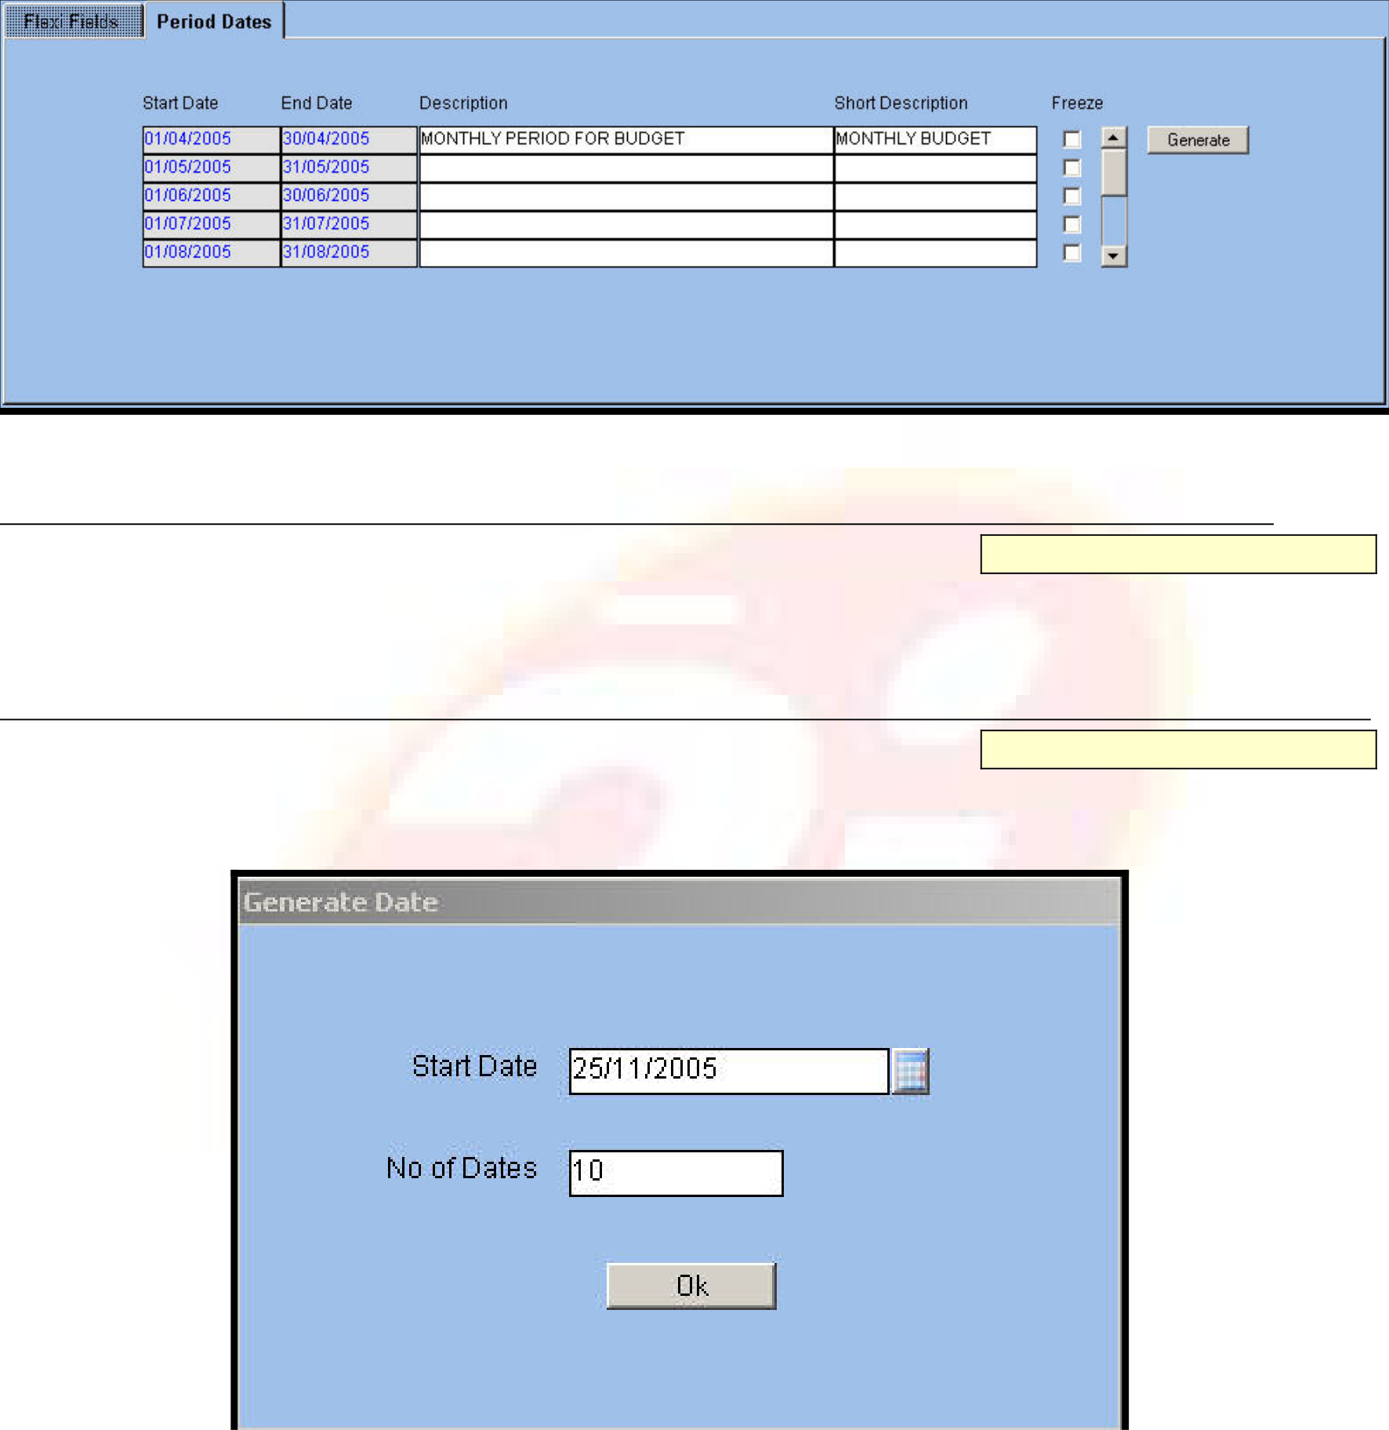





Period Dates
This tab displays the start and end dates of Budget Period in the ‘Start Date’ and ‘End Date’ fields. This auto-generation of dates is based on the Calendar created by clicking on the Generate button.
Fig. 4 - Period Dates Screen Description/Short Description
Alphanumeric – 240, 30
Enter a description for the period range in this field. A bilingual option is also provided. The application defaults the first 30 characters of the description in the adjacent field.
Generate
Button
Click the button to create a calendar for the budget. The Generate Date window is displayed as follows.
Fig. 5 - Generate Date Window 9Start Date
Date
Enter or select from LOV the start date for calendar generation in this field.
ORION Budget User Manual | Version 1.1 | 8





9Number of Dates
Date
Enter the number of dates for which the application is to display the period. If the period is set as Fortnightly and 5 is the entry for this field, ORION displays five fortnight periods in the Budget Period master.

ORION Budget User Manual | Version 1.1 | 9

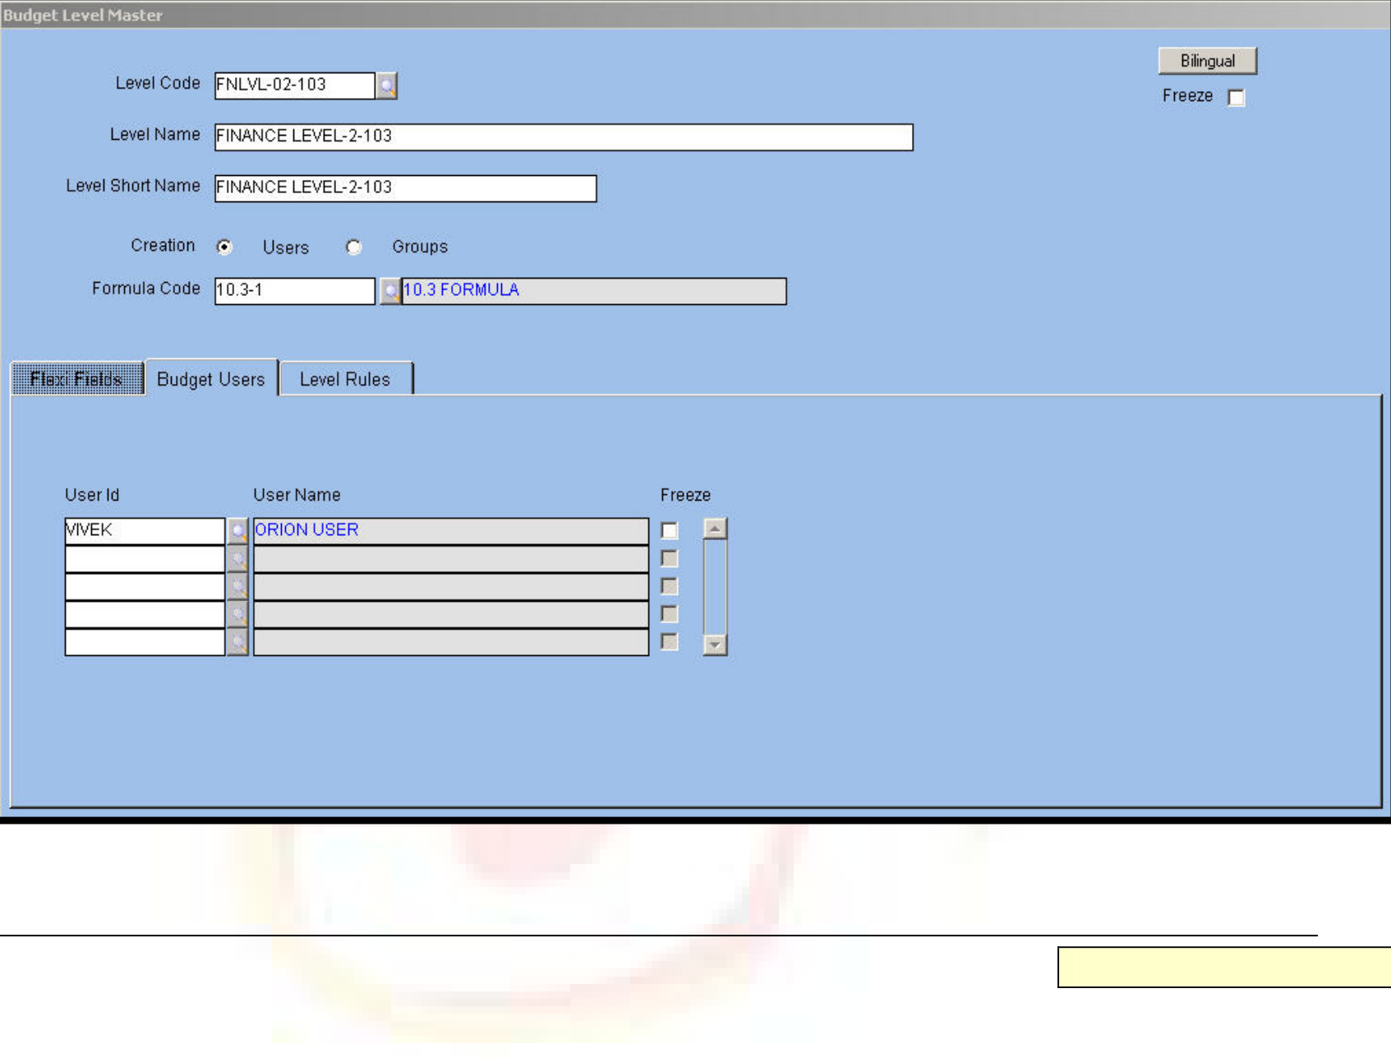





Budget Level Master
Each organization follows a pattern of levels for preparation of budgets. In some cases, users at the lower levels prepare the budget and send it to the next level for approval. Users at the next level approve the budget directly or modify the same. The budget then passes to the next higher level till it reaches the highest level for final approval. All these levels are linked to provide a hierarchy for budget approval. Some of the levels are given the authority to validate and correct the budget figures given by various departments. For example, an intermediary level is grouped into a Budgeting department.
The Budget Level master defines all levels involved in the budget process. Each level is then mapped to the ORION User/Group to define users allowed to enter the budget at each level.
The Budget Level Master is displayed below.
Fig. 6 - Budget Level Master
9Level Code/Name/Short Name
Alphanumeric – 12
Enter or select from LOV a unique Level Code for the level in the hierarchy. This code cannot be duplicated. The code determines the approval and authorization rights for users of the budget document. Next, enter a name that denotes the level in the hierarchy. The application defaults the shorter version of the name for printing reports.
9Creation - Users/Groups
Option Button
Select the option button to assign a level each to an ORION user or group.
This option button is to determine the users applicable for the budget at the attached Level Code.
NOTE: Based on the logged in user or the group to which the logged-in user is assigned, data filter of the budget document occurs. Through data filter, budget creation is facilitated.
ORION Budget User Manual | Version 1.1 | 10

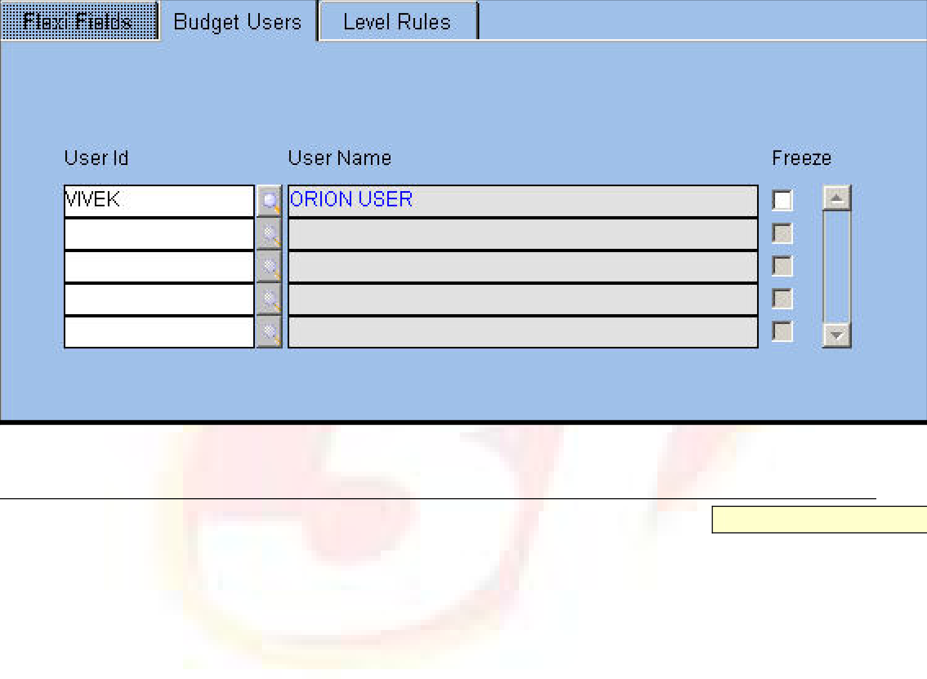





9Formula Code
Alphanumeric – 12
Attach the Formula Code defined in the Formula master.
This code is attached to the topmost level or the parent level in the Budget Level master. In the case of a Top Down approach, the budget details are distributed across the child levels. The code is to determine the value at each child level.
Budget Users/Budget Group
The Budget Users/Budget Group tab label changes dynamically based on the option selected for the ‘Creation’ option button in the header block. This tab allows assigning users or groups to the selected Level Code. At this particular level, only the assigned users or groups are able to create and modify the budget.
Fig. 7 - Budget Users/Groups Tab
9User Id/Group Code
Alphanumeric – 12
Enter or select from LOV the ID assigned to a particular user or group in this field. On selecting the User ID, the User Name gets automatically defaulted in the adjacent field.
ORION Budget User Manual | Version 1.1 | 11

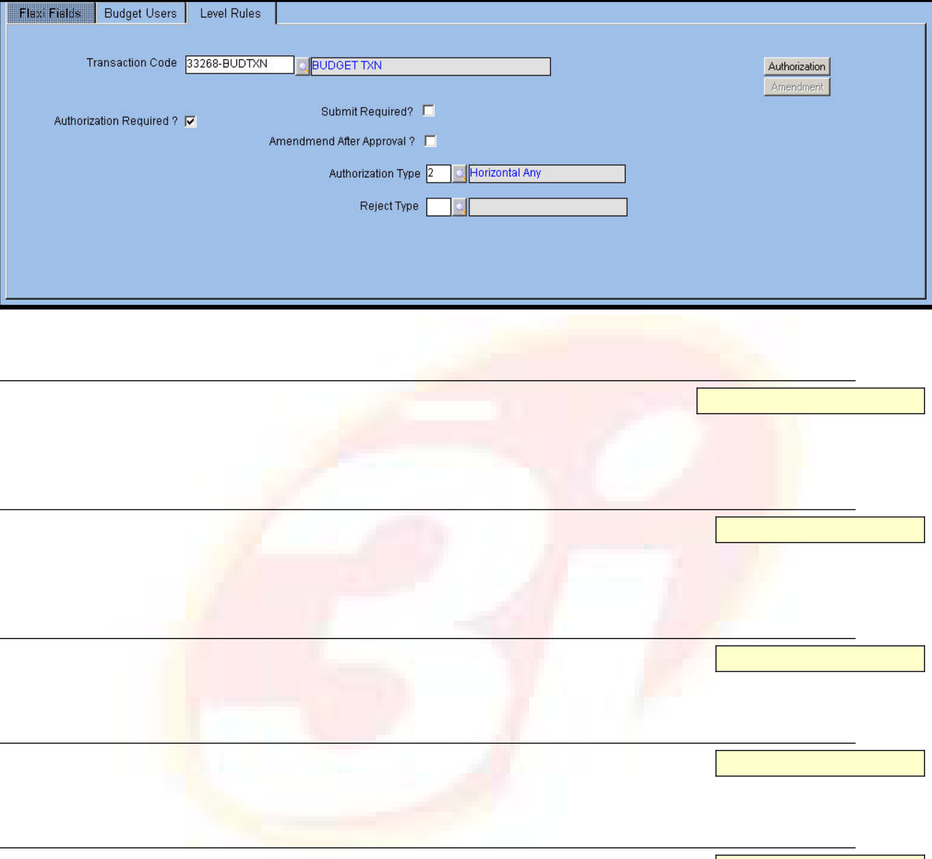





Level Rules
The tab allows the user to set amendment and authorization rules for transactions applicable to the Level code.
The Level Rules tab is displayed below.
Fig. 8 - Level Rules Tab 9Transaction Code
Alphanumeric – 12
Enter or select from LOV the Transaction Codes (defined in Transaction master) applicable for the level code. The application displays the description in the adjacent field.
Authorization Required?
Check box
Select the check box if authorization is required for the budget document against the chosen Transaction Code within the attached Level Code.
Submit Required?
Check box
Select the check box if the budget document requires submission. Amendment After Approval?
Check box
Select the check box if the document is amendable after the approval is complete. 9Authorization Type
Numeric
Enter or select from LOV an authorization type. The available options are:
 Horizontal Any
 Horizontal All
 Vertical All
 Vertical Bypass
NOTE: This field is applicable only when the user selects the ‘Authorization Required’ check box.
ORION Budget User Manual | Version 1.1 | 12

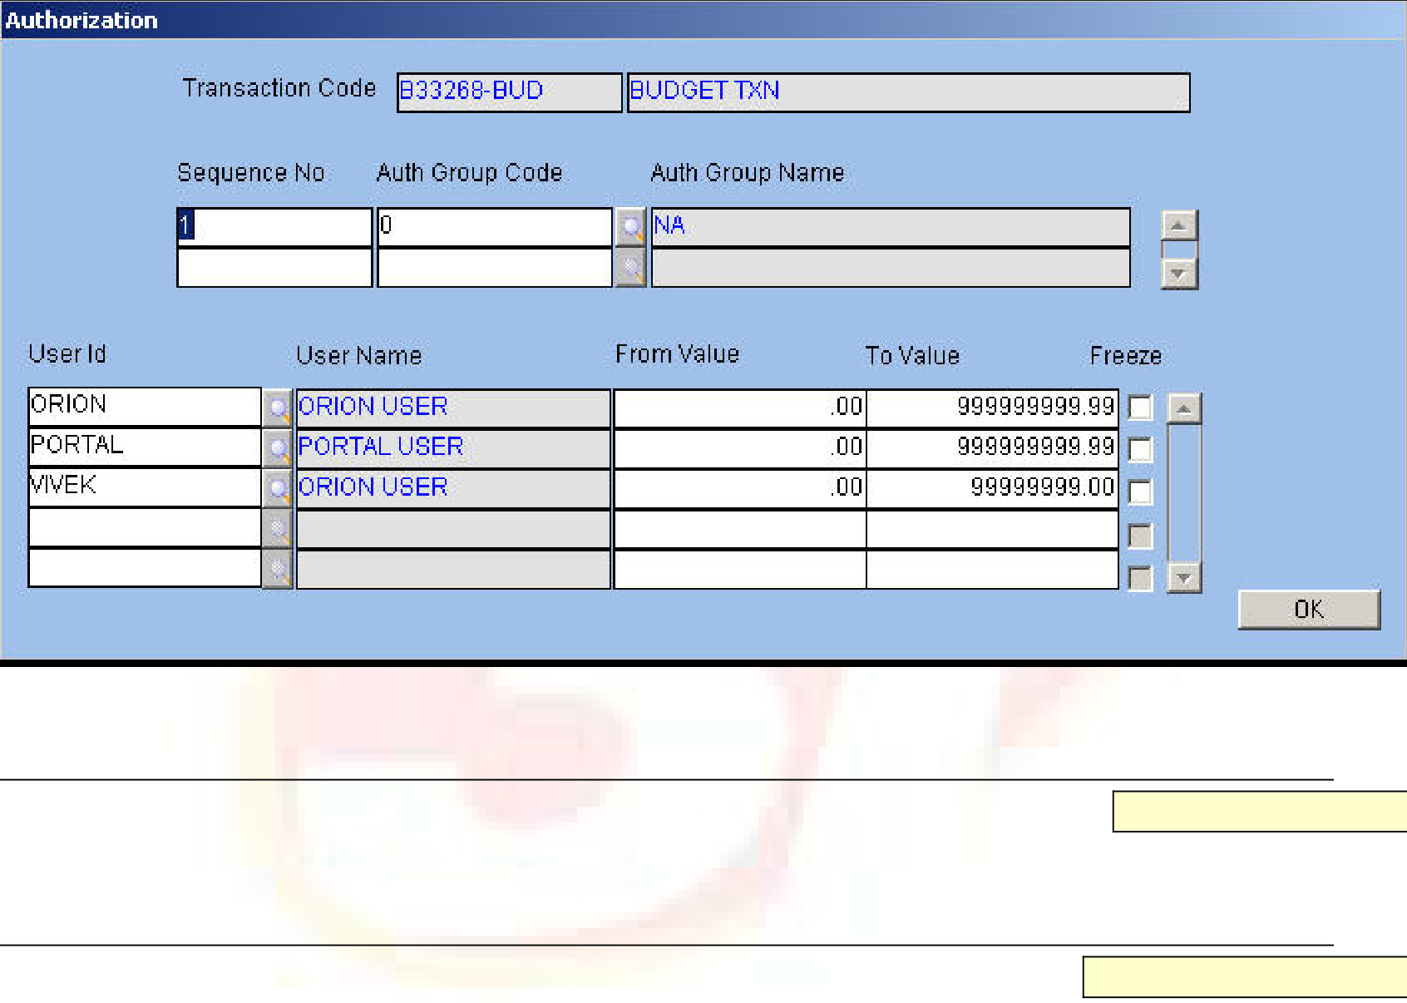





9Reject Type
Alphanumeric – 12
If the attached Authorization Type is Vertical All or Vertical Bypass, then enter or select from the LOV an appropriate reject type. The available options are:
 Reject and Return to Beginning Level
 Reject and Return to Previous Level.
Authorization
Button
Click the button to enter authorization details. The Transaction Code and its description are automatically displayed on entering this screen.
The Authorization window is displayed below.
Fig. 9 - Authorization Window 9Sequence Number
Numeric
Enter a sequence number. for the authorization
9Authorization Group Code/Authorization Group Name
Alphanumeric – 12
Enter or select from LOV the Authorization Group Code. Once a code is entered, the application displays the description in the adjacent field.
9User ID/Name
Alphanumeric – 240
Enter the ID of the user belonging to the attached Authorization Group. Once a name is entered the description pertaining to it gets automatically displayed in the adjacent field.
9From and To Value
Numeric
Enter the range of amounts of the budget that a particular user is authorized to approve.
ORION Budget User Manual | Version 1.1 | 13

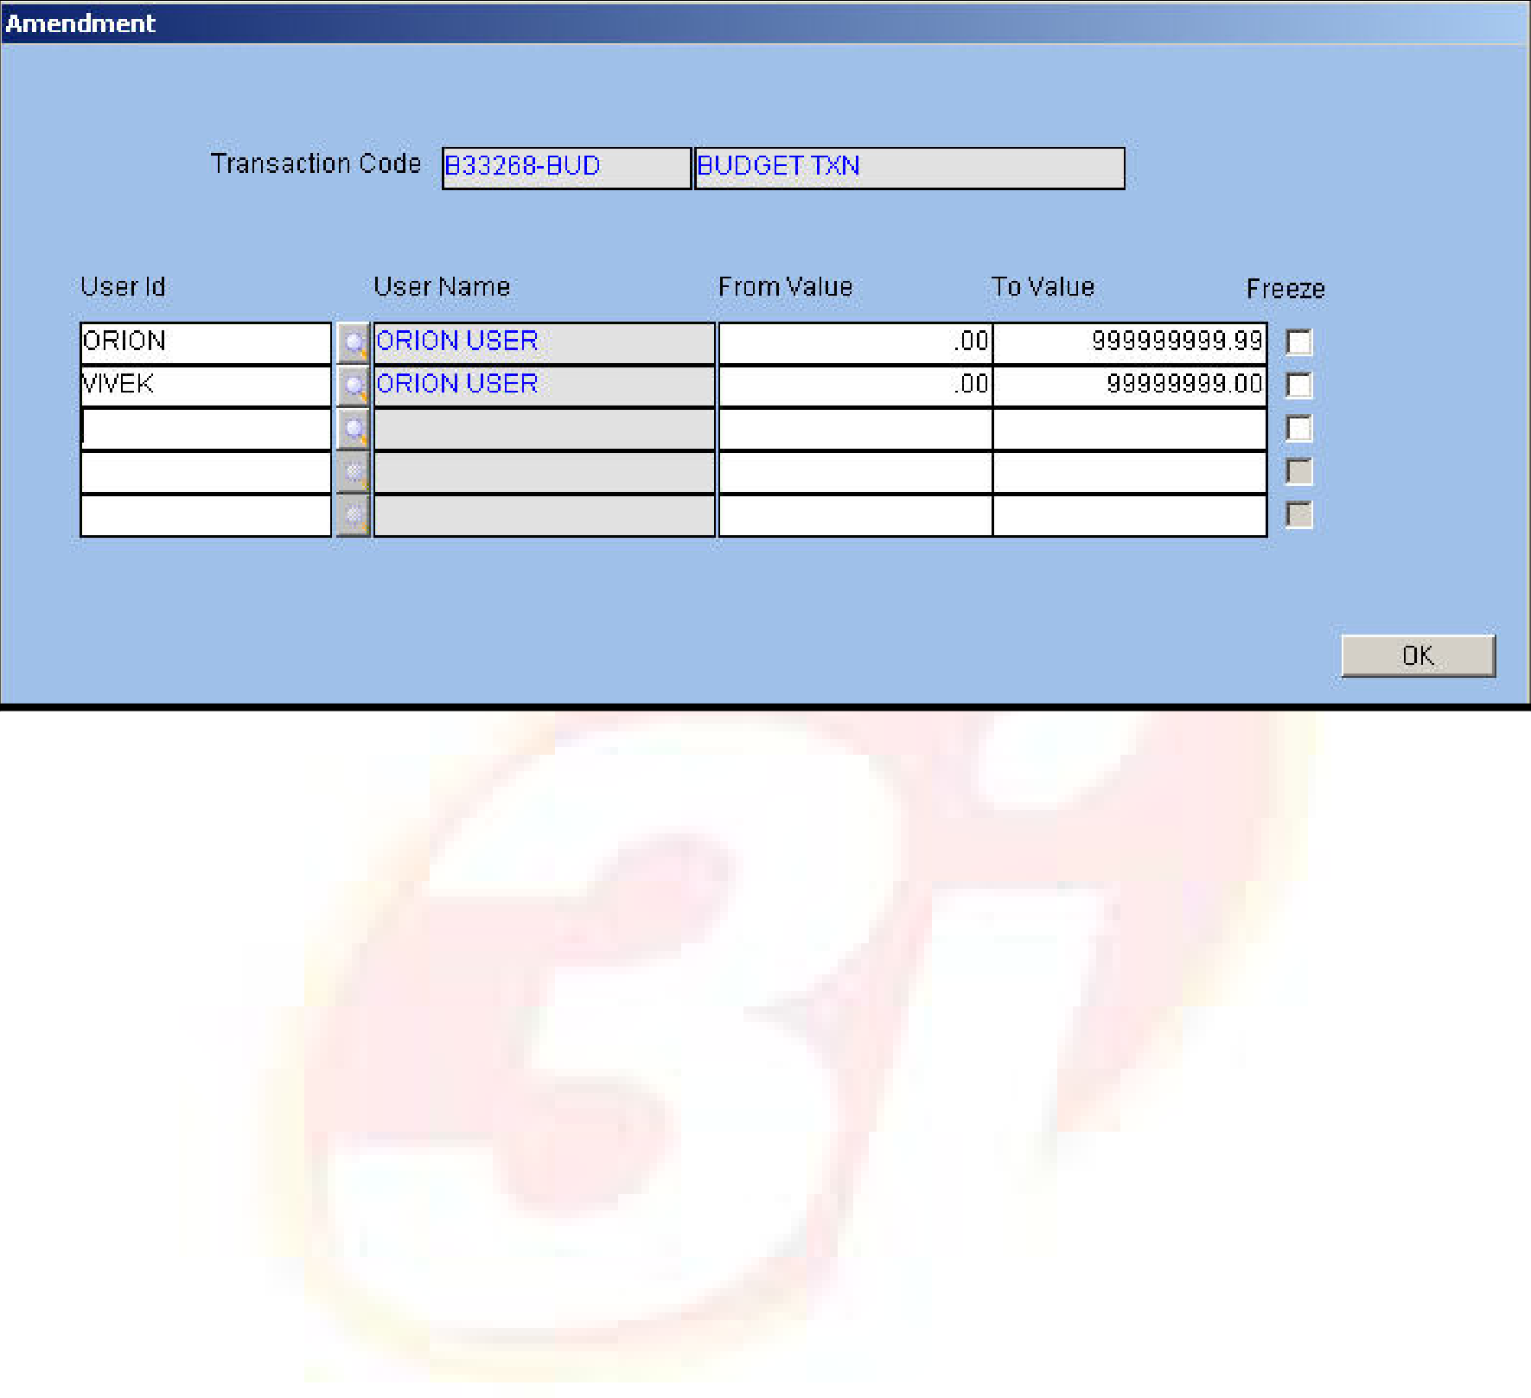





Amendment
Numeric
Click the button to define users who are allowed to amend the document after approval. The Amendment window is displayed below.
Fig. 10 - Amendment Window
For field-level explanation of this window, please refer the Authorization window.
ORION Budget User Manual | Version 1.1 | 14

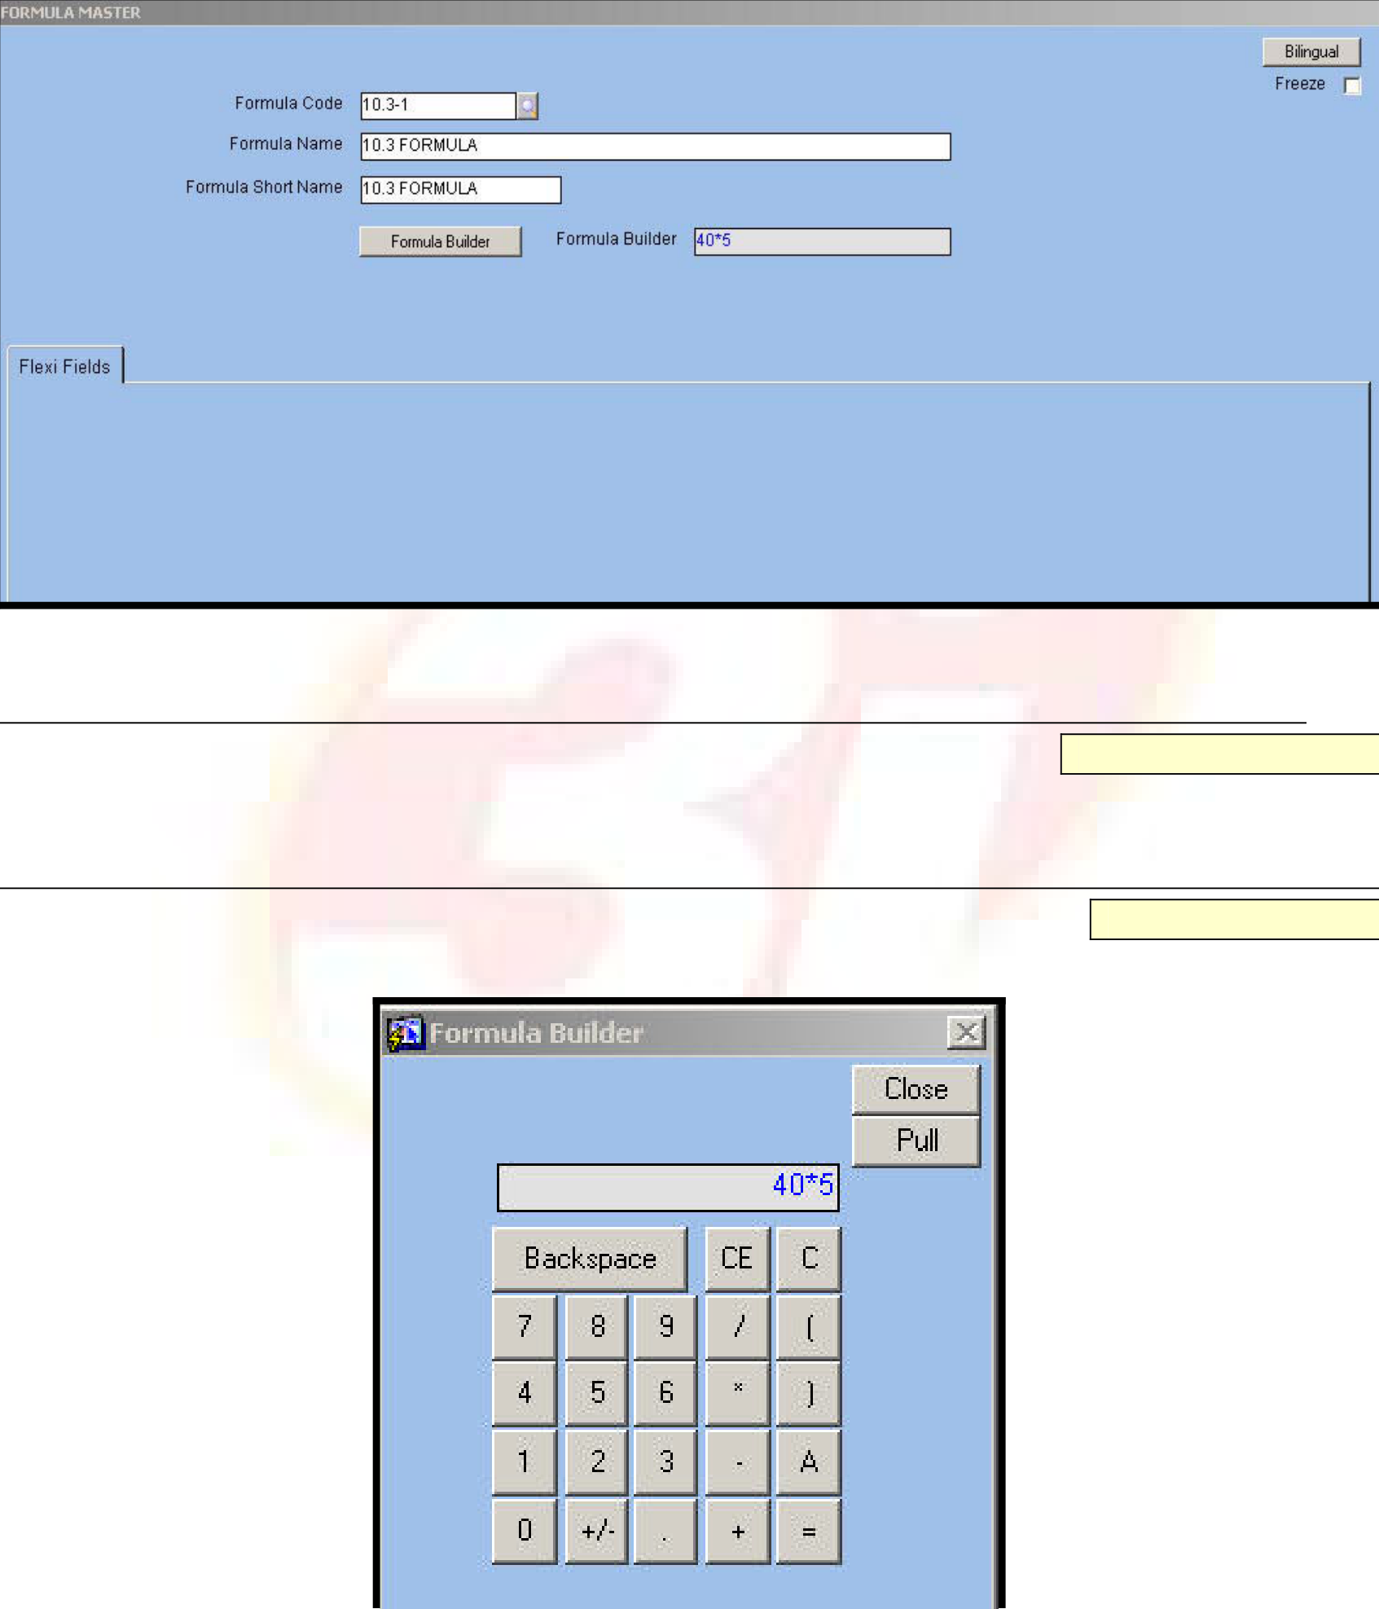





Formula Master
When the Budget Approach is Top Down, the Budget Details entered at the higher levels are distributed to the lower levels. In other words, the budget created at the Parent Levels is de-aggregated down to the child levels. In the Budgeting module, this distribution of Budget Details is done using formula defined in the Formula master. The formula created using the Formula master is attached to the Parent Level and defines the value at Child Level. The Formula Code is attached to a Level code in the Budget Level master.
The Formula master is displayed below.
Fig. 11 - Formula Master
9Formula Code/Name/Short Name
Alphanumeric – 12
Enter or select from the LOV a unique code to identify the formula in this field.
Formula Builder
Button
Click the button to open the calculator window. This calculator builds the formula.
Fig. 12 - Formula Builder Window
ORION Budget User Manual | Version 1.1 | 15







Buttons | Usage
Backspace | Deletes only one character at a time, the last entered character.
CE | Clears the formula entered so far
C | Clears the formula entered so far
0, 1, 2, 3, 4, 5, 6, 7, 8, 9 | Includes the respective numerals in the formula being created
. | Includes the decimal point in the numerical
+/- | Toggles a positive value to a negative value and vice versa
+, -, *, / | Arithmetic operators to be embedded amongst the operands in the formula
[,] | Brackets to highlight precedence
A | Indicates a variable, the forecast value that is passed on to the lower level
= | None
Click the ‘Pull’ button to pull the formula into the ‘Formula Display’ field and the ‘Close’ button to
close the Formula Builder.
ORION Budget User Manual | Version 1.1 | 16

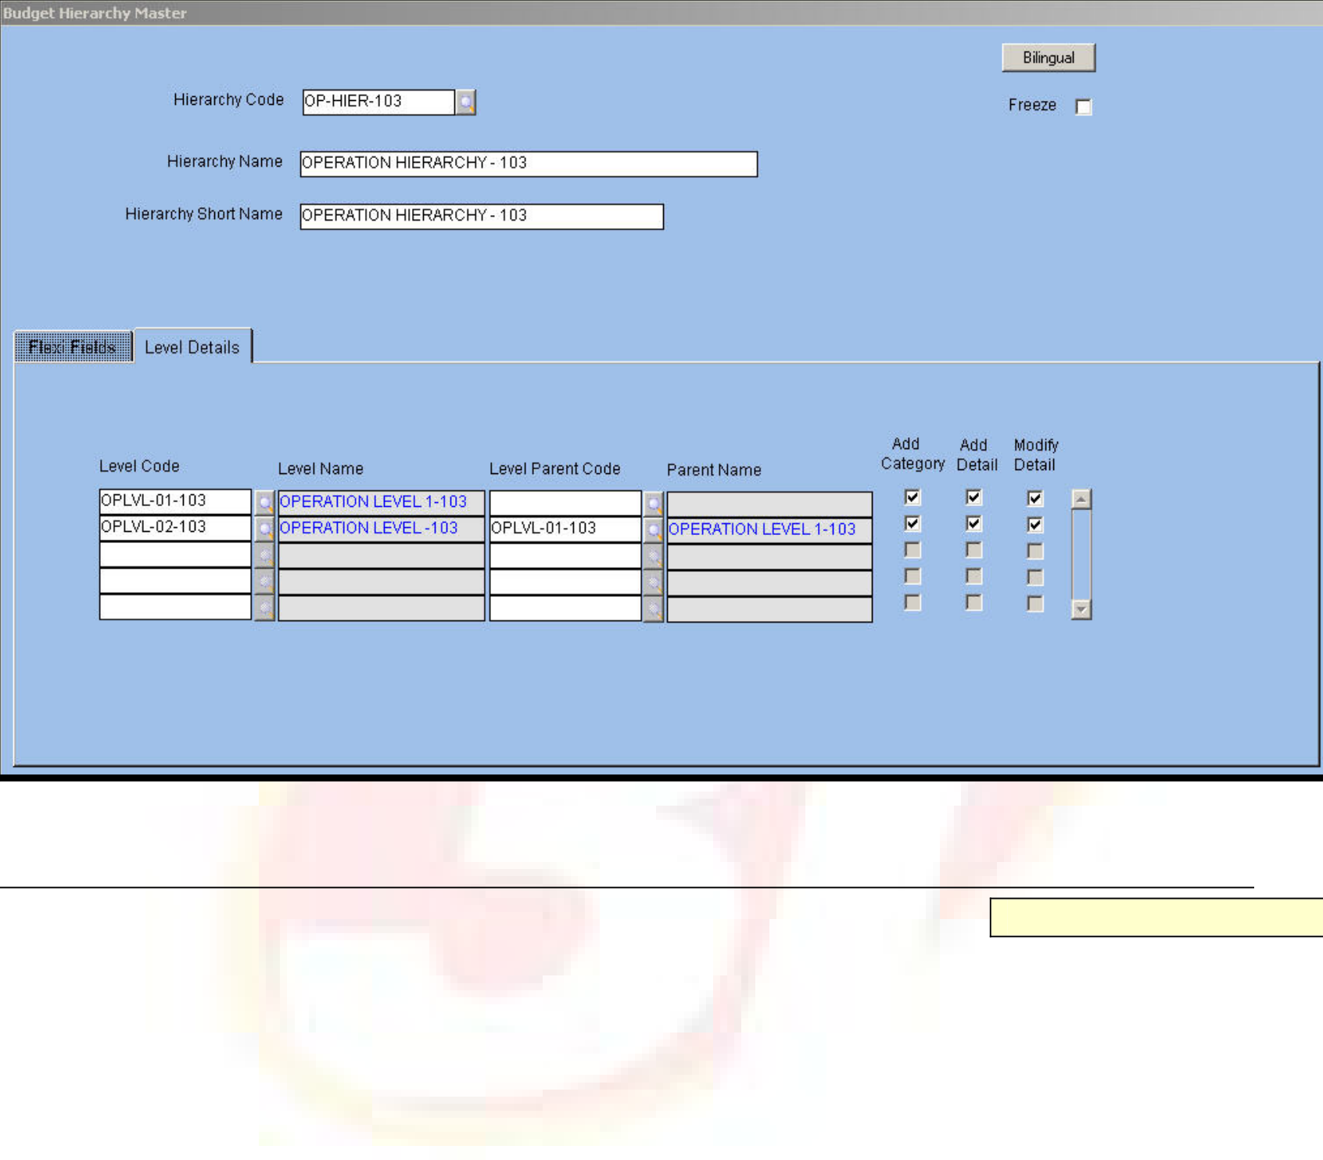





Budget Hierarchy Master
The Budget Hierarchy master interrelates levels to form a hierarchical structure for budget approval. This relationship is created based on Level Code and Parent Level Code. Further, the hierarchy is the basis to define the authority of the intermediary levels. For example, the intermediary level is given the authority only to pull and consolidate budget data but not add a new budget item or a new budget category at the same level.
The Budget Hierarchy master is displayed below.
Fig. 13 - Budget Hierarchy Master
9Hierarchy Code/Name/Short Name
Alphanumeric – 12
Enter or select from the LOV a distinct code to denote the hierarchy. Next, enter a name for the hierarchy. The application defaults the shorter version of the name for printing reports.
ORION Budget User Manual | Version 1.1 | 17

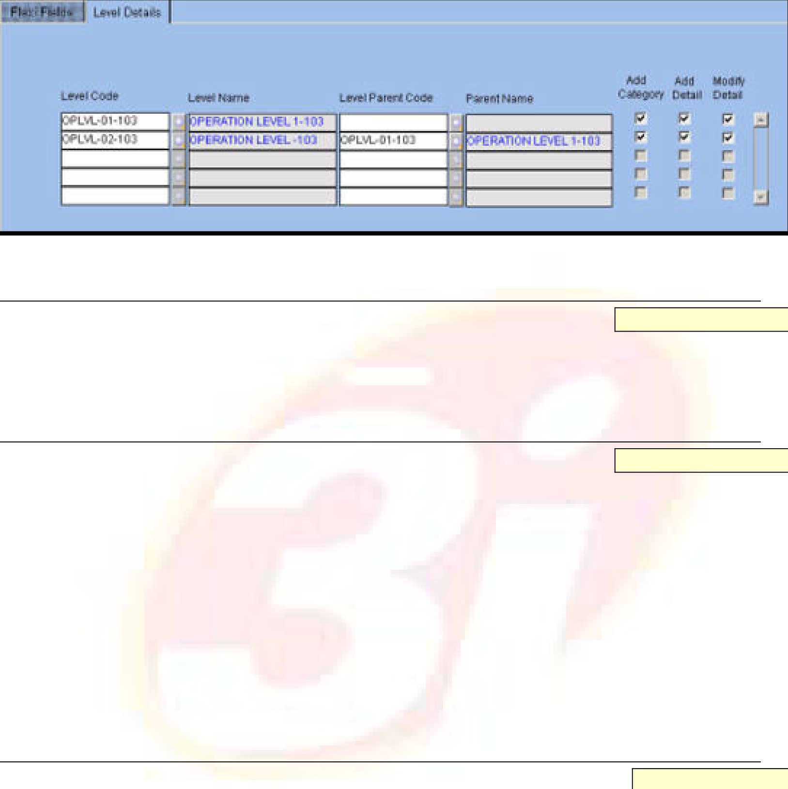





Level Details
This tab allows the user to build the hierarchy between Level Codes and to assign rights including category addition, detail addition and detail modification to each Level.
The Level Details tab is displayed below.
Fig. 14 - Level Details Tab
9Level Code
Alphanumeric – 12
Enter or select from LOV the required Level Code. The options available in the LOV are those defined in the Budget Level Master. The application automatically displays the name in the ‘Level Name’ field.
9Level Parent Code
Alphanumeric – 12
Enter or select from LOV a code for Level Parent. The application automatically displays the name in the ‘Parent Name’ field.
NOTE:
 Each level is a child level to a parent. The level for which no parent code is attached is the top level in the hierarchy. The lowest level is when the level is not defined as parent for any subsequent level. Many such lowest level codes can exist.
 There can be only one record in the hierarchy with no parent code. The NULL value is allowed for this record.
Add Category
Check box
Select the check box if the user is allowed to add a category at intermediate level.
Add Detail
Check box
Select the check box if a user at a particular level is given rights to add details to the budget.
Modify Detail
Check box
Select the check box if a user at a level is allowed to modify details entered by users at the child or parent levels. If the user does not have rights to carry out add, modify, or delete actions, then the Intermediate Level is able to only pull the values from lower or higher level and confirm the value. This signifies that changes in value or new addition at intermediate level are not allowed.
ORION Budget User Manual | Version 1.1 | 18

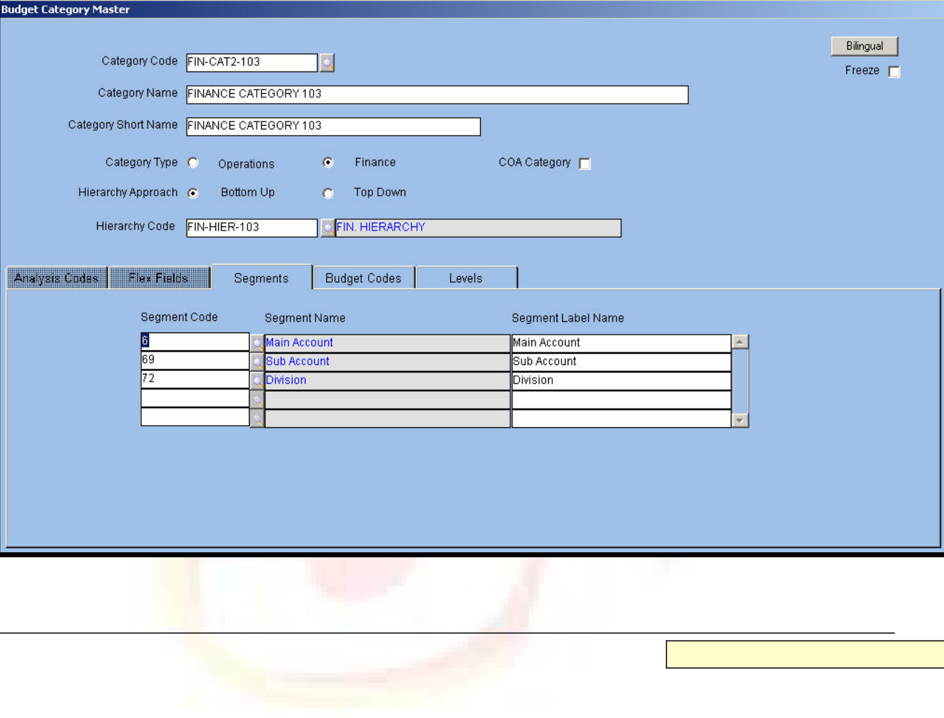





Budget Category Master
Budget Category codes are created for Operations and Finance budgets. The hierarchy approach is also assigned simultaneously. Based on the nature of the Budget, applicable segments are assigned to the Budget category. Applicable segments are predefined for the group. For example, the applicable segments for Operations budget are Item Code, Grade Code, and so on. User-defined grouping for budget creation is also possible. For Finance budget, Main Account, Sub-account, Division, Department, and so on form the basis of grouping. The Finance budget is also user defined.
If Analysis Codes 1 to 20 are defined for Budget Category, then the application displays these in the Analysis Codes tab.
The Budget Category master is displayed as follows.
Fig. 15 - Budget Category Master
9Category Code/Name/Short Name
Alphanumeric-12, 240, 30
Enter or select from the LOV the required category code. Next enter a name for the category. The application defaults the shorter version of the name for printing reports
Category Type
Option Button
Select the required Category Type from the available options, namely, Operations and Finance.
Hierarchy Approach
Option Button
Select the required Hierarchy Approach from the available options, namely, Bottom Up or Top Down for creating budgeting level hierarchies.
NOTE:
 In the Bottom Up Approach, users at the lower levels enter the budget first and pass it on to users at the higher levels for consolidation.
ORION Budget User Manual | Version 1.1 | 19

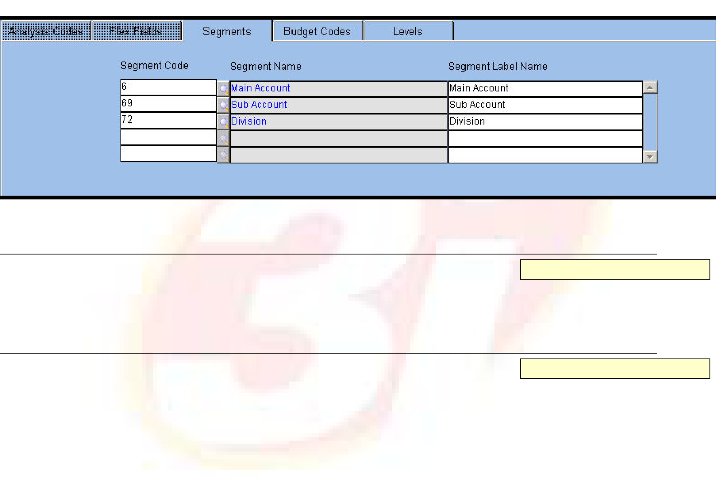





   | In the Top Down Approach, the budget is created at the highest level. Users at the lower levels enter values less than or equal to the value
entered at the higher level.
9Hierarchy Code
Alphanumeric – 12
Enter or select from LOV a Hierarchy Code defined in the ‘Budget Hierarchy’ master.
Segment
Click the tab to define segments that form part of Budget Category. The module permits 12 segments in each category. Budget is created for segments defined in the Budget Category setup. Once the category is set up and segments defined, no addition or deletion of the segments is possible if the category is used in the setup or in the Budget transaction. Select the segment as applicable.
The Segment tab is displayed below.
Fig. 16 - Segment Tab
9Segment Code/Name
Alphanumeric – 12
Enter or select from LOV a unique Segment Code defined in the System Value Set. Once a code is entered, the application displays the description in the adjacent field.
9Segment Label Name
Alphanumeric – 240
Enter the label to be displayed in the transaction form in this field.
The Segment values are distinct for the Operations and Finance budgets based on the chosen Category Type. Segments are not interchangeable and are created in the System value set. If a value is frozen in the value set, it is not available for selection.
ORION Budget User Manual | Version 1.1 | 20







The predefined Segment Codes for the Finance category are as follows:
Segment Code | Segment Description
3 | Main Account Category
6 | Main Account
9 | Main Account Classification 01
12 | Main Account Classification 02
15 | Main Account Classification 03
18 | Main Account Classification 04
21 | Main Account Classification 05
24 | Main Account Classification 06
27 | Main Account Classification 07
30 | Main Account Classification 08
33 | Main Account Classification 09
36 | Main Account Classification 10
39 | Main Account Classification 11
42 | Main Account Classification 12
45 | Main Account Classification 13
48 | Main Account Classification 14
51 | Main Account Classification 15
54 | Main Account Classification 16
57 | Main Account Classification 17
60 | Main Account Classification 18
63 | Main Account Classification 19
66 | Main Account Classification 20
69 | Sub Account
72 | Division
75 | Division Classification 01
78 | Division Classification 02
81 | Division Classification 03
84 | Division Classification 04
87 | Division Classification 05
90 | Division Classification 06
93 | Division Classification 07
96 | Division Classification 08

ORION Budget User Manual | Version 1.1 | 21







99 | Division Classification 09
102 | Division Classification 10
105 | Division Classification 11
108 | Division Classification 12
111 | Division Classification 13
114 | Division Classification 14
117 | Division Classification 15
120 | Division Classification 16
123 | Division Classification 17
126 | Division Classification 18
129 | Division Classification 19
132 | Division Classification 20
135 | Department
138 | Analysis - 01
141 | Analysis - 02
144 | Activity - 01
147 | Activity - 02
Similarly, the preset value sets for the Operations category are as follows:
Segment Code | Segment Description
3 | Location Type
6 | Location Code
9 | Location Analysis 01
12 | Location Analysis 02
15 | Location Analysis 03
18 | Location Analysis 04
21 | Location Analysis 05
24 | Location Analysis 06
27 | Location Analysis 07
30 | Location Analysis 08
33 | Location Analysis 09
36 | Location Analysis 10
39 | Location Analysis 11
42 | Location Analysis 12
45 | Location Analysis 13

ORION Budget User Manual | Version 1.1 | 22







48 | Location Analysis 14
51 | Location Analysis 15
54 | Location Analysis 16
57 | Location Analysis 17
60 | Location Analysis 18
63 | Location Analysis 19
66 | Location Analysis 20
69 | Supplier Code
72 | Supplier Analysis 01
75 | Supplier Analysis 02
78 | Supplier Analysis 03
81 | Supplier Analysis 04
84 | Supplier Analysis 05
87 | Supplier Analysis 06
90 | Supplier Analysis 07
93 | Supplier Analysis 08
96 | Supplier Analysis 09
99 | Supplier Analysis 10
102 | Supplier Analysis 11
105 | Supplier Analysis 12
108 | Supplier Analysis 13
111 | Supplier Analysis 14
114 | Supplier Analysis 15
117 | Supplier Analysis 16
120 | Supplier Analysis 17
123 | Supplier Analysis 18
126 | Supplier Analysis 19
129 | Supplier Analysis 20
132 | Item Code
135 | Grade Code 1
138 | Grade Code 2
141 | Item GL Code
144 | Job Charge Area
147 | Employee Charge Area

ORION Budget User Manual | Version 1.1 | 23







150 | Cost Centre Charge Area
153 | Supplier Charge Area
156 | Location Charge Area
159 | Customer Charge Area
162 | Charge Code
165 | Item Analysis 01
168 | Item Analysis 02
171 | Item Analysis 03
174 | Item Analysis 04
177 | Item Analysis 05
180 | Item Analysis 06
183 | Item Analysis 07
186 | Item Analysis 08
189 | Item Analysis 09
192 | Item Analysis 10
195 | Item Analysis 11
198 | Item Analysis 12
201 | Item Analysis 13
204 | Item Analysis 14
207 | Item Analysis 15
210 | Item Analysis 16
213 | Item Analysis 17
216 | Item Analysis 18
219 | Item Analysis 19
222 | Item Analysis 20
225 | Country
228 | State
231 | County
234 | City
237 | Sector

ORION Budget User Manual | Version 1.1 | 24

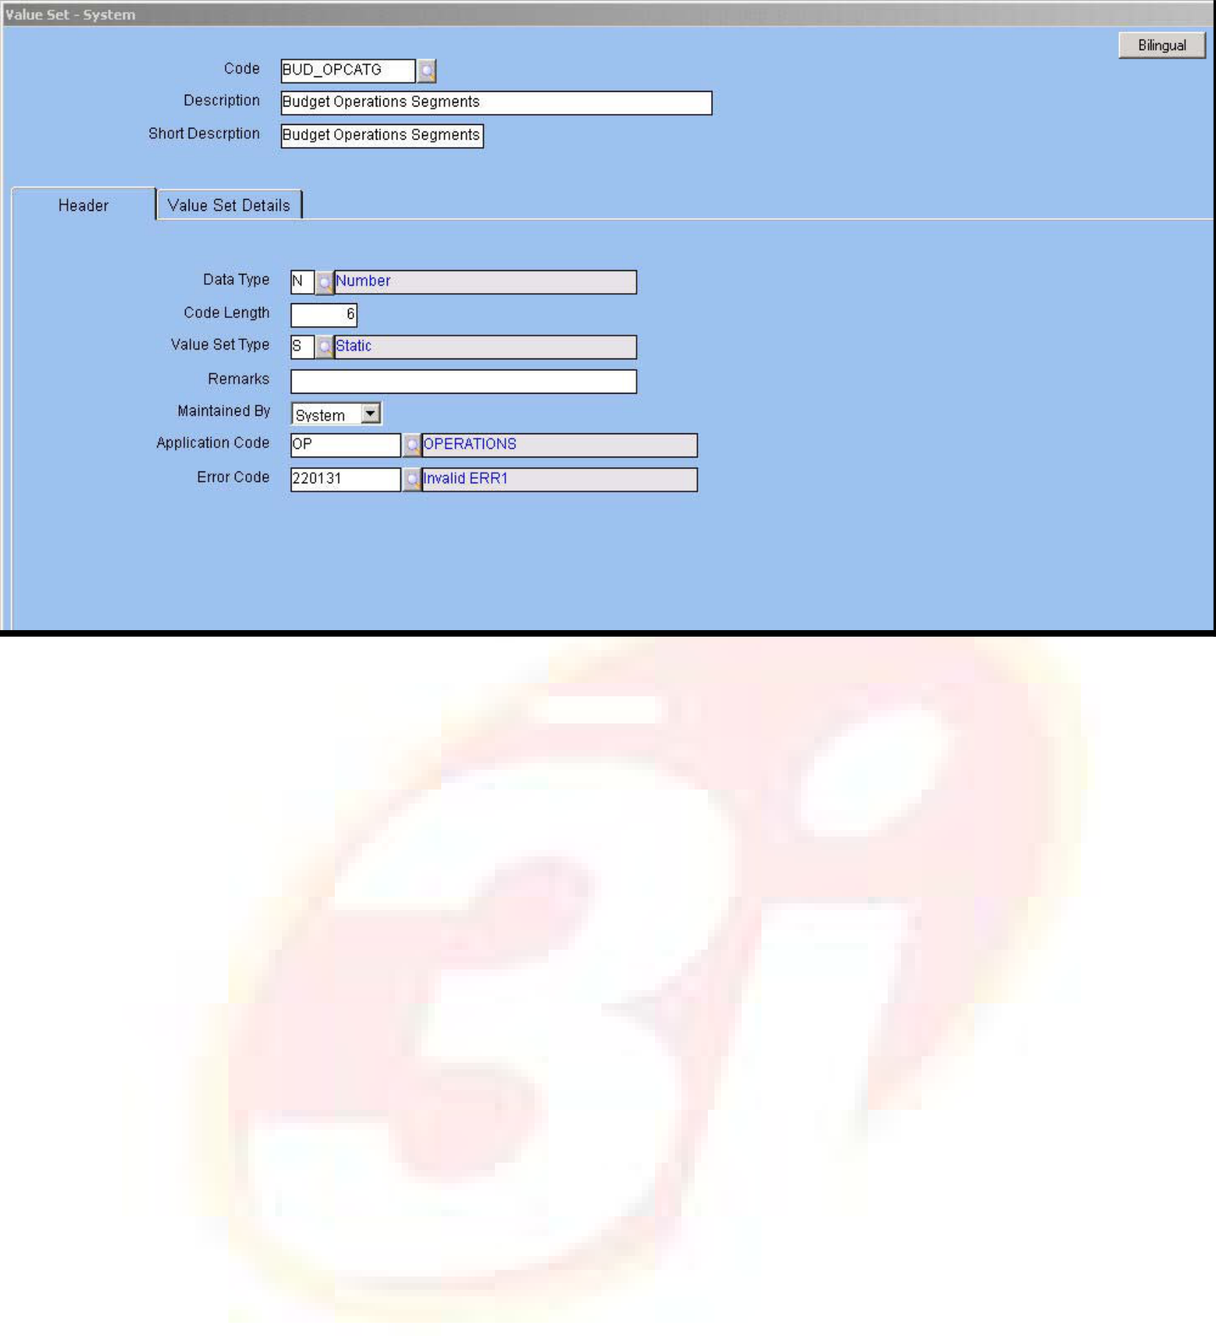





The system values are displayed as follows:
Fig. 17 – Value set System Screen
There are conditions that govern the selection of Segment Codes. They are:
 | Item GL Code/Item Analysis Code is not selected with Item Code
 | Location Type/Location Analysis Code is not selected with Location Code
 | Supplier Analysis Code is not selected with Supplier Code
 | Division Classification Code is not combined with Division Code
 | Main Account Classification Code is not selected with Main Account Code
 | To select Charge Code, select multiple Charge Area Segments
 | Main Account is selected if Sub Account and Activity Code are also included
 | Department Segment Code is selected if Division Segment Code is also selected
 | Main Account Category is not selected with Main Account Code
ORION Budget User Manual |  | Version 1.1 | 25







Budget Codes
The tab aids in grouping values of each category into Budget Codes. In this tab, the user defines the category-wise Budget Codes and their descriptions.
The Budget Codes Tab is displayed below.
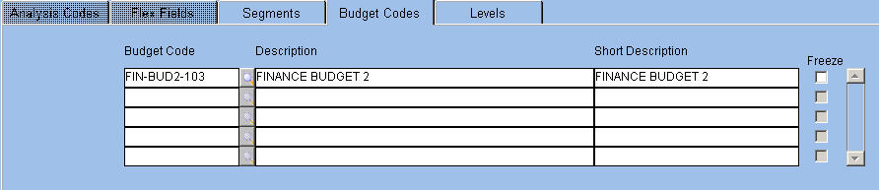
Fig. 17 - Budget Codes Screen 9Budget Code/Description
Alphanumeric – 12, 240
Enter or select from the LOV a unique code for the budget as defined in the Budget Code master. Next, enter a description for the budget. The application defaults the shorter version of the description for reporting purposes.
ORION Budget User Manual | Version 1.1 | 26

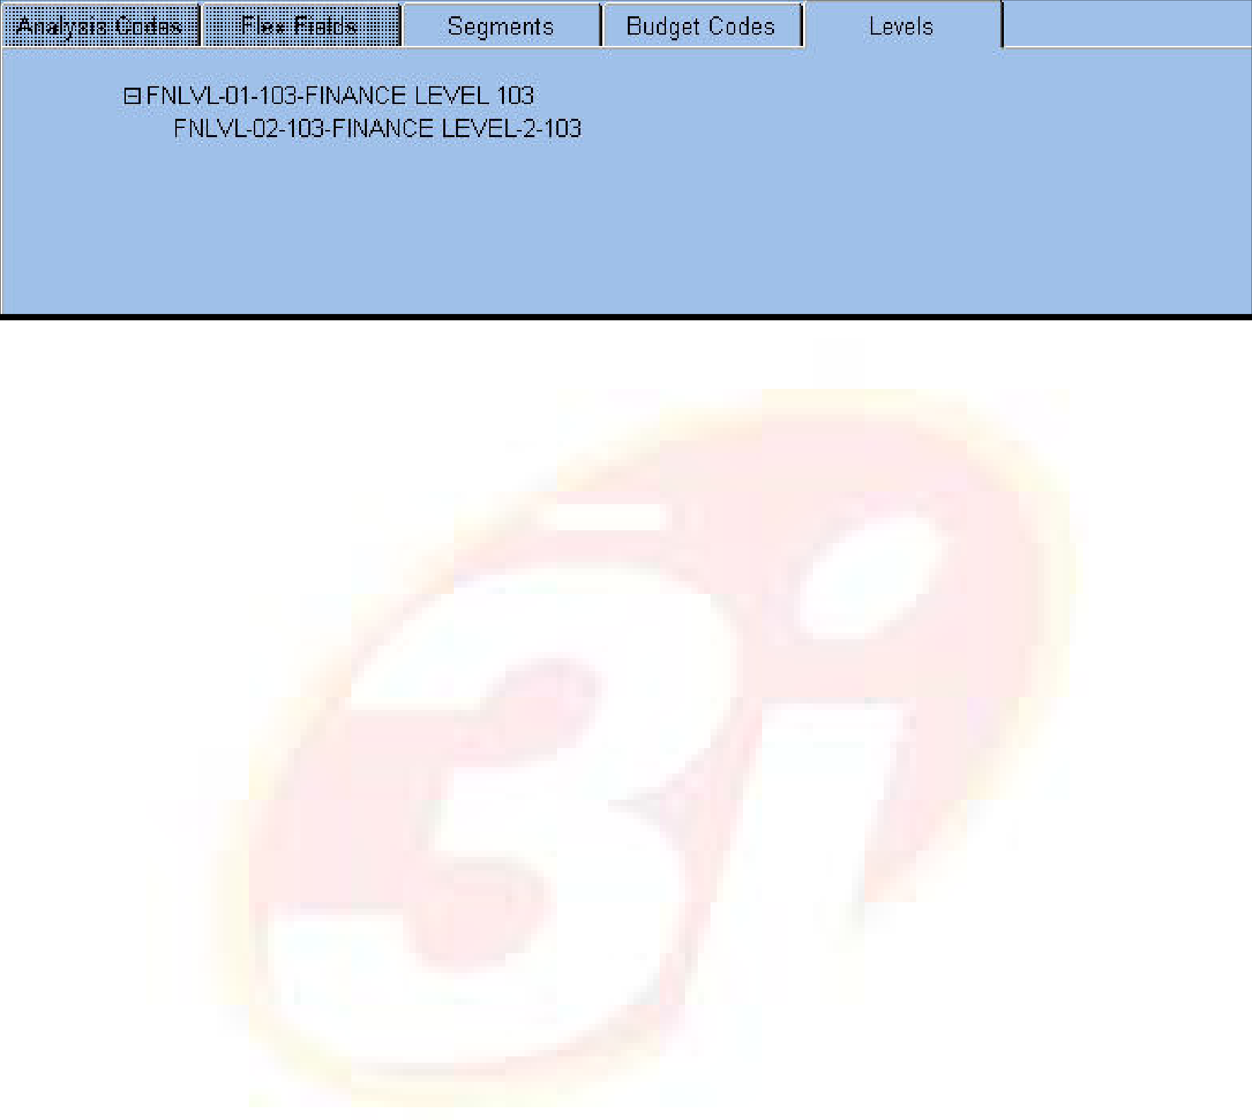





Levels
Click the tab to view the hierarchy levels at which the budget is entered for the selected category. The hierarchy tree is displayed based on Hierarchy Code attached to the category. The tree starts at the topmost level.
The Level tab is displayed as follows.
Fig. 18 - Level Tab
ORION Budget User Manual | Version 1.1 | 27

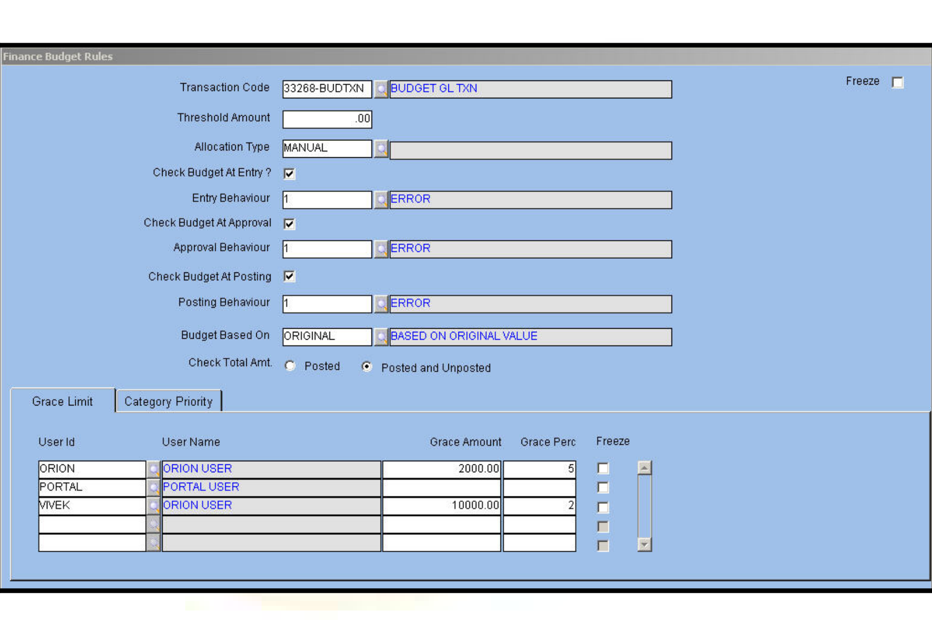





Finance Budget Rules
Budget Rules for Finance Category are applicable for the GL transaction entry and batch processing of transactions.
Points differentiating Finance Budget Rules from Operations Budget Rules include:
 The budget is applicable only at the document level in the Applicable at field because each document is considered as a GL entry.
 This leads to the allocation of budget in Finance Category through the GL transaction entry. The utilization of the budget is calculated after posting of entries.
Select the ‘Check Budget at Posting’ check box to verify and allocate Finance Budget. The other check boxes are:
Check Budget at Entry – The budget amount is validated when the GL entry is passed using the GL Transaction Entry screen
Check Budget at Approval –Allows budget allocation and control at the time of approval
The Finance Budget Rules master is displayed as follows.
Fig. 19 -Finance Budget Rules Master
For field level explanation of this master, please refer the Budget Rules Setup in General Ledger module.
ORION Budget User Manual | Version 1.1 | 28

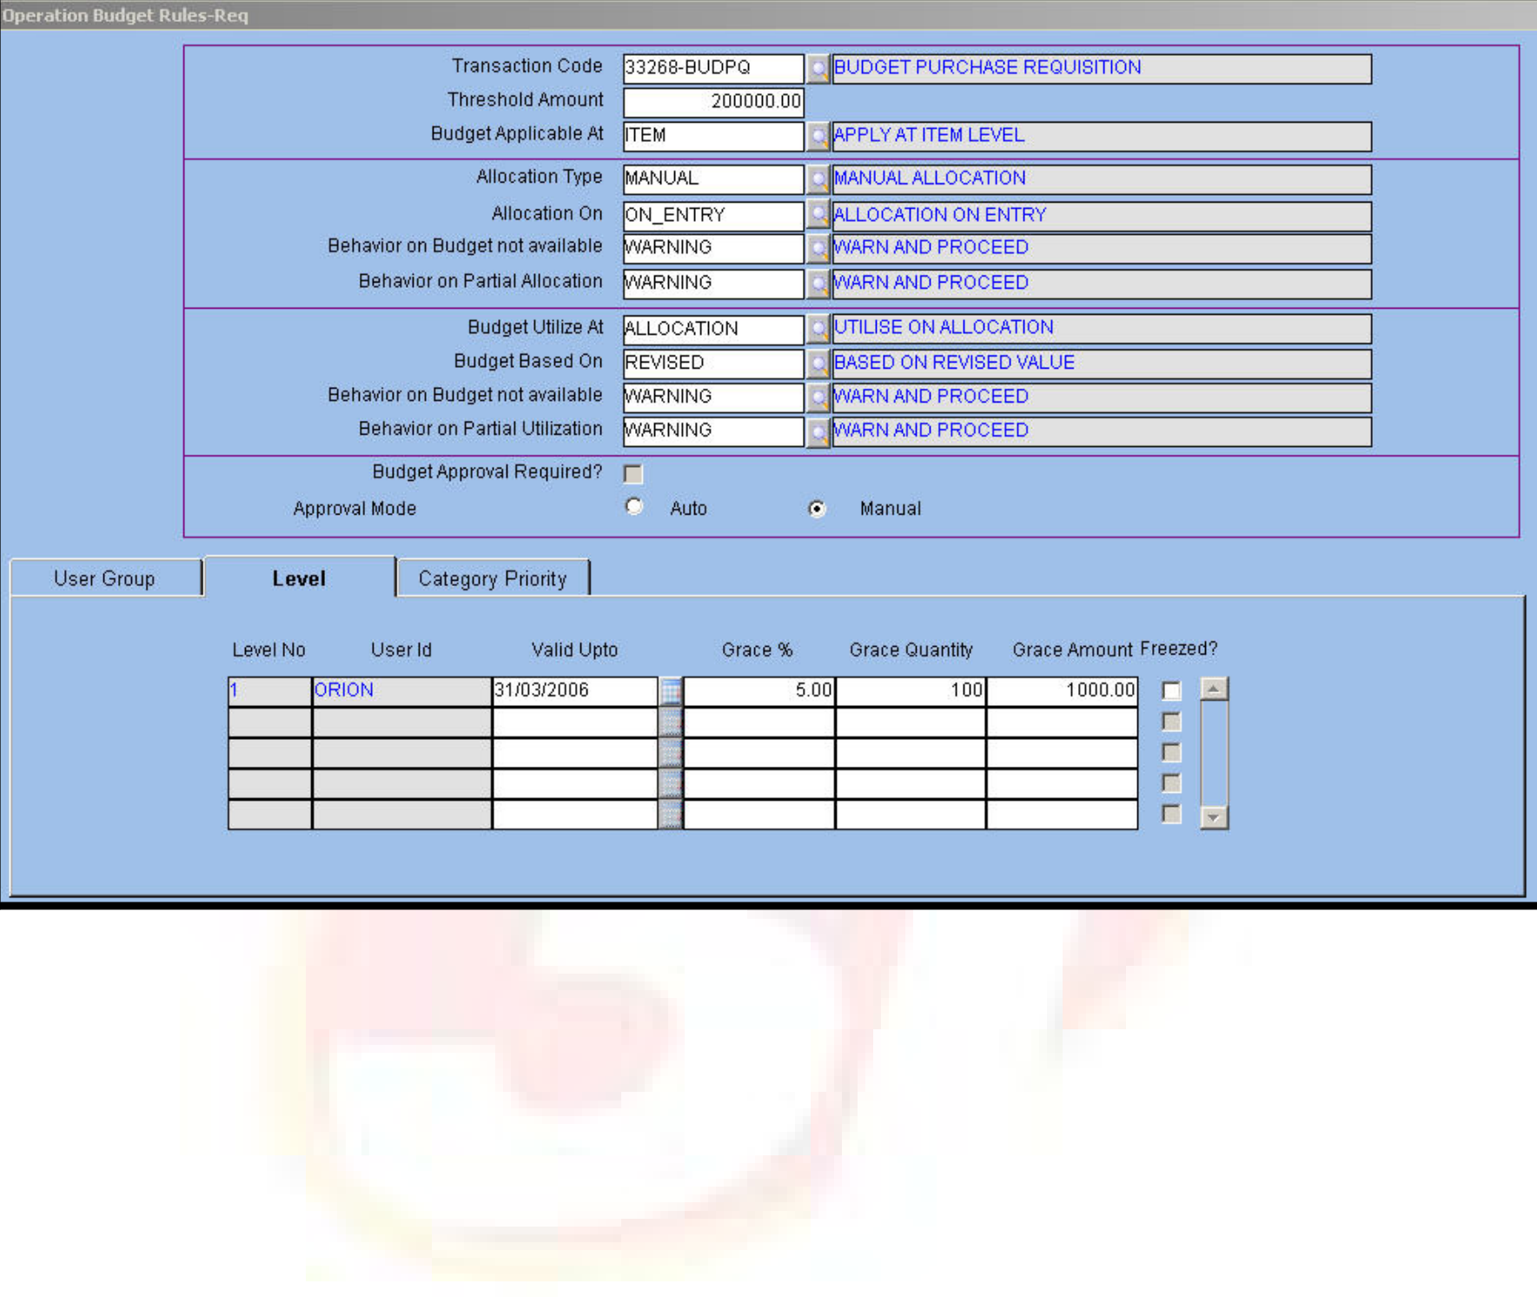





Operations Budget Rules – Purchase Requisition
Operations Budget Rules for purchase requisition are defined in ORION company wise and transaction wise. Once the budget is approved, utilization of the budget amount and control of the same occurs through the Purchase Requisition transaction.
The Operations Budget Rules master is displayed as follows.
For field level explanation of Category Priority Tab, please refer the Operation Budget Rules PO master in Budget module and Budget Rules master in Procurement module
ORION Budget User Manual | Version 1.1 | 29

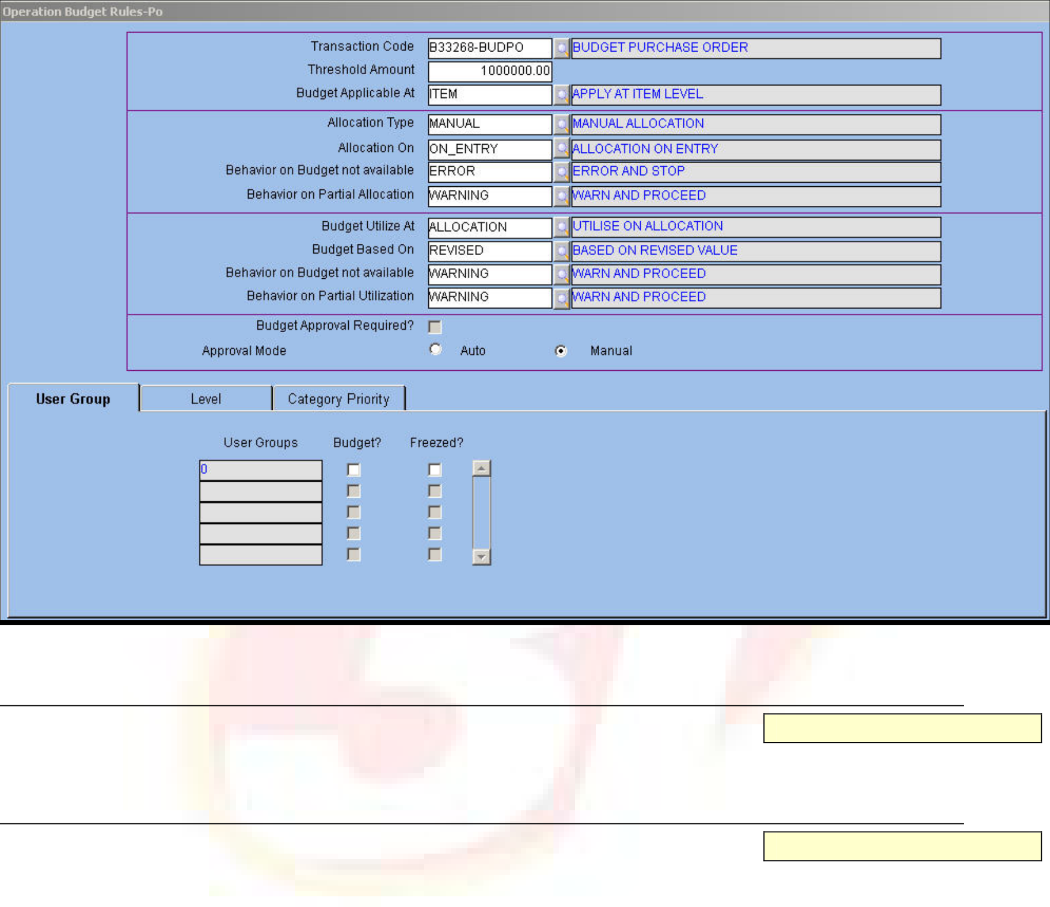





Operations Budget Rules – PO
Operations Budget Rules for Purchase Order (PO) are defined company wise and transaction wise. Once the budget is approved, utilization of the budget amount and control of the same occurs through the PO transaction.
The parameters defined for Operations Budget Rules, which are pulled when the transaction form is loaded, are displayed in the following screenshot:
Fig. 20 - Operations Budget Rules – PO Master
9Transaction Code
Alphanumeric – 12
Enter or select from LOV the transaction code for PO transition.
9Threshold Amount
Numeric
Enter the threshold amount for the budget. The transaction permits allocation, utilization and control of budget only when the document amount is above the threshold amount.
9 Budget Applicable At
Alphanumeric – 12
Enter or select from LOV the level at which the budget is applicable. The valid values are:
 Item or Detail level – budget information is entered for each item
 Document level – budget information is entered only at the Document level and not at the Item level.
9Allocation Type
Alphanumeric – 12
Enter or select from the LOV the allocation type applicable to the budget in this field. The valid values are:
ORION Budget User Manual | Version 1.1 | 30

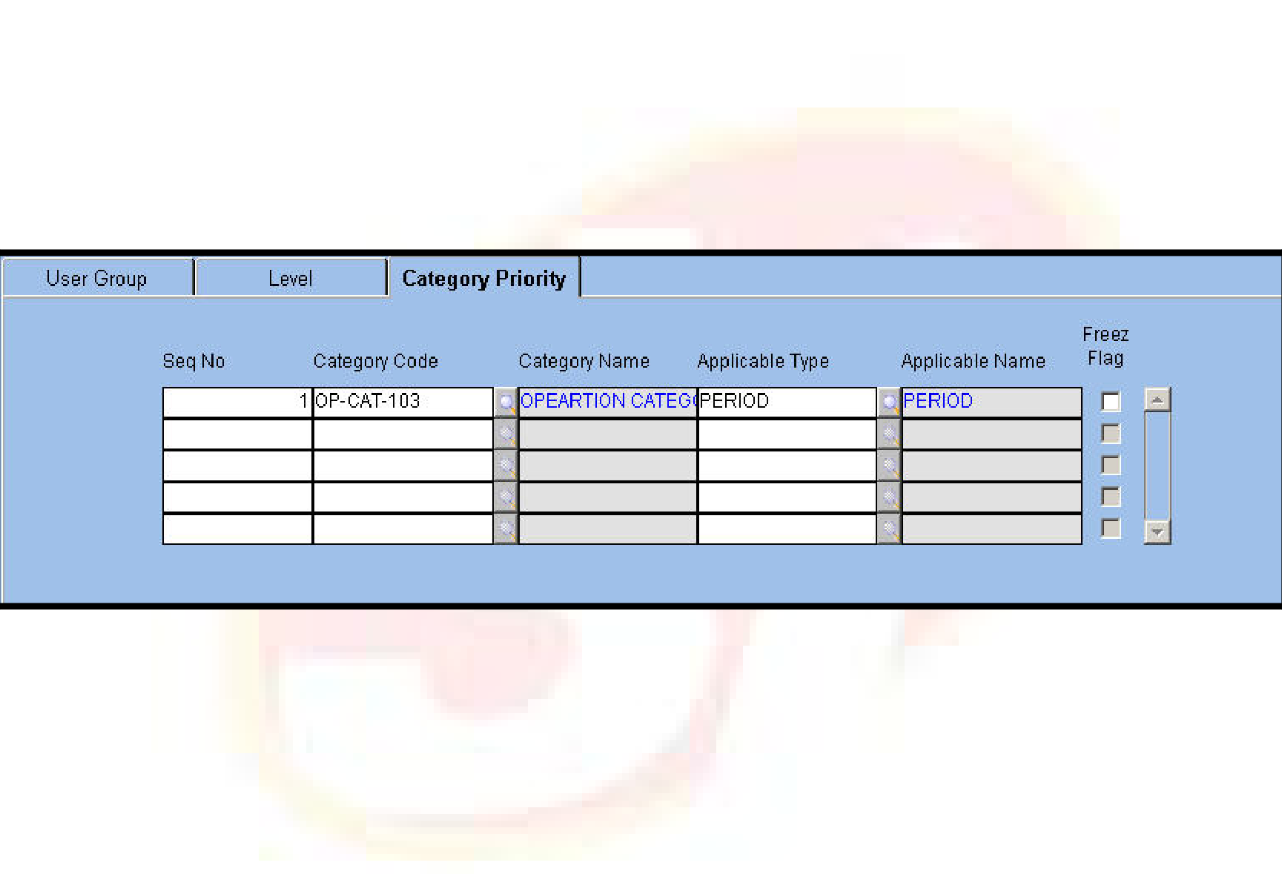





 | Not Required - does not allocate the budget to any item or document. Therefore, utilization
does not take place.
 Automatic - automatically allocates the budget at the Item or Document level. The prioritization of the budget categories is required for ORION to do the allocation. When the transaction needs budget allocation, ORION chooses the first category where budget is allocated.
 Manual - Budget Category Code is entered in the header and Budget Details in the Details block when Allocation Type is manual. Next, based on Setup, click the Allocate button to allocate the budget.
Based on Category Code entered in the header block, select the PO details, Budget Description, Budget Code, applicable segments for the selected category, and the available Quantity or Value of the item.
Category Priority
Budget Rules are attached to Budget Categories in a sequential manner. Click the Category Priority tab to define categories applicable for PO. In case allocation is automatic, the application verifies the priority assigned to categories by sequence number so as to identify the category against which budget allocation is required.
Based on the applicable type defined for the category, budget control is done at the Detail, Period, or Sub Period levels.
The Category Priority Tab is displayed as follows.
Fig. 21 - Category Priority Tab
For further information on Operations Budget Rules – PO, please refer the Budget Rules master in Procurement module.
ORION Budget User Manual | Version 1.1 | 31

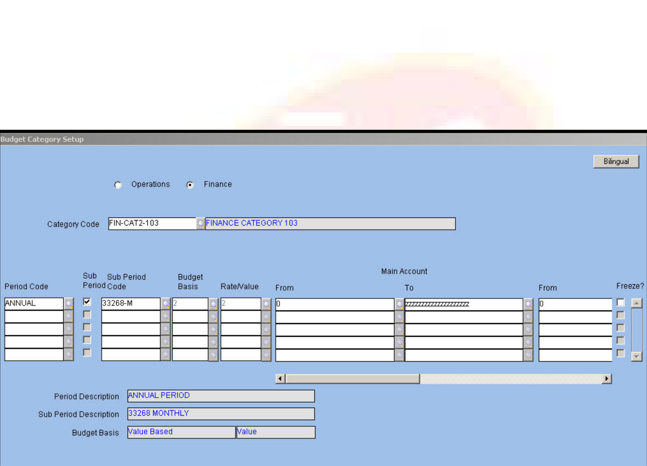





Setups
Budget Category Setup
This Setup screen links Period, Sub Period, and Category Segment Values defined in the Budget Category master. These Periods and Sub-periods are defined using Period Codes that take up the application-defined period type values such as Annual, Half Yearly, Quarterly, Monthly, Fortnightly, Weekly and Daily.
The application validates Period and Sub-period on the basis of these values. For user-defined periods and Daily, Weekly and Fortnightly periods, the break period in days is used. For Annual and user-defined combination, the Annual period is broken up into days based on the Standard Number of Days company parameter.
Moreover, for each of the defined Segment Values, the Budget Category setup determines if the budget for segments is quantity based, value based or Both. This is defined by specifying budget basis. When Budget Basis is Both, the Rate or Value flag determines whether the users enter Rate or Value. If the user enters Rate, the value is computed and the reverse is also true. The user sets the applicable values for the segments corresponding to the Category code from LOV and assigns to the Category code, period wise.
NOTE: Category is to be previously defined in the Category master.
Fig. 22 - Budget Category Setup
9Category Type
Option Button
Select the Category Type option button as Operations or Finance.
9Category Code
Alphanumeric – 12
Enter or select from LOV the category code as defined in the Category master. Once a code is entered the Description pertaining to it gets defaulted in the adjacent field.
ORION Budget User Manual | Version 1.1 | 32







9Period Code
Alphanumeric – 12
Enter or select from LOV the period code as defined in the Budget Period master. The application displays the name in the ‘Period Description’ field.
9Sub Period
Alphanumeric – 1
Select the check box to enable entry of Sub Period Code. Sub Period is optional. 9Sub Period Code
Alphanumeric – 12
Enter or select from LOV the sub period as defined in the Budget Period master. Once a code is entered, the application displays the description in the ‘Sub Period Description’ field.
NOTE: The sub period entered should be less than the Period. If the period is fortnightly, Sub-period is to be Weekly or Daily.
9Budget Basis
Numeric
Enter or select from LOV the basis for budget as defined in the Category master. The available options are:
 Quantity – only Quantity is entered
 Value – Only Value is entered
 Both – Budget is based on both Quantity and Value. Whether you enter rate to obtain value or enter value to obtain rate is determined by defining the Rate or Value flag.
NOTE: Budget Basis is modifiable to Quantity and Both only when Item Code is defined as a segment. Otherwise, Value is the default entry.
Once the basis is entered, the application displays the description in the ‘Budget Basis’ field.
‘9Rate/Value
Numeric
Fields related to Rate or Value get enabled or disabled based on choice of the Rate/Value Flag when the Budget Basis is Both.
9Location Code From/To
Alphanumeric – 12
Enter or select from LOV a range of locations defined for the Category Code.
NOTE: Depending on segments defined in the Category master for the selected Category Code, the segment field labels are displayed.
ORION Budget User Manual | Version 1.1 | 33

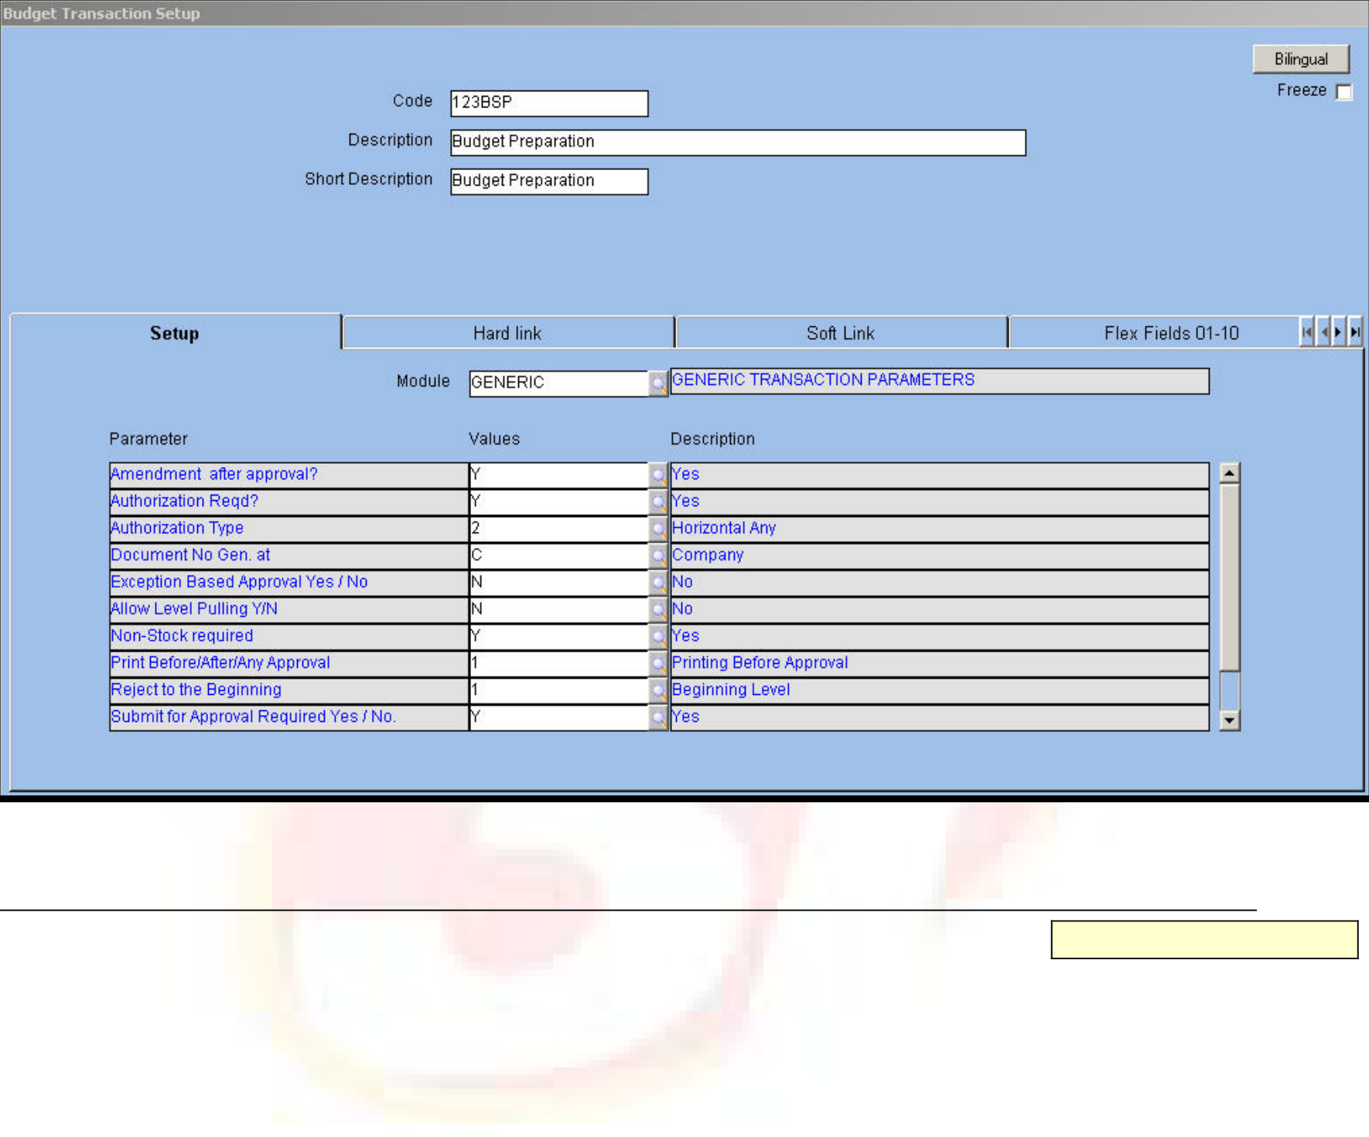





Budget Transaction Setup
The Budget Transaction setup consists of transaction parameters pertaining to the Budget module.
In this module, the approval and amendment rules are derived from the Budget Level master. Therefore, generic parameters related to approval and amendment are inapplicable to this module. Likewise, only two values; namely, C and M are applicable for document generation in the Budget module.
The Budget Transaction Setup screen is displayed below.
Fig. 23 - Budget Transaction Setup
9Allow Level Pulling Y/N
Alphanumeric – 1
When this parameter is set to Y, the higher levels are allowed to pull budgets entered by the child levels and the intermediary levels pull budgets entered by both the higher and lower levels.
NOTE: This is set to Y for the Budget Addition, Modification and Deletion transactions.
9Transaction Operation
Alphanumeric – 1
The value of this parameter differs according to the transaction. Values are as follows:
 | P - for budget creation or preparation transaction
 | A - for budget addition
 | D - for budget deletion
 | M - for budget modification
ORION Budget User Manual |  | Version 1.1 | 34

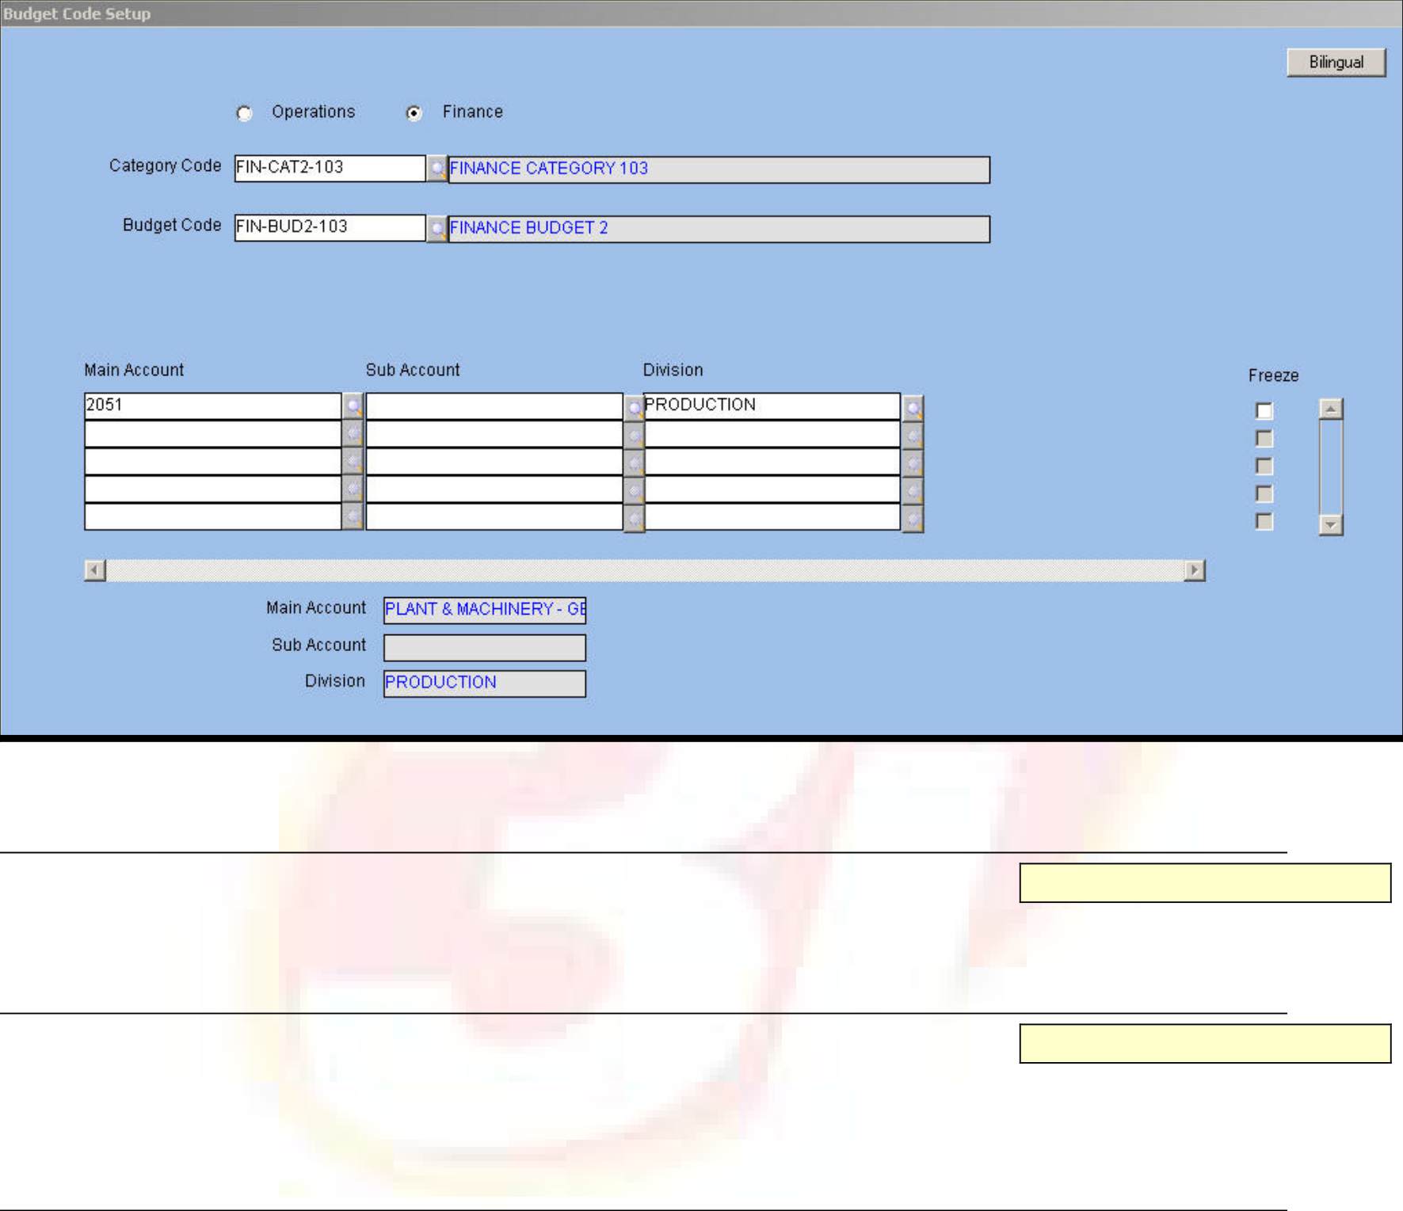





Budget Code Setup
Budget Code setup enables the grouping of budget details. A set of Segment Values defined for a category is assigned to a Budget Code. When creating the budget, enter Budget Code and click the ‘Pull’ button to pull all segments defined in the Budget Code setup into the Budget Creation form. This process reduces data entry.
The Budget code setup is displayed as follows.
Fig. 24 - Budget Code Setup
9Category Type
Option Button
Select the Category Type option button as Operations or Finance.
9Category Code
Alphanumeric – 12
Enter or select from the LOV the required category code. The application displays the description in the adjacent field.
9Budget Code
Alphanumeric – 12
Enter or select from the LOV the Budget Code associated with the selected Category Code in this field. The application displays the description in the adjacent field.
NOTE: Once Category Code and Budget Code are selected; the application displays segments with appropriate labels based on segments defined in the Category master. For example, Location Code, Item Code, Grade Code 1 and Grade Code 2 being segments of the category, the form displays these segments.
ORION Budget User Manual | Version 1.1 | 35







9Location Code
Alphanumeric – 20
Enter or select from the LOV the code of the location. 9Item Code
Alphanumeric – 20
Enter or choose from the LOV the item code.
9Grade Code 1 and 2
Alphanumeric – 20
Enter or select from the LOV the Grade Code 1 and 2 values in their respective fields. 9Job Charge Area
Alphanumeric – 20
Enter or select from the LOV the charge area to which the job is assigned.
Once a code is entered in each of these fields the description pertaining to them get automatically displayed in their respective Description fields.
The following transactions relate to a budget:
 | Budget Entry and Approval
 | Budget Deletion
 | Budget Addition
 | Budget Modification
ORION Budget User Manual |  | Version 1.1 | 36

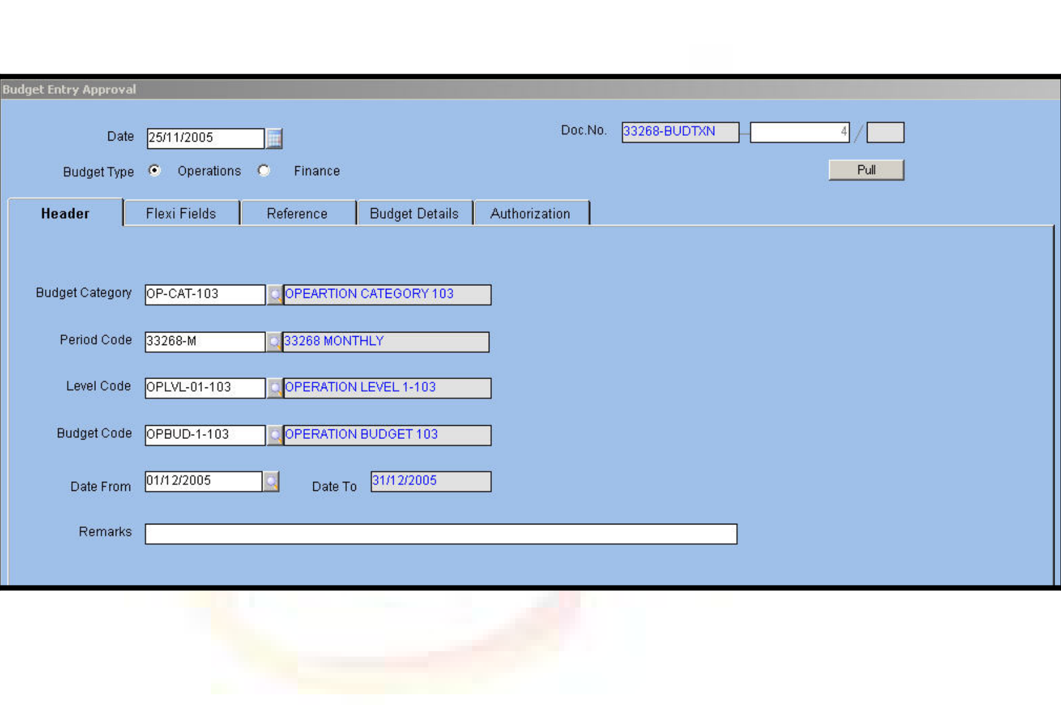





Transactions
Budget Entry and Approval - Operations
The entry and approval of budget is dependent on the approach defined in the Category master. Budget Entry is based on levels where users at each level have different rights to enter or approve the budget depending on the selected Budget Category Code and Level Code. Further entry and approval is allowed when a budget entry exists for the immediate child or the level is permitted to include categories in the budget starting at the intermediary level.
Segments on which the budget is defined are determined once Budget Category is selected. Labels for the Detail fields are determined based on segments selected for the category and the label defined for each of the segments.
NOTE: Budget Category is not modified once set-up is complete and budget entry for a category is created. Segments once defined are not altered. Additionally, changes in Level Codes are not possible.
The Budget Entry and Approval transaction screen is displayed as follows.
Fig. 25 - Budget Entry and Approval Transaction - Operations
The system date is defaulted as the Budget Document Date in the Date field.
The document number is system generated and displayed in the Document Number field.
9Budget Type
Option Button
Select the required Budget Type from the available options – Operations and Finance.
9Budget Category
Alphanumeric – 12
Enter or select from the LOV the code of Budget Category defined in the Category master. Once a code is entered the description pertaining to it gets displayed in the adjacent field.
NOTE: Categories appearing in LOV depend on the Budget Type. If Operations is selected as Budget Type, the application permits only those categories with Category Type as Operations.
ORION Budget User Manual | Version 1.1 | 37







9Period Code
Alphanumeric – 12
Enter or choose from LOV the code of the Budget Period. The options available in the LOV are related to the budget category selected in the previous field.
9Date From and To
Date
Enter or select from the Calendar help the budget commencement date related to the selected Period Code. The applicable dates are created or auto generated in the Period master for the selected period using Calendar. Based on the date entered in this field and the Period Code, the budget completion date gets auto generated. The number of periods defined in the Budget Category setup is used to calculate the ending date of the budget.
For example, the budget projection is until 31/1/07 for a half-yearly budget period if the beginning date is 1/1/05 and the number of periods is 3.
NOTE: The Budget Category, Period Code, Date From, and Level Code combination needs to be unique.
9Level Code
Alphanumeric – 12
Enter or select from the LOV the required hierarchy code defined in the Budget Hierarchy master. Level Codes are related to the attached Budget Category. Select only those levels that are defined for Hierarchy Code attached to the selected category. Each level is linked to a set of users or groups. ORION displays in LOV only those Level Codes that are applicable to the logged-in user. The rights of the users are defined in the Budget Level master.
Moreover, depending on the Top Down or Bottom Up approach selected in the Category master, the Budget Entry level is the lowest or the highest.
9Budget Code
Alphanumeric – 12
Enter or select from the LOV the Budget Code in this field. Next, click the ‘Pull’ button to pull Segment Values related to Budget Code defined in the Budget Code Setup.
9Remarks
Alphanumeric – 2000
Enter remarks related to fields.
NOTE: The Detail Flex button is enabled when the Budget Details Flex fields is set up.
ORION Budget User Manual | Version 1.1 | 38

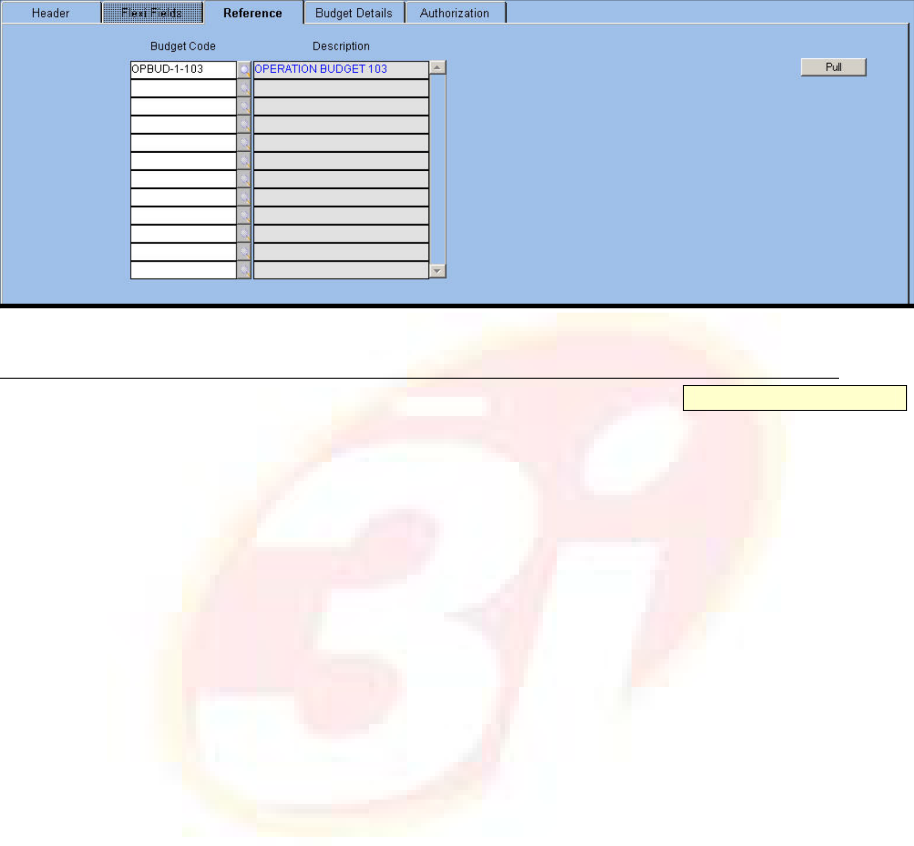





Reference
Click the tab to view Budget Codes duplicated from the header block. Modify these if required.
The Reference Tab is displayed as follows.
Fig. 26 - Reference Tab
9Budget Code
Alphanumeric – 12
When the user pulls the budget details from the Budget Code setup by entering Budget Code in the header, the record is copied in the Reference block and segments are pulled into the Budget Details tab.
If more records need to be pulled for other Budget Codes, enter Budget Code in the Reference block and click the ‘Pull’ button in this block.
Budget Details
Click the tab to enter details based on Budget Category and Level Code. If the approach defined in the category is Bottom Up then pull Segments for the lowest level from the Budget Code setup or enter them manually. For higher-level codes, the application pulls details along with quantity/value based on the selected category and level. Additionally, the fields are displayed and labeled as defined in the Budget Category Setup. Therefore, these fields are dynamic.
For example, Budget Category has Item Code, Grade Code 1, and Grade Code 2 as segments in the Budget Category setup. These fields are then displayed with the default values of Grade Code 1 and 2, which in turn are enabled or disabled depending on the Grade Code 1 and Grade Code 2 Required transaction parameter in the Item master
ORION Budget User Manual | Version 1.1 | 39

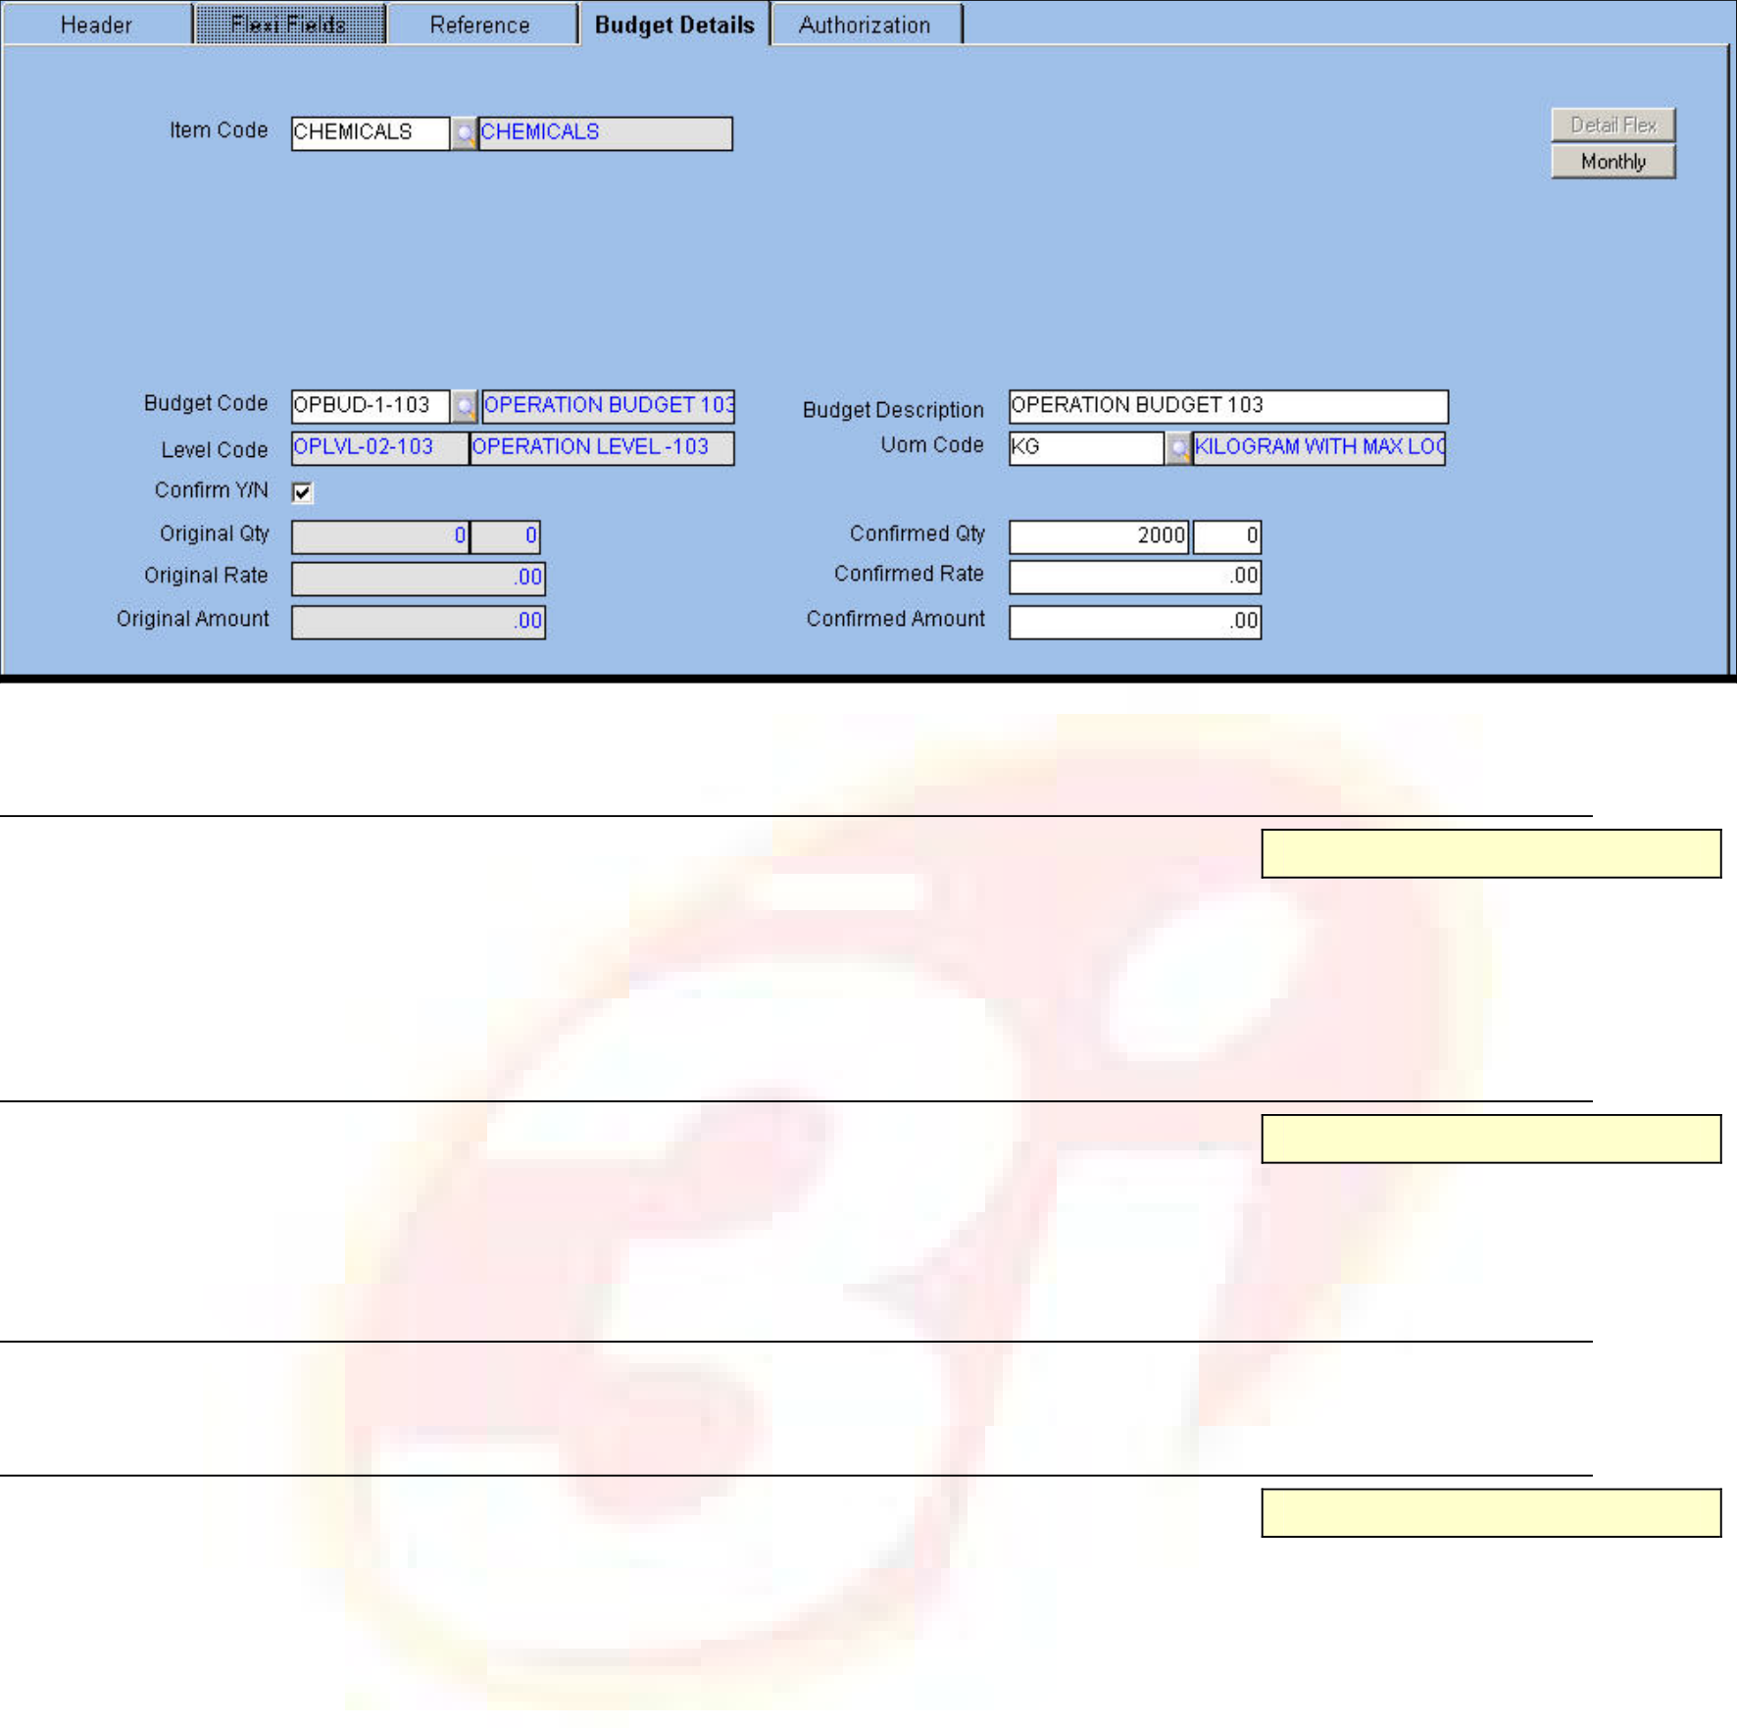





The Budget Details tab is displayed as follows.
Fig. 27 - Budget Details Tab
9Budget Code
Alphanumeric – 12
The Budget Code specified in the header block gets defaulted in this field, which can be modified if required. The description of this code gets defaulted in the adjacent field. The field is left blank if Budget Reports are not required.
9Budget Description
Alphanumeric -– 240
Enter the description for each budget in this field. If budget details are pulled from the Budget Code Setup then the application displays the description in the ‘Budget Code Description’ field.
9Level Code
The application displays the child levels of the selected Parent Level Code in the header block.
9UOM Code
Alphanumeric-12
Enter or select from LOV the currency code. The application displays the description in the adjacent field. The UOM Code field is visible only when Item Code is one of the segments defined in the Category and the Budget Category Setup is Quantity-based or BOTH. This field is enabled or disabled based on the UOM Can Be Modified Y/N transaction parameter.
ORION Budget User Manual | Version 1.1 | 40







The valid values for a budget are:
Quantity-based - Limiting the quantity for the Operations item controls budget. A value cannot be entered when Quantity is the basis. This is applicable in the Operations budget if Item Code is one of the segments.
Value-based - Controlling the value controls the budget. Quantity cannot be entered when value is selected as basis.
BOTH - Both quantity and value are used for control purposes. This is applicable in the Operations budget if Item Code is one of the segments.
Confirm Y/N
Check box
Select the check box to confirm the original quantity, rate and value entered by users at the child levels. If the record is entered by any of the other levels, the check box is to be selected. If pulled from higher or lower level, it is to be cleared. The current level validates the Confirm block to determine whether the details are accepted at the current level or not.
9Original Quantity
The application displays the quantity entered by users. If the Top Down approach is the basis, the parent level users enter this field and if the approach is Bottom Up, the child levels enter this field.
Original Rate
The application displays the rate entered by users. The child level users enter the rate in case of Bottom Up approach and parent level users enter the rate for Top Down approach.
Original Amount
The application displays the original amount as entered by users at the child levels for Bottom Up approach and parent level users for Top Down approach.
Confirmed Quantity
The consolidated quantity that appears on clicking the ‘Monthly’ button is pulled. The quantity is set to 0.00 by default.
Confirmed Rate
The confirmed rate that appears on clicking the ‘Monthly’ button is pulled. Users at the parent level or child levels depending on the Top Down or Bottom Up approach confirm the rate. The rate is set to 0.00 by default.
Confirmed Amount
The amount confirmed by the users at the parent or child levels depending on the Top Down or Bottom Up approach is pulled. The amount is set to 0.00 by default.
Period
Button
Click the button to enter Sub Period and the budget basis defined in the Budget Period setup. It is optional to enter the Sub Period details. The label of the Period button changes as per the chosen Budget Period to Weekly, Fortnightly, and so on.
If the Sub Period breakup is required, the value entered as Confirmed Amount in the period level is equally disbursed among Sub Periods. For example, if Confirmed Amount is INR 60,000 then each Sub Period is given INR 20,000.
ORION Budget User Manual | Version 1.1 | 41

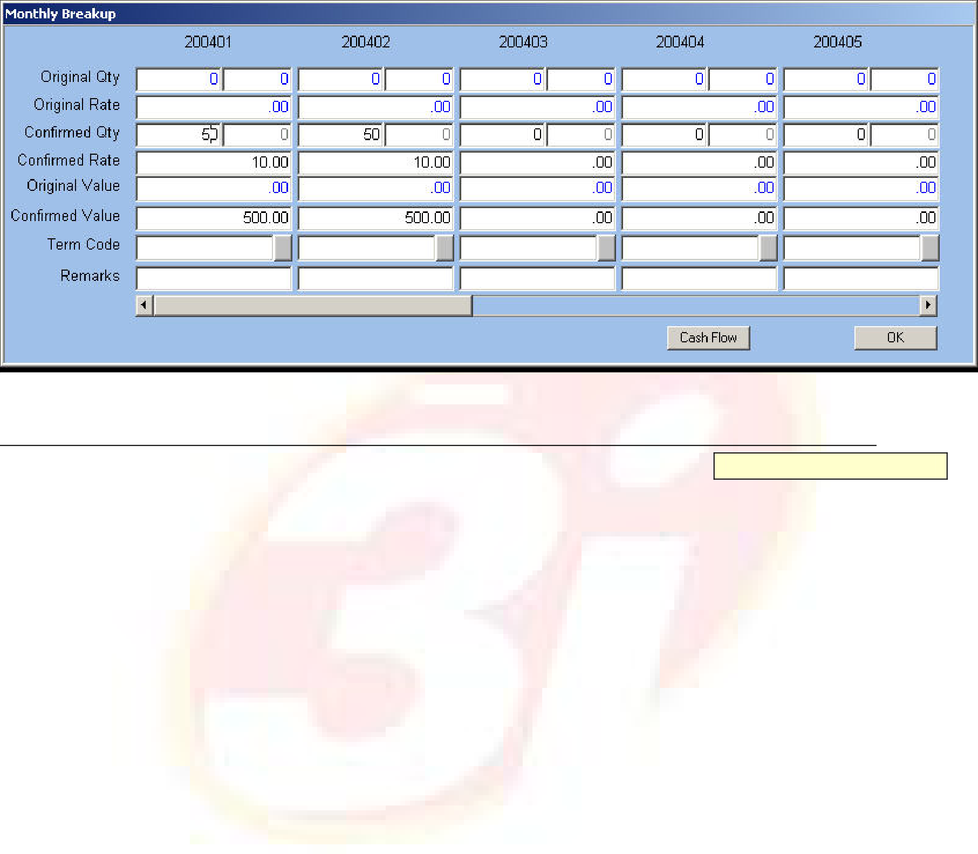





Monthly Break-up
Click the Period button to view the breakup in the Monthly Breakup pop-up window. This breakup depends on the chosen Budget Period. The Original Quantity, Rate and Amount fields are displayed along with the Confirmed Quantity, Rate and Amount fields, which are amendable. The Monthly Break-up Window is displayed below.
Fig. 28 - Monthly Break-up Window 9Term Code
Alphanumeric – 12
Enter or select from LOV the term code as attached to Budget Period. This is used to determine the cash flow for Budget Period.
ORION Budget User Manual | Version 1.1 | 42

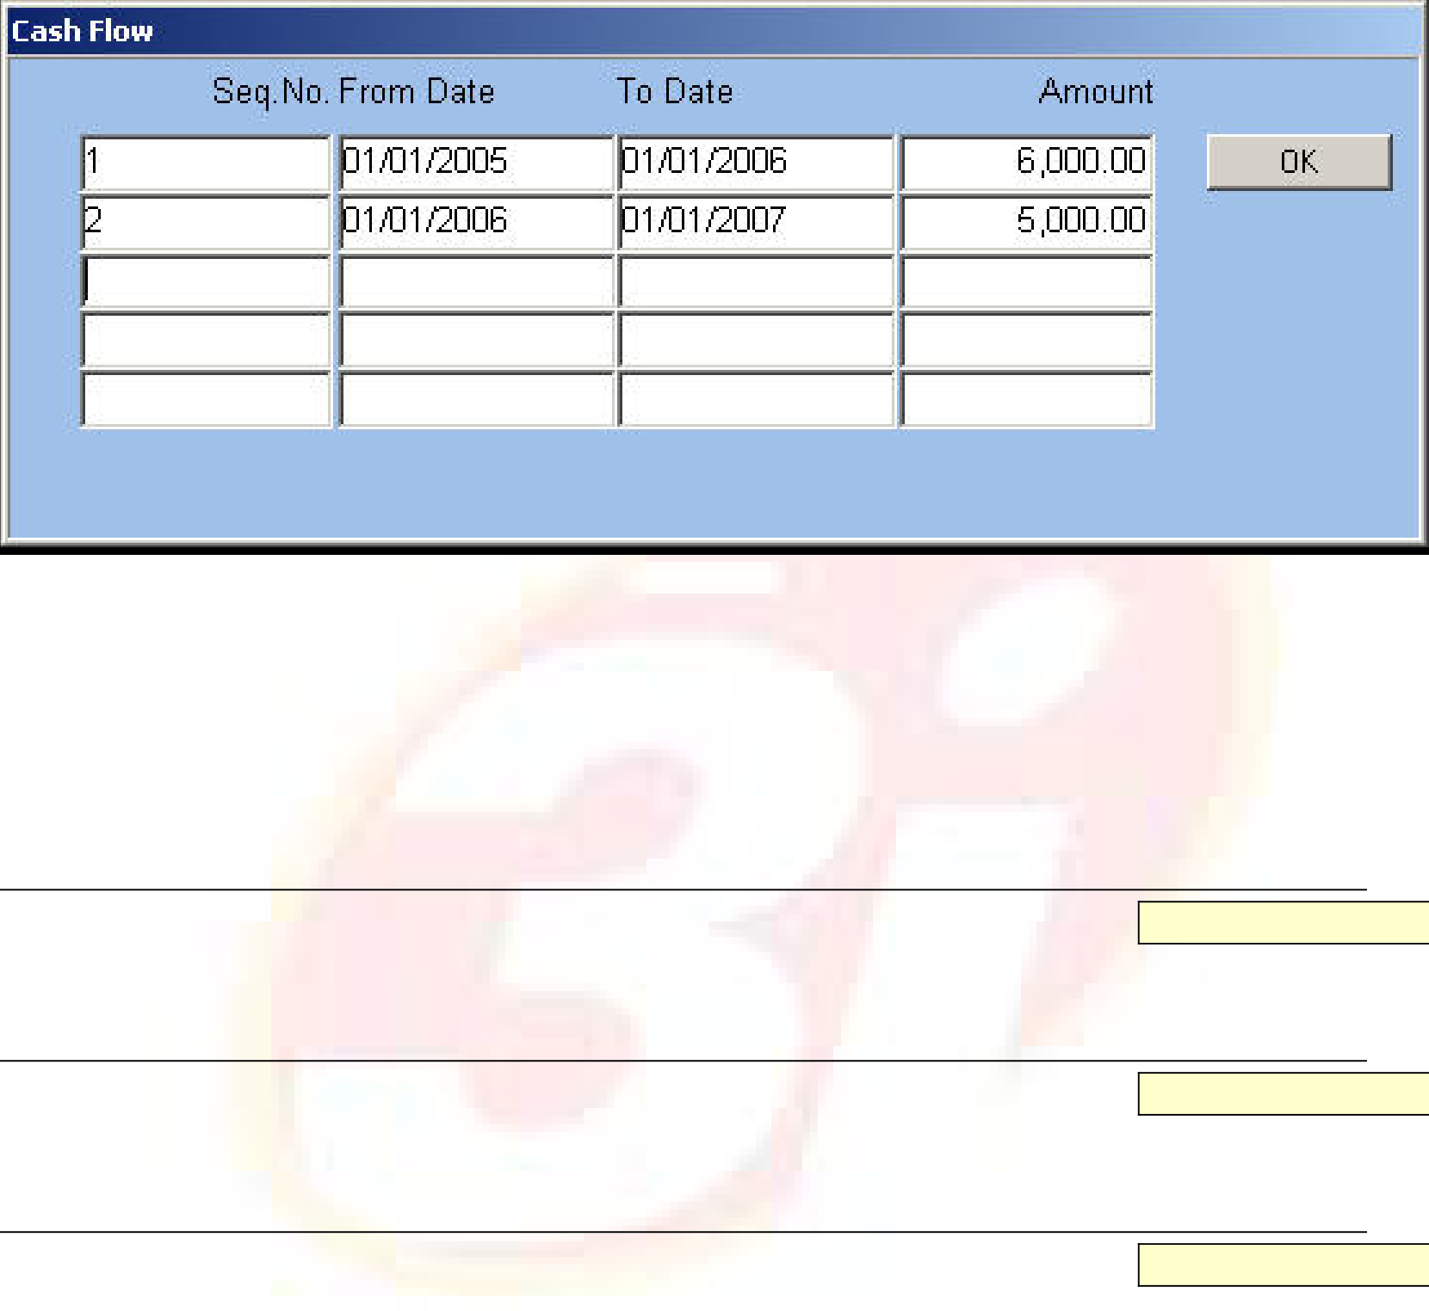





Cash Flow
Button
Click the button to project the cash flow for a future period based on the input values during budget creation. The input values are the budgeted expenses and credit term in the form of term code for these expenses.
The Cash Flow Window is displayed below.
Fig. 29 - Cash Flow Window
NOTE: Term Code and Cash Flow are enabled only when Budget Basis is Value or Both.
When Term Code is attached at the Period level, the application generates the information required for cash flow. When Term Code is not used, enter values in fields. The cash flow is determined for each record and needs to match with the overall cash flow.
9Sequence Number
Numeric
Enter the sequence number of the record.
9From Date/To
Date
Enter the date range for which cash flow is to be determined.
9Amount
Numeric
Enter the amount that is projected as expenses for the specified period.
ORION Budget User Manual | Version 1.1 | 43

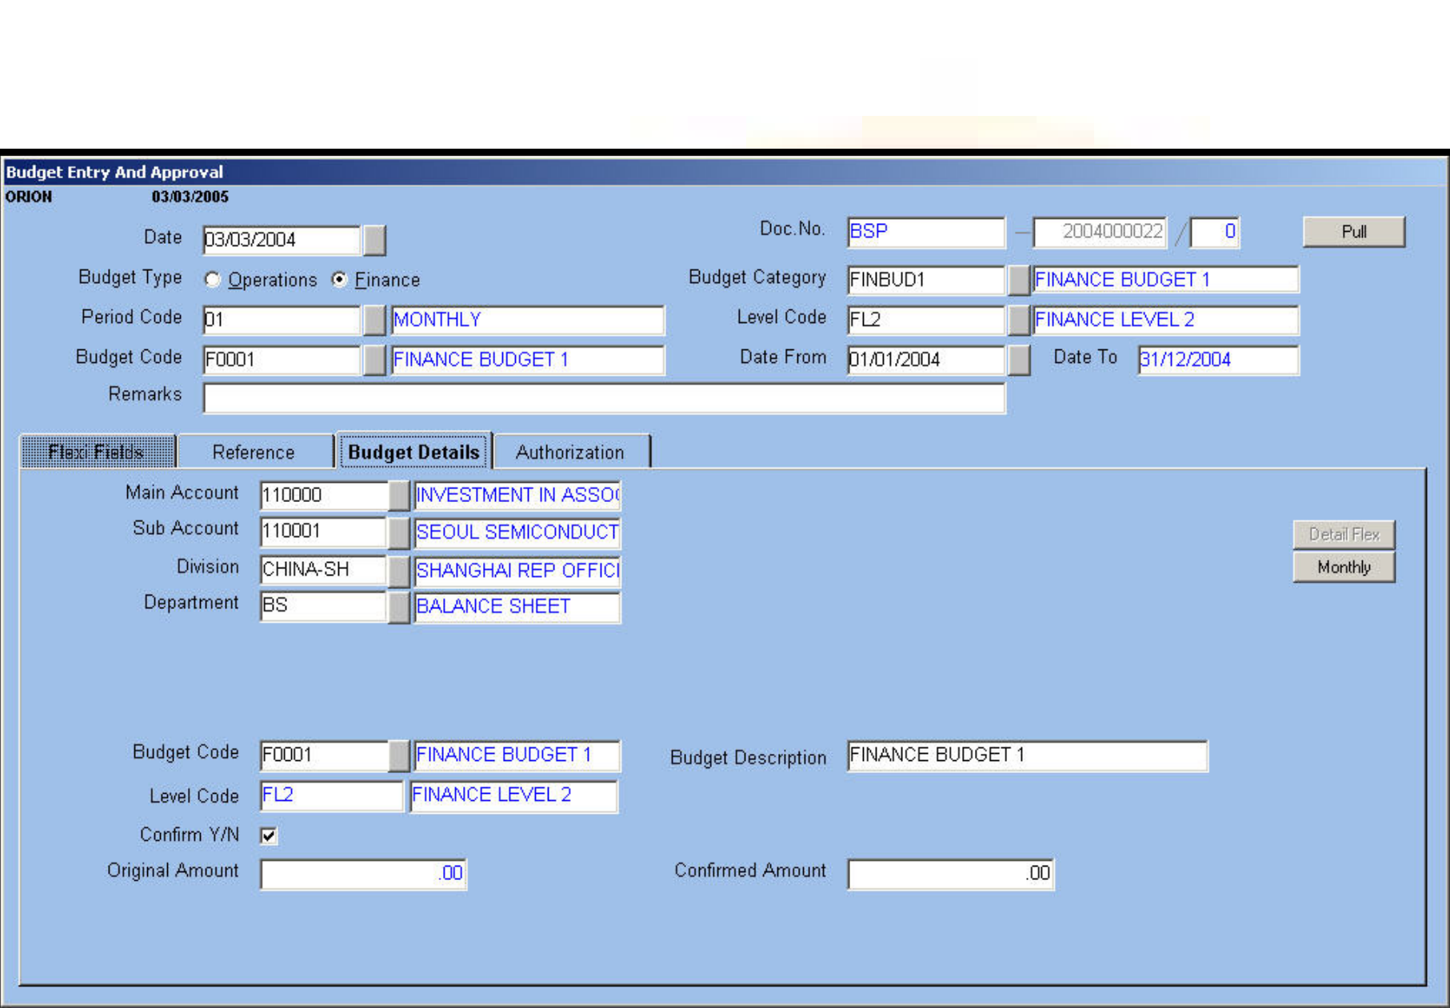





Budget Entry and Approval - Finance
The Finance Budget is created when the Budget Category is chosen as Finance and the Category Code is applicable to the Finance Budget. The Categories related to the Finance budget and the defined segments are filtered. The segments that are applicable for the Finance budget category codes are Main Account, Sub Account, Division and Department. The Finance budget is also user-defined and includes segments as per user needs.
Budget Entry and Approval for the Finance budget is as follows:
Main Account Type determines values entered in the Main Account Code field. The valid values for Account Types are:
 A – Asset
 L – Liability
 E – Expense
 I – Income
The Expense and Asset Account types are debited while the Income and Liability Account types are credited in financial entry.
The Budget Entry and Approval Transaction for Finance is displayed below.
Fig. 30 – Budget Entry and Approval Transaction
For the Finance budget, enter Confirmed Amount in the Budget Details tab. Similar to the Operations Budget entry, this Confirmed Amount is apportioned to Periods and Sub Periods. In case you pull the budget details from the child levels, the application pulls the Period and Sub Period amounts or values. Changes in Confirmed Amount or Value in the budget details are reflected as new values in Periods and Sub Periods.
ORION Budget User Manual | Version 1.1 | 44

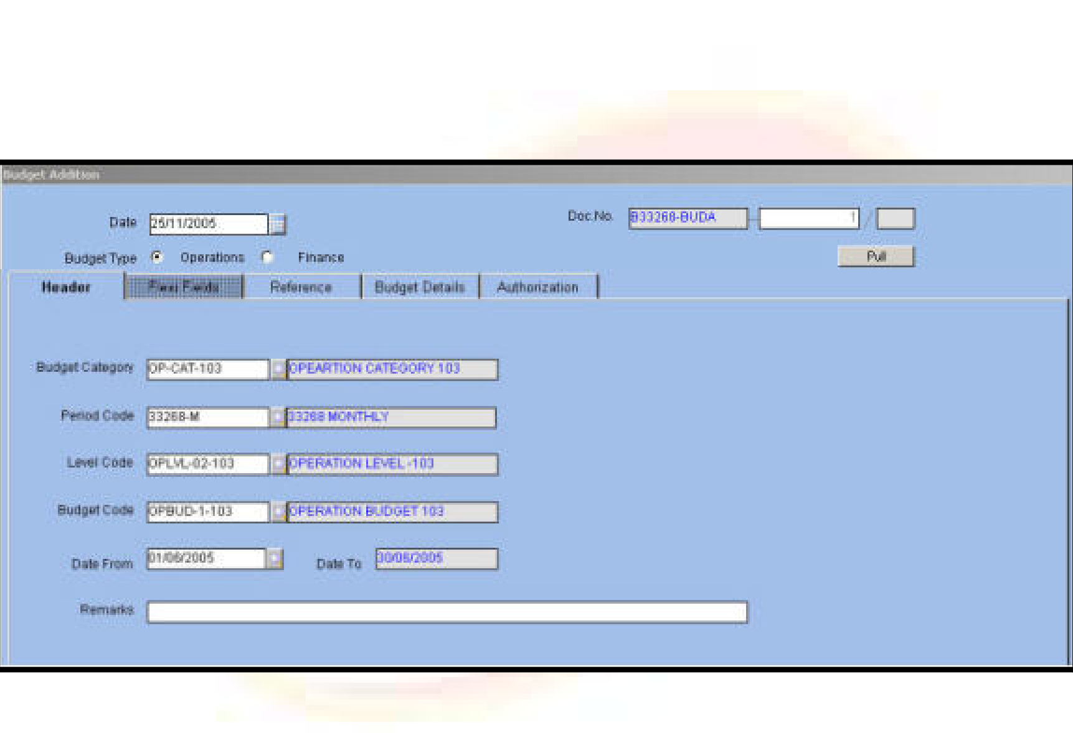





Budget Addition/Modification/Deletion
It is possible to add, modify and delete budget details after final approval of the budget by the users at the highest level. These actions are controlled by various transaction parameters. Budget Allocation displays all existing categories in the budget for modification and deletion. The new category option enables users to make additions.
The Level Rules Setup is the basis to pull levels. Enter Level Code only when you require to pull levels. In such a case, rights applicable to a concerned level determine the details and authorization of the performed action.
When this authorization of the budget is mandatory without the need for level pulling, use authorization parameters such as Authorization Required Y/N, Amend after Approval Y/N and Authorization and Amendment Groups/Users from Transaction Setup.
The end result of budget addition, modification and deletion is an approved budget document.
Budget Addition
New categories and details related to the category and for a specific period are added through the Budget Addition window. Click the ‘Monthly’ button to view the monthly breakup details of the budget. Similarly, to view the details of cash flow for a particular period, click ‘Cash Flow’ button. The Budget Addition Transaction screen is displayed below.
Fig. 31 - Budget Addition Screen
The application verifies if these details already exist. If existing, it displays an error message and does not allow the user to make entries.
Budget Modification
Budget modification is based on the Budget Category, Budget Period, and the Date (From) fields. When all the above fields are entered, ORION displays budget details such as Segment Values, Budget Detail Flexi fields, Budget Code and Budget Description.
Select the budget details to be modified. These details are displayed with the available quantity and value. Modify the Quantity and Value fields using the Quantity/Value Flag option. Enter a value greater than or equal to zero. This value is either negative or positive.
The Cash Flow details are also amendable if available. Modification of cash flow ensures that this amount tallies with the revised budget amount.
ORION Budget User Manual | Version 1.1 | 45





Budget Deletion
For Budget Deletion, the revised Quantity or Value fields are defaulted to zero after deletion. A negative sign is placed next to the available quantity. For example, available quantity of 1000 when revised to –1000 implies zero budget. Similarly, the Cash Flow amount is also set to zero.

ORION Budget User Manual | Version 1.1 | 46

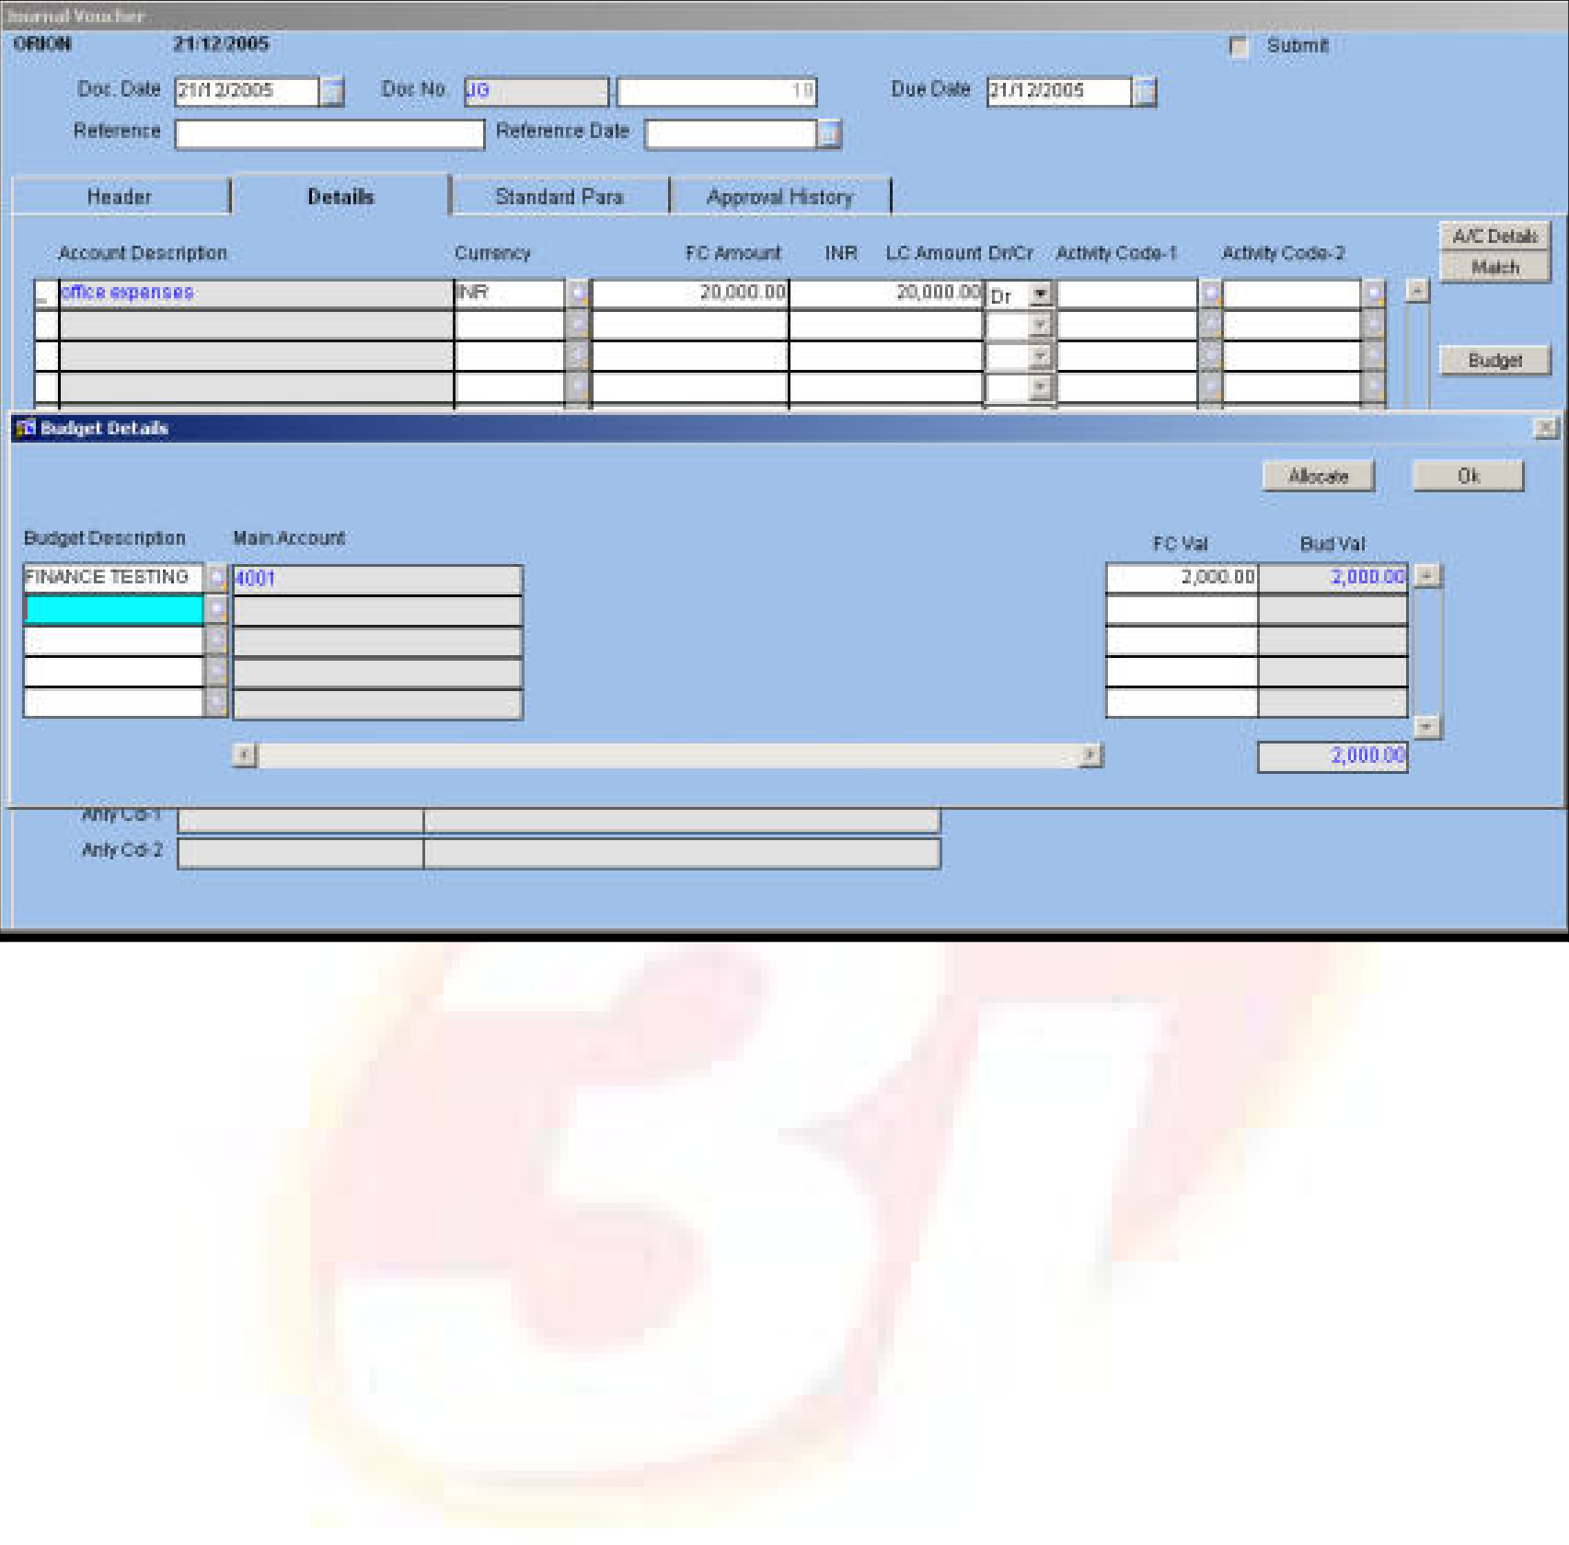





GL Transaction Entry
The allocation of budget is done in Finance through the GL transaction entry. Finance Budget Rules are applicable to this entry.
Fig. 32 - GL Transaction Entry Screen
Enter the account, amount, and debit or credit details in the Details tab. Based on the selected Budget Category Code and values specified in the Details tab, enter the budget details.
If the allocation type is manual, click the ‘Budget’ button to enter budget allocation details. Enter or select from LOV the Budget Description, Budget Code and segments. Click LOV to view the available budget details.
Next, enter the amount to be allocated and click ‘Allocate’ button. Repeat the process for all lines in the Details tab. Completed entries in a GL transaction are displayed in the main GL Transaction screen.
ORION Budget User Manual | Version 1.1 | 47

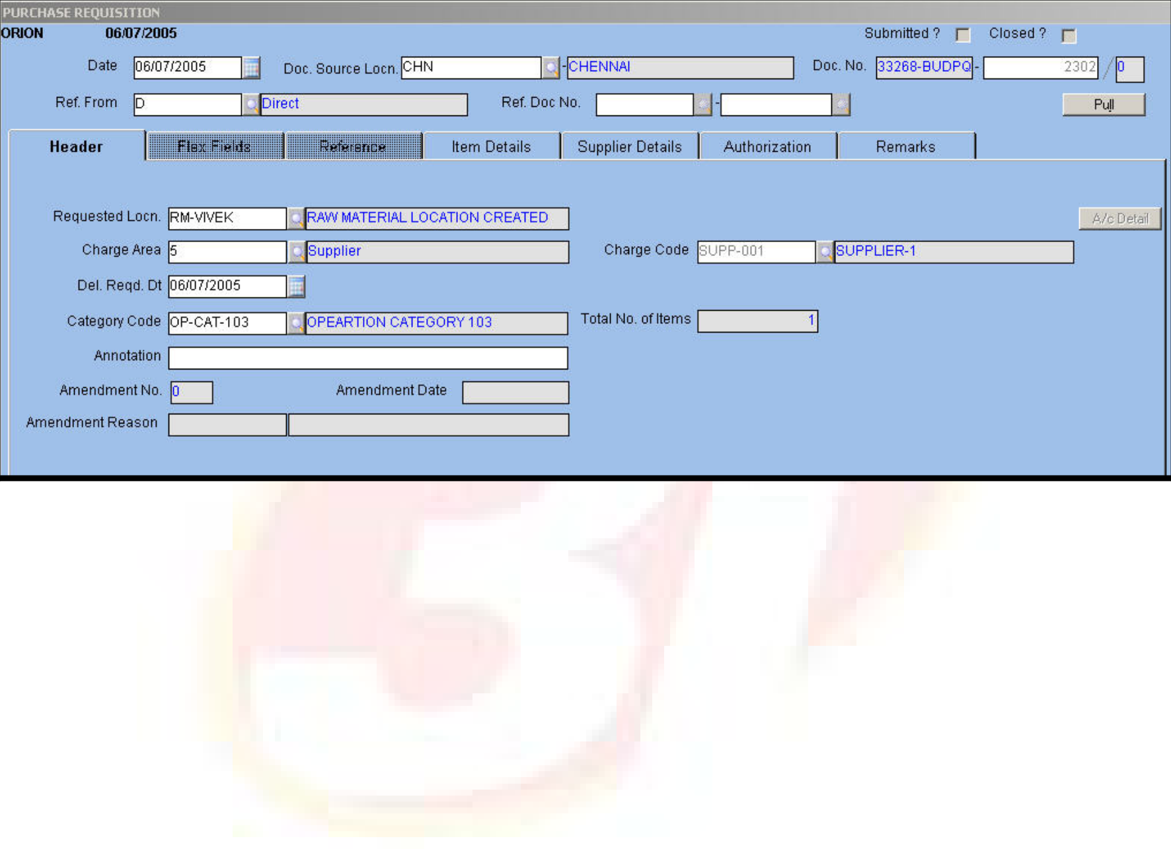





Purchase Requisition
Once the budget is approved, the consumption of the budget is done in Operations through the PRQ transaction. Budget Rules set in ‘Operations Budget Rules for PRQ’ are applied to the transaction.
In the Budget module when the ‘Applicable At’ field is selected at the Item level and Allocation Type is Manual, Budget Category Code is entered in the header. Additionally, enter the Budget Quantity and Budget Value fields depending on Budget Basis for the selected Budget Segments. Click the ‘Item Budget’ button to enter the budget details. Once fields in the ‘Item Details’ tab are entered, the budget details are captured in the ‘Document Budget’ field with the Segment Codes appearing as per the selected Category Code.
The Purchase Requisition transaction screen is displayed below.
Fig. 34 - Purchase Requisition Transaction
When the ‘Applicable At’ field is set to the Item level and Allocation Type is Automatic, the application defaults the Budget Description, Budget Code, Quantity and Value fields and segments such as Location Code and Item Code depending on the code entered in the Transaction Code field in the header block. This way, the budget is automatically allocated when the requisition is saved.
NOTE:
 If the basis is Quantity, only the Quantity field is entered.
 If the basis is Value, only the budget value is entered.
 If the budget basis is Both, both quantity and value are selected for budget availability.
ORION Budget User Manual | Version 1.1 | 48

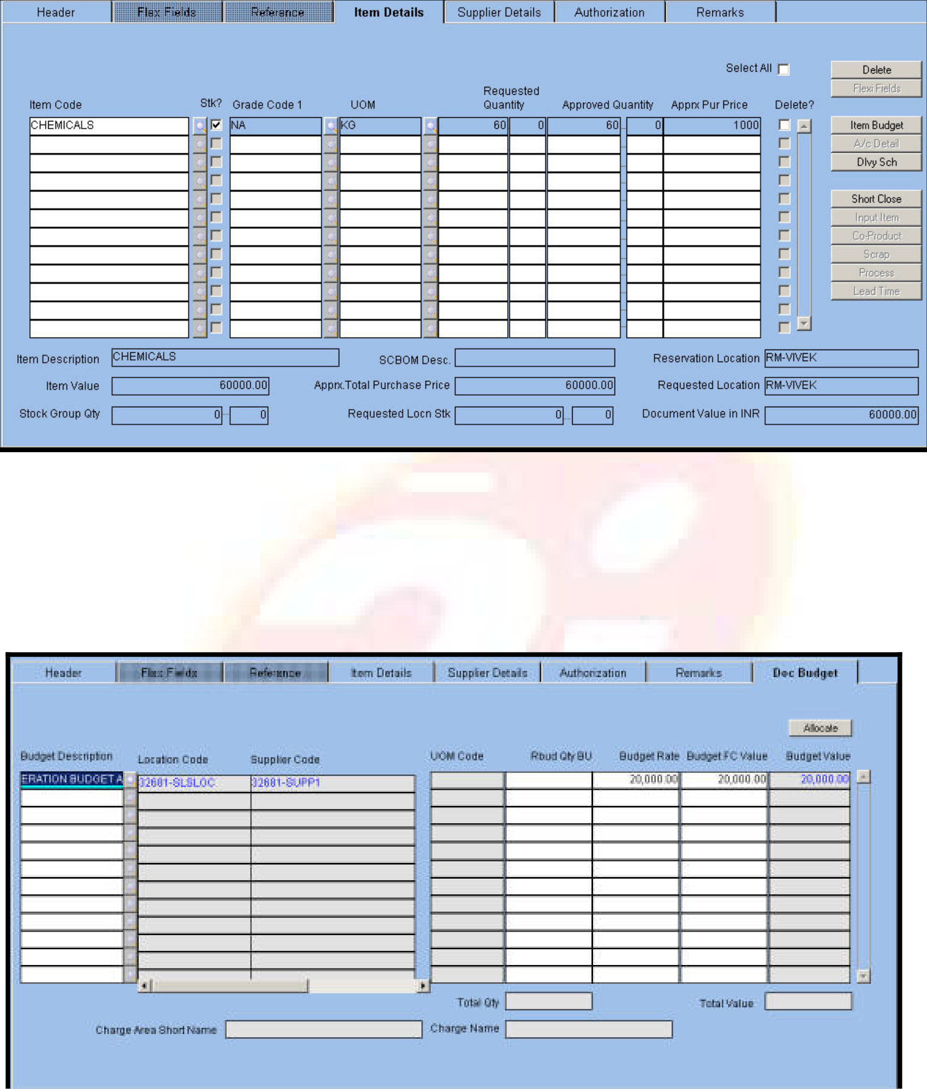





In the ‘Item Details’ tab, enter the quantity to be purchased and the loose quantity as per UOM defined at Item level.
Fig. 35 - Item Details Tab
When the ‘Applicable At’ field is selected at the Document level, Budget Category Code is entered at the header and the budget details are displayed in the Document Budget tab. Additionally, you view Base UOM. The quantity to be purchased is entered only in Base UOM.
Click the ‘Allocate’ button for the application to allocate the quantity and value based on the budget details and Budget Basis.
The Document Budget tab is displayed below.
Fig. 36 - Document Budget Tab
Related Topics: Purchase Requisition Transaction in Purchase module.
ORION Budget User Manual | Version 1.1 | 49

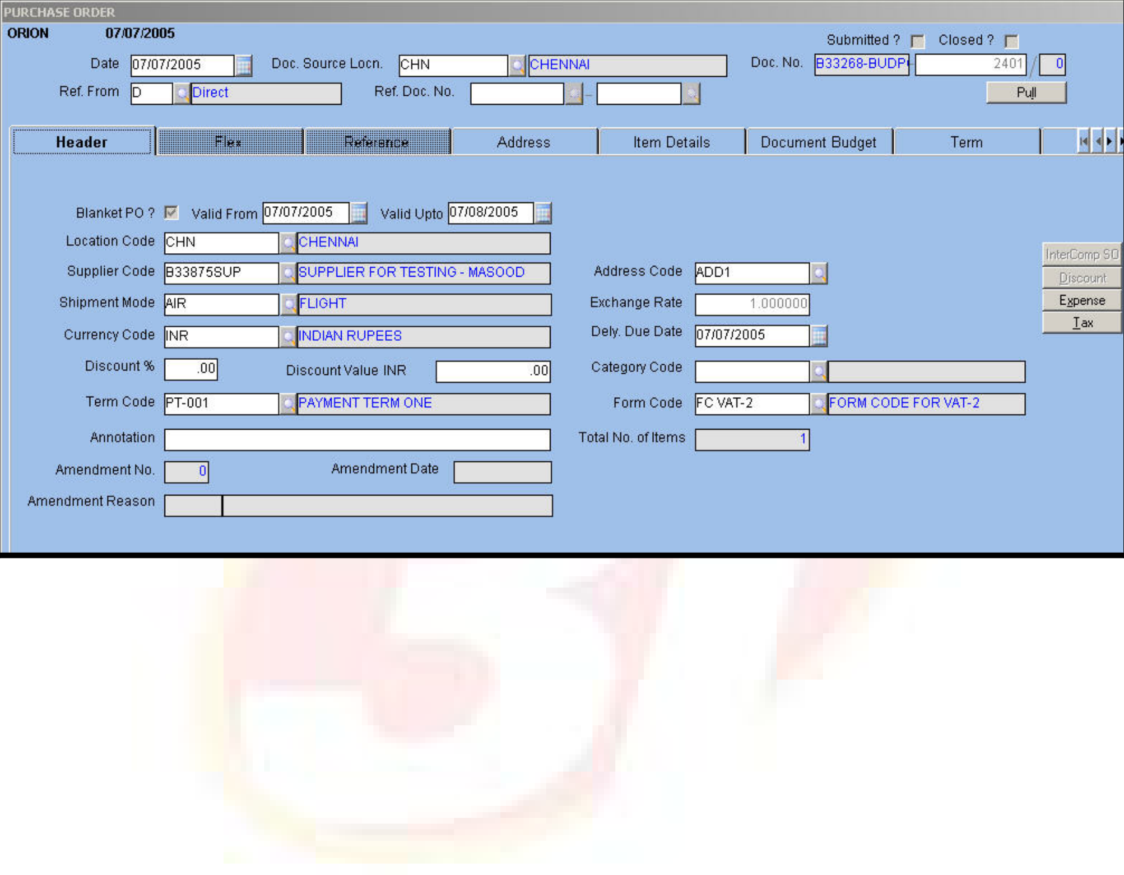





Purchase Order
Purchase Order (PO) is prepared based on quotations received from vendors offering the requisite supplies. PO is sent to the Inventory department as well as the Accounts department for verification. The latter makes use of PO to process the purchase transactions and allocate the budget amount for a purchase.
The allocation of budget for PO transactions is similar to the purchase requisition transactions. The user enters the Budget Category Code in the header block and the budget details in the Item Budget window when options are at the Item level and allocation is of type Manual.
The PO transaction screen is displayed below.
Fig. 37 - PO Transaction
For field-level explanation of the purchase requisition and PO screens, please refer the Purchase module.
ORION Budget User Manual | Version 1.1 | 50

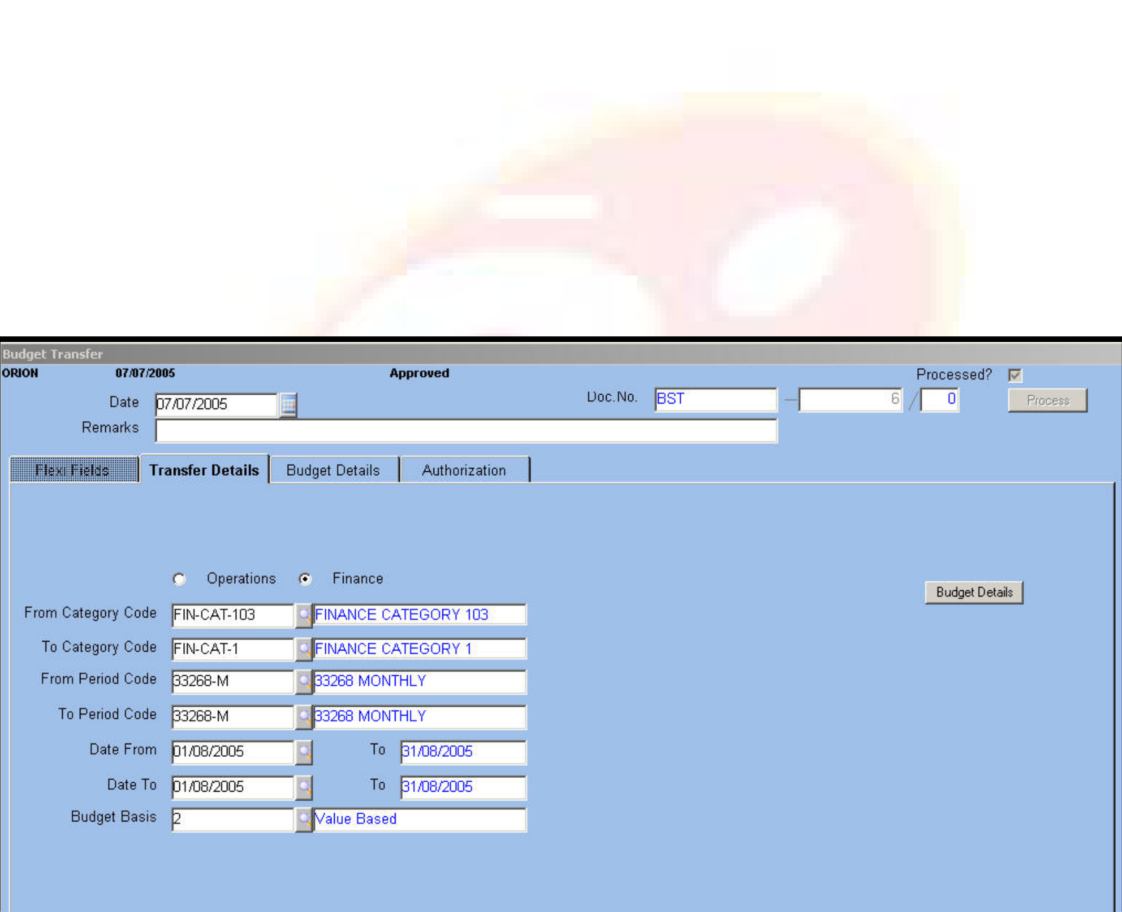





Budget Transfer
Pre-requisite:
 For the Budget Transfer transaction to be enabled, set the Carry Forward / Transfer? Transaction parameter to ‘1’, denoting transfer.
 For negative balance to be transferred, set the Transfer Negative Balance Y/N transfer parameter to ‘Y’.
The transfer transactions allows the user to transfer budget quantity or amount to another record, period or sub period once the budget is prepared and approved,
Budget Transfer is possible on the following levels:
One to One – One budget detail to the other
One to Many – One Budget detail to more than one Budget detail
Many to One – Multiple Budget details into a single budget detail
Many to Many
The screen allows a single transaction to handle One to One, One to Many and Many to One transfers. However, for the Many to Many transfer, a contra entry is necessary.
The contra entry is where a dummy budget is created for facilitating the transfer. The multiple values to be transferred are first to a single budget (many to one) and then the dummy budget is transferred to multiple budgets (one to many).
For example, item Values A, B, C, D need to be transferred to E, F, G, H.
Instead of transferring directly, transfer the Values of A, B, C, D into Z item (dummy entry) and then transfer the value from Z (-) to E, F, G, H.
The Budget Transfer transaction screen is displayed below.
Fig. 38 – Budget Transfer Transaction
Date
The application defaults the system  ORION Budget User Manual | date. To modify, enter the date of budg  Version 1.1 | et transfer.  51







Document Number
The application displays the document number with the amendment counter, if any.
Remarks
Alphanumeric – 12
Enter remarks pertaining to the transfer if any.
Transfer Details
Budget Type
Option Button
Select the option button as per the applicable budget type. From and To Category Codes
Alphanumeric-12
Enter the range of category codes to be transferred. The LOV is populated with the codes applicable to the chosen budget type.
NOTE: If the From and To category codes are the same, it is mandatory that the Period Codes are different.
From and To Period Code
Numeric
The application defaults the Period To field if only one period is defined for the selected category code.
Date From and To
Dates
Enter or select from LOV the starting and ending dates within the selected periods for transferring the budget amounts.
NOTE: Transfer from Current Period to Past Period is not possible. The module supports transfers from current period to current period, current to future, future to current, future to future, past to future.
Budget Basis
Numeric
Enter or select from LOV the basis of the budget. The applicable values are:
 1 – quantity based
 2 – Value Based
 3 – Both
NOTE: When saving the transfer details, the applicable displays an error message if the Value based budget is transferred to a quantity based or BOTH budget. The converse too is not allowed.
Budget Details
Click the Budget Details button once you fill in all the fields. This tab comprises two parts – Transfer From and Transfer To. The Transfer From part is populated with the following details:  Budget Code and description
ORION Budget User Manual | Version 1.1 | 52

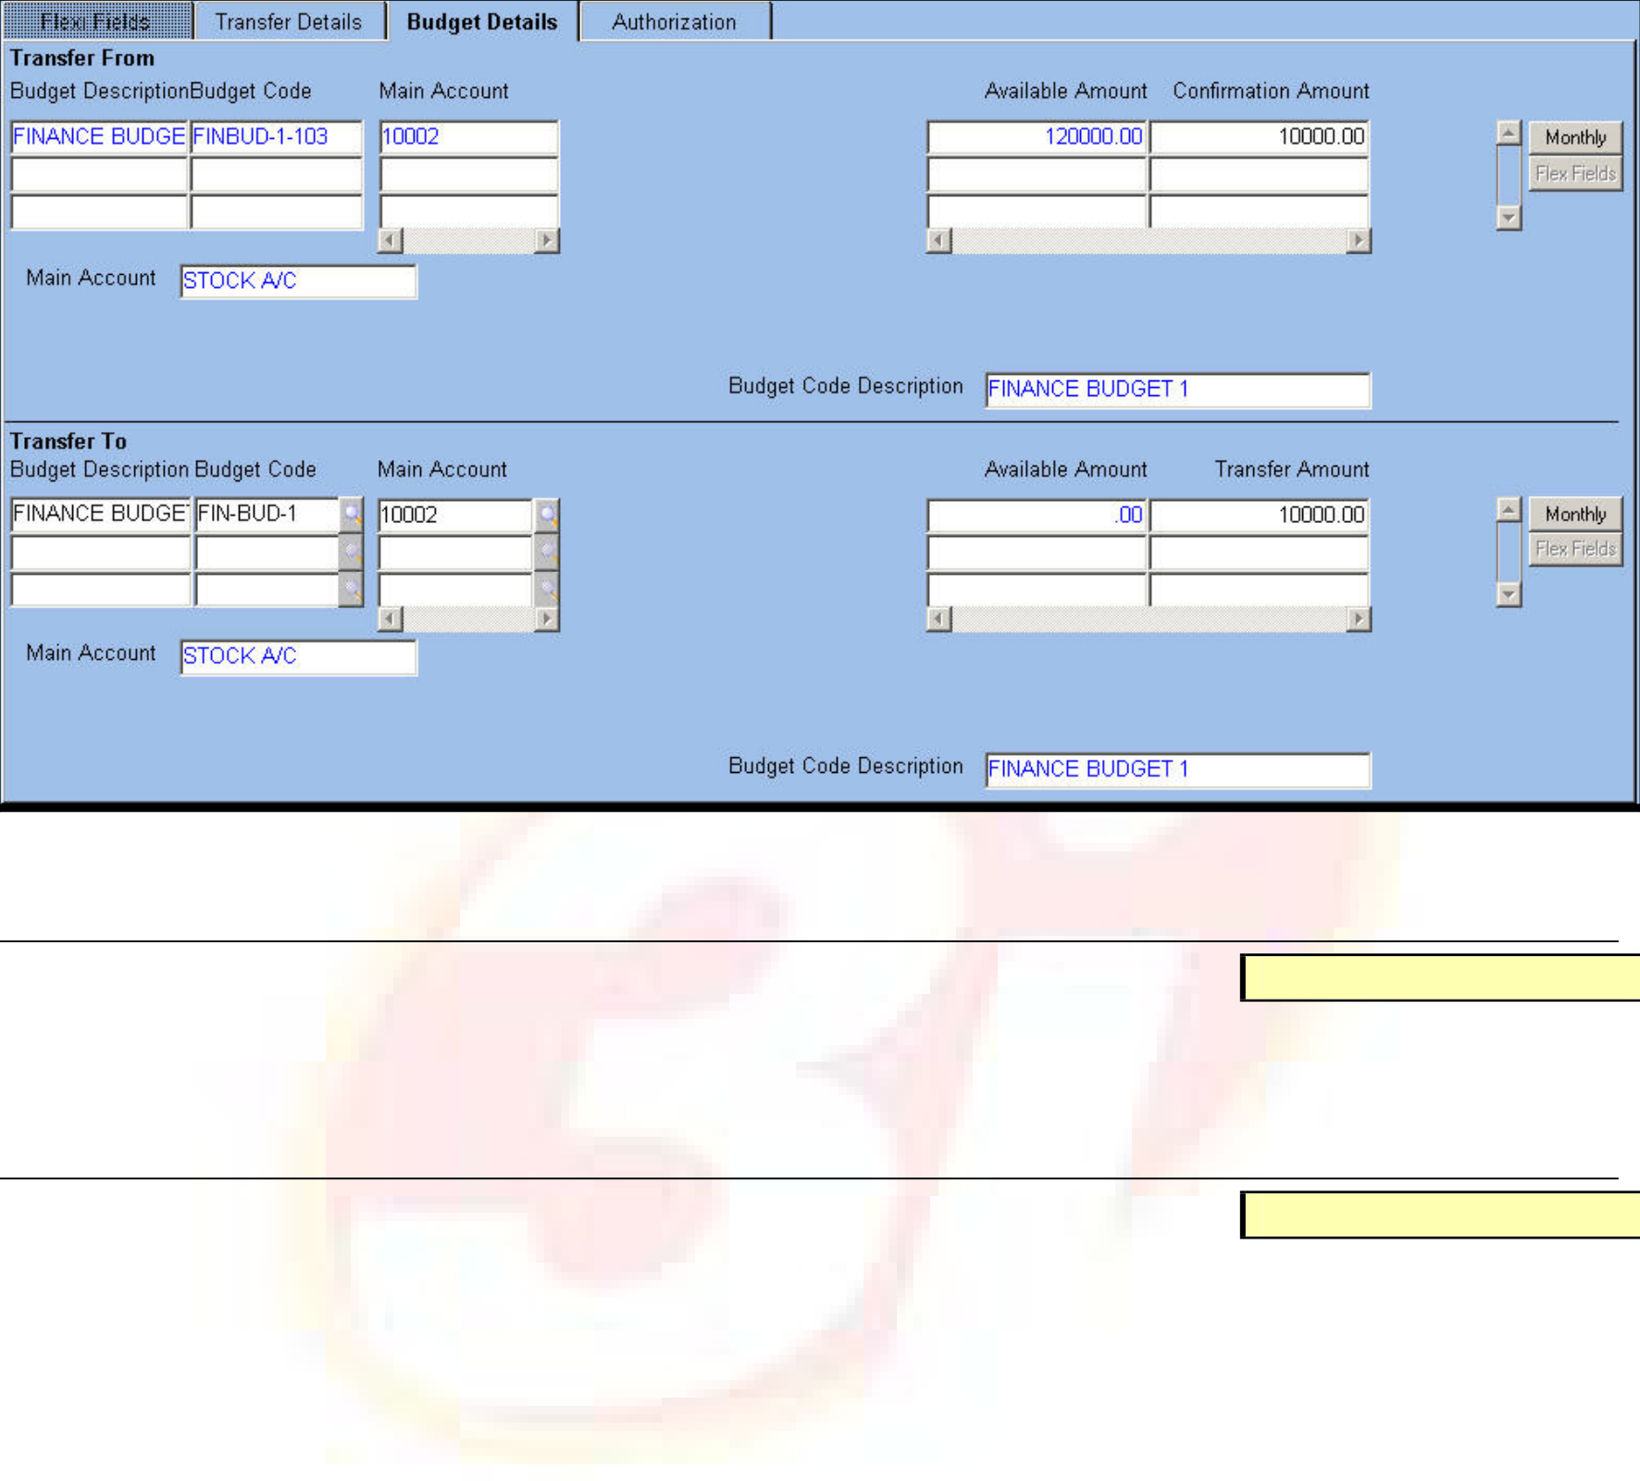





 Segments applicable to the chosen budget category – in the screenshot, the Main Account Segment and its description are displayed
 The total budget amount available for transfer
 The user is allowed to do full or partial transfer of the available budget amount. The Details tab is displayed below.
Fig. 39 – Budget Details Tab of Budget Transfer Confirmation Amount
Numeric
Enter the actual amount to be transferred from one budget to another. Of the available amount, the user is allowed to transfer completely or partially.
Monthly
Button
Click the button to view the break-up details of the transferable amount. The user is able to see the allocation of the entire amount across months.
NOTE: The Button label is dynamic and changes as per the chosen Period Code.
In the Transfer To part, the application defaults the details from the previous tab. The user is allowed to modify any of the defaulted fields. For example, the budget code to which the amount is to be transferred is modifiable.
The application defaults the following details:
 Budget Code and description
 Segments applicable to the category code
 The transfer amount (defaulted from the Transfer To part) Click the Process button to complete the transfer process.
Authorization
The tab displays details of the users who authorized the transfer. The Authorization tab is displayed below:
ORION Budget User Manual | Version 1.1 | 53







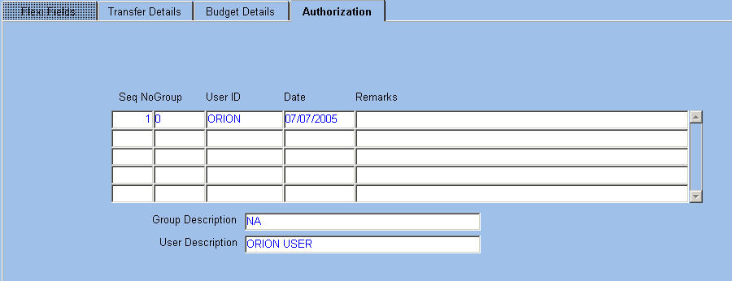
Fig. 40 – Authorization Tab of Budget Transfer The application displays the following details:
 Sequence number
 Group to which the authorized users belong and its description  ID of the authorized user and description
 Date of authorization
The user is allowed to enter any remarks pertaining to the transfer.
Budget Transfer for Operations Budget
The transfer mechanism for Operations budget is similar to the Finance budget. A few variances are listed below:
In case Item Code, Grade Code 1 and Grade Code 2 are segments of the category, the application defaults the Grade Code 1 and 2 values based on the Item Code.
NOTE: The Grade Code 1 and Grade Code 2 Required transaction parameter setting determines the enabling/ disabling of the fields.
When Item Code is one of the segments, the UOM and Budget Basis are defaulted. The user is able to enter the UOM only if Budget is Quantity based or Both
When the budget transfer is saved, the budget summary is updated. In case document approval is required, the adjustment amount in budget summary is updated when the document is approved.
ORION Budget User Manual | Version 1.1 | 54

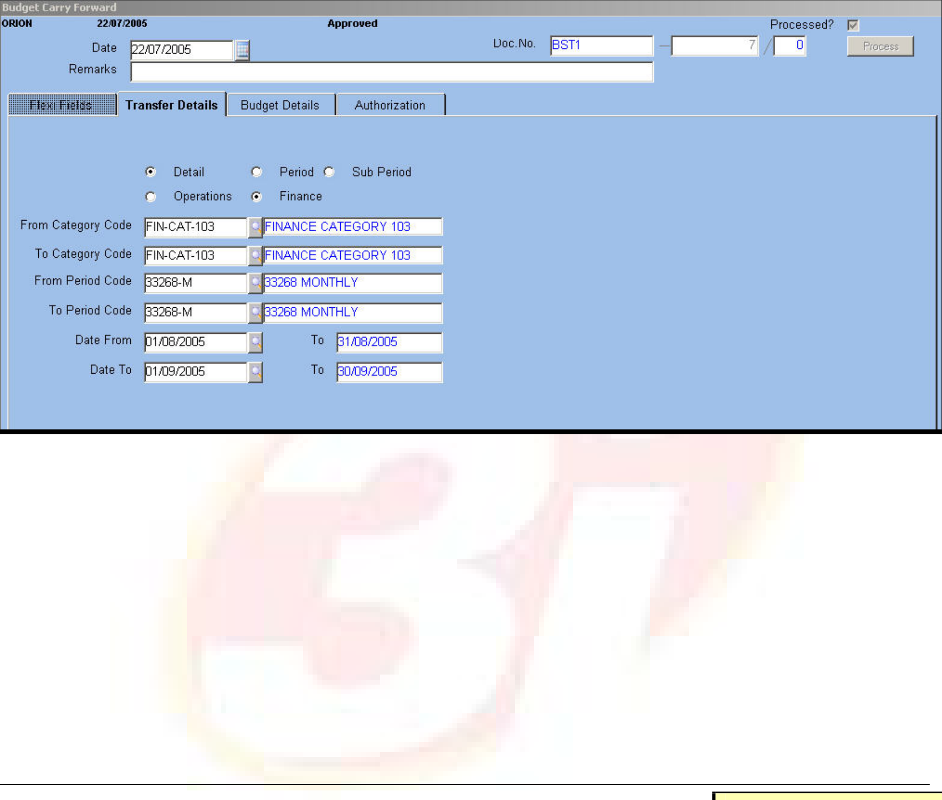





Budget Carry Forward
Prerequisite:
Set the Carry Forward/Transfer transaction parameter to C
The application allows carrying forward of available budget amounts and other details from one period to another. The user is allowed to transfer only positive budget balance.
The Budget Carry Forward transaction screen is displayed as follows.
Fig. 41 – Budget Carry Forward transaction
The application allows carry forward of budgets at the following levels
 Budget Detail Level – all budget details are carried forward including entries in the Period, Sub Period and Cash Flow blocks
 Period Level – amount/quantity is carried forward from one period to the other along with the Sub Period and Cash Flow details
 Sub Period Level –amount/quantity is carried forward from one Sub Period to another provided Sub Period is defined.
The Category From and Category To fields need to be the same. The application defaults the Category To field based on data entered in the Category From field.. It is the same for the Period Code To field.
Date To
Date
Enter a future date compared to the Date From field.
NOTE: Partial carry forward of budget quantity/amount is not possible. The segments and budget basis are automatically defaulted
For field level explanation of the Budget Details and Authorization tabs, please refer the Budget Transfer transaction.
ORION Budget User Manual | Version 1.1 | 55

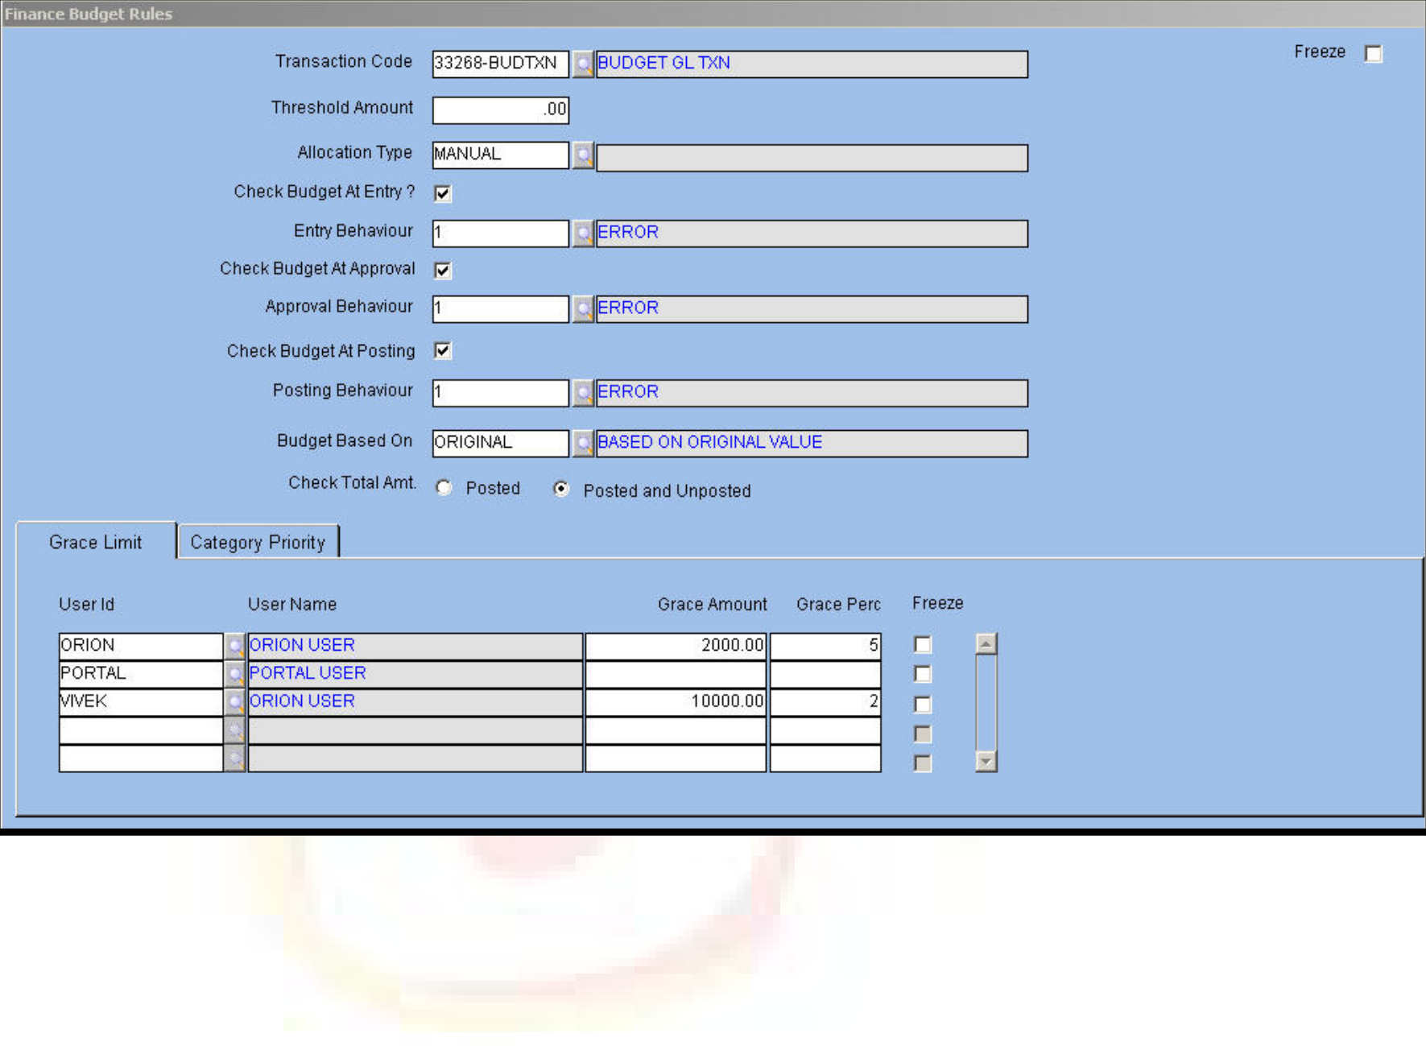





Processing
Transaction Processing
Transaction processing or posting is done for both single and batch transactions. During batch processing, all the unprocessed transactions are submitted for processing. Once processed, these cannot be modified except by introduction of additional vouchers to effect changes.
Select the ‘Check Budget on Posting’ check box for the application to validate the budget at the time of posting. This validation is either in GL or in the Batch Posting screen.
The Finance Budget Rules screen is displayed below.
Fig. 42 – Finance Budget Rules Master
Processing of transactions impacts balances of accounts, and the transaction is visible in various reports pertaining to Trial Balance, Balance Sheet, Profit and Loss Statement, GL and Daybook. The Transaction Processing screen is displayed below.
ORION Budget User Manual | Version 1.1 | 56

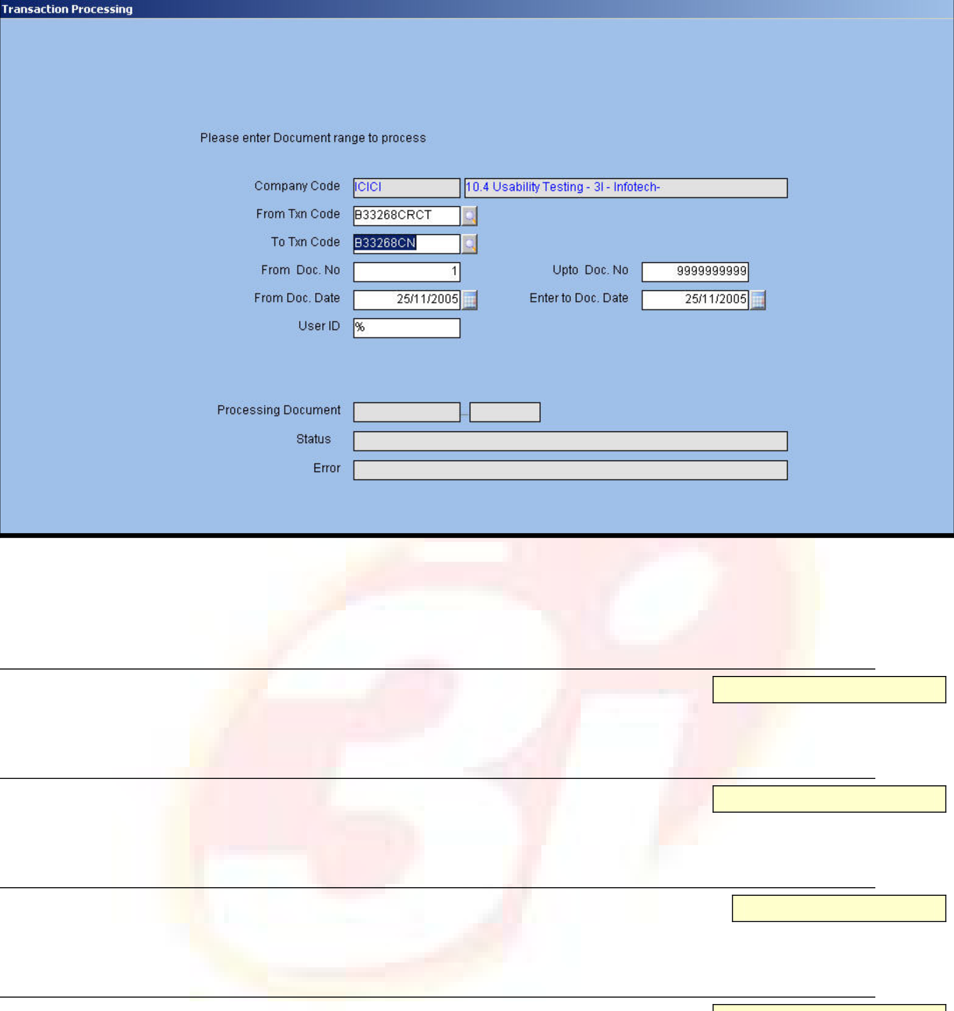





Fig. 43 - Transaction Processing Screen
The code of the logged in company and its description get defaulted in the Company Code field on entering this screen.
9Transaction Code From/To
Alphanumeric – 2
Enter or select from the LOV the codes of the range of transaction that is to be processed.
9Document Number From/To
Alphanumeric – 10
Enter the range of document numbers for which the transaction is to be processed.
9 Document Date From/To
Date
Enter or select from LOV the start and end document dates of transactions.
9User ID
Alphanumeric – 12
Enter the Id of the user whose documents need to be processed. To process the documents of all applicable users of the logged-in company, enter a percentage symbol, which is the default value.
The following fields are populated with details on processing a transaction:
 | The document code and number of the processed transaction
 | The status of the transaction
 | Errors, if occurred during transaction processing
ORION Budget User Manual |  | Version 1.1 | 57

